**Iteration 4: BDAS: Predicting price for Ethereum and Litecoin**

1. **Business Understanding**
   1. **Determining Business Objective**

Background information: Bitcoin as we all know is an electronic based cryptocurrency without any central governing body. Transactions can be done between users or peers authenticated through cryptography and stored in a public repository called a block chain. Bitcoins are produced through a process called as mining. It was introduced in the year 2009 by a group of anonymous users using the name Satoshi Nakamoto. During recent years, it has been seen that bitcoin prices rose the highest in the year 2017 and then plunged by 70% in Februaury 2018 and ever since bitcoin investors have been decreasing day by day. Alternative cryptocurrencies like Ethereum and Litecoin grew into the market but it has been very uncertain as to how the prices would vary. This is where price predictability plays a major role and machine learning aids in predicting the same. Price predictability is not majorly covered in other works. The main objective of this data mining model is to analyse the dataset of cryptocurrency like Ethereum and Litecoin and try to predict the future high prices.

**Business objective:**

* To analyse the dataset for historical price information listed for Ethereum and Litecoin achieved from Kaggle for the year starting from 2013 until now. The data is taken from coinmarketcap and it is free to use. And Ethereum dataset is obtained from Etherscan.
* To analyse how market capitalization change over time and to predict future prices which can be helpful in deciding which cryptocurrency has a positive future and would produce benefits.
* Try to analyse which cryptocurrency is stable and is a better option to invest.
* The process of prediction of the prices can be done by using models like Regression, Logistic Regression, Neutral Network, Decision Tree or Naïve Bayes model by considering target as prices which were high on a particular day. Main objective of using these models is to see how each model could affect the performance of the model. Also, all the models would be assessed on how well they generate the results and what is our analyses by viewing the outcome of each model.

This objective would be successful if I can analyse these datasets and predict the future prices, and if this analyses can be achieved in given scope and time.

**Key Problems**: Major problem could be the ever fluctuating market since the market is very uncertain and unpredictable. So, the accuracy in predicting the future prices may not be very accurate. Also, another issue faced was having a broad scope which included various other cryptocurrencies but later I focused on just Ethereum and Litecoin’s price. And the lack of information in regards to predicting prices is available in literature which makes this predictability criteria challenging. The dataset that I’m using is only till February, 2018 so prediction of the next months would also follow.

**Goal**: Thus, now my objective is to try to predict future prices of both Ethereum and Litecoin, and also analyse how market capitalization changed over time. Hence, concluding by giving insights as to which cryptocurrency is stable to invest in based on the price prediction results and visualization.

**Motivation**:

1. To analyse the market capital of the cryptocurrency that we have, and stating certain insights about the same.
2. Try to determine future prices of both the cryptocurrencies.
3. To conclude with insights as which currency is stable and better to invest based on the results.
4. Also, how can this dataset be useful to achieve our goal.

**Limitation**: Market uncertainty and missing values in the dataset is an issue which could hamper in predicting an accurate result.

**Current solution:**

Researchers have used various algorithms like decision tree, random forest model and forward feed neutral network and many more to predict prices for bitcoin considering time series pattern. The result accuracy for decision tree and random-forest model is 57% whereas by using a forward feed neutral network, researchers achieved 60% accuracy in predicting changes in Bitcoin price. Researchers also consider time series prediction in predicting the price by using regression. There is lack of literature explaining the process to predict future price using machine learning. Few papers stated deep learning as the best method in predicting prices and achieving better accuracy.

Research on predicting the price of Bitcoin using machine learning algorithms specifically is lacking. Shah et al. (20) implemented a latent source model as developed by Chen et al. (17) to predict the price of Bitcoin. The model received an impressive 89 percent return in 50 days with a Sharpe ratio of 4.1. The Sharpe ratio examines performance of an investment while adjusting for its risk.

**Success Criteria**: This prediction would be a success only if the prediction accuracy is about 80% or above. After running all the models stated above, by analysing the result set can help in stating which crypto crrency can be stable and positive to invest in.

* 1. **Business Assessment:**

**Resource inventory:**

**Hardware use**: Personal Lenovo laptop

**Data sources and knowledge source:**

**Data reference**:

Kaggle, and the data on Kaggle was obtained from coinmarketcap and Ethereum dataset is obtained from Etherscan.

The above source has dataset in csv format with 1761 rows and 7 columns each with continuous numeric values. Data is stored in a personal directory in the laptop. Given data was free to use and no purchase of extra data. No security and legal issues are possible as the dataset is free for use. No economic factors were affected.

**Personnel resources**: None

**Risk**: Schedule plays an important role here, so forming a timeline in the initial stage and following the same is very essential or else the project would be at risk. Also, scope of the project, i.e. the goal, should be formed and carried out properly. No immediate risk of using given data or any other confidentiality issue, if so then the scope would be reduced and redefined. No economic factors affected.

My audience that I would consider are all the citizens’ worldwide.

**Contingency plans**:

If project doesn’t work according to the timed schedule, then the scope of the project would be reduced and would be made very specific to a particular topic.

If data is of poor quality then, I would search for new datasets and I have backup datasets in case the current dataset won’t fulfil the project plan.

If results are less than expected, then I would try to get desired result by reiterating all the steps all over.

**Terminology**:

DM: data-mining

Ether: Ethereum

**Cost/Benefit Analysis:**

No operating cost or purchase of extra data. If the objective stated above is achieved then it could be claimed that one of the two currency is stable and better option to invest in. After exploring the data, I realised that the market capital depends on what was the price when listing opened and the highest it could go on that particular date. Also the dataset after analysing can give us a view as to which currency was the highest in a particular year.

* 1. **Determining Data Mining Goals:**

Data mining problem is prediction and lack of information about prediction in literature. Technical goal is to achieve within 15 days. Regression model can be used to deal with the prediction problem. After cleaning and filtering the dataset, regression model would be applied and later after training the dataset and splitting and scoring, the dataset would be evaluated for further result. Re-iteration of the similar steps with the use of other possible models would be run and evaluated. After running all the models, the one which would have the best accuracy score would be considered as the best model.

* 1. **Sample project plan:**

|  |  |  |  |
| --- | --- | --- | --- |
| Phase | Time | Tool | Risk |
| Iteration 1- Proposal | 1 week | IBM SPSS Modeller | Data quality, technology |
| Iteration 2 ISAS | 2 weeks | IBM SPSS Modeller | Data problem, technology problem |
| Iteration 3 MSAS/OSAS | 3 weeks | Microsoft SQL server, Azure machine learning, Power BI.  Python, Jupyter, MySQL, MySQL workbench, Kettle/Spoon, Tablue & Weka | Technology problem, inability to get desired result |
| Iteration 4 BDAS | 3 weeks | GitHub, AWS (EC2/AMI), Jupyter, PySpark, Spark | Technology problem, inability to get desired result |
| Resubmit Iteration 2 & 3 | 1 weeks | Same as 2 & 3 |  |

1. **Data Understanding**

**2.1) Collecting initial data:**

The data was downloaded from Kaggle, and the data on Kaggle was obtained from ‘coinmarketcap’ and Ethereum dataset is obtained from ‘Etherscan’.

The above source has dataset in csv format with 1761 rows and 7 columns each with continuous numeric values. Data is stored in a personal directory in the laptop. No external issues were faced while downloading the dataset as it was very easily accessible through Kaggle.

There are two datasets that I’m using to analyse, which are crypto-currencies like Ethereum and Litecoin. Both the datasets are in csv format and the price history is included from April 28, 2013 until this February 20, 2018. Each of those two datasets have the following:

* Date: Oate of observation,
* Open: Opening price on the given day
* High: Highest price on the given day
* Low: Lowest price on the given day
* Close: Closing price on the given day
* Volume: Volume of transactions on the given day
* Market cap: Market capitalization in USD

Thus, there are 1761 rows and 7 columns. Focus would be on the column of ‘high’ and ‘close’ as these two seem very useful in predicting the result. The ‘high’ column seems very promising as it might be very insightful to analyse its relationship with the ‘date’ column. Current data seems enough to achieve the desired stated goal. Merging the datasets is essential since both the datasets would be predicted side-by-side as it would be helpful in comparing them both. Merging would be easy since column name is same for both the dataset. There would be few missing/blank values which would be substituted with ‘N/A’ and based on that I will be constructing a new column which will help in understanding the data precisely.

**2.2) Data Description:**

After the dataset was collected, I uploaded the dataset on Jupyter Notebook which is an open source platform. To open the Jupyter Notebook, an AWS account was created and an instance was launched and then I can login to ‘putty’. After logging into ‘putty’, I just type ‘jupyter notebook’ which returns me with an address which I will copy in my browser and just modify the IP address with that of my launched instance. In order to import and read the data, I created a notebook on Jupyter notebook with the name ‘Demo2’ imported the required libraries as shown below. Then I import the dataset, where ‘lp’ represents dataset for **litecoin** and ‘ep’ represents for **ethereum**. The ‘header’ is used to specify each column and ‘inferschema’ is used to automatically detect data types.

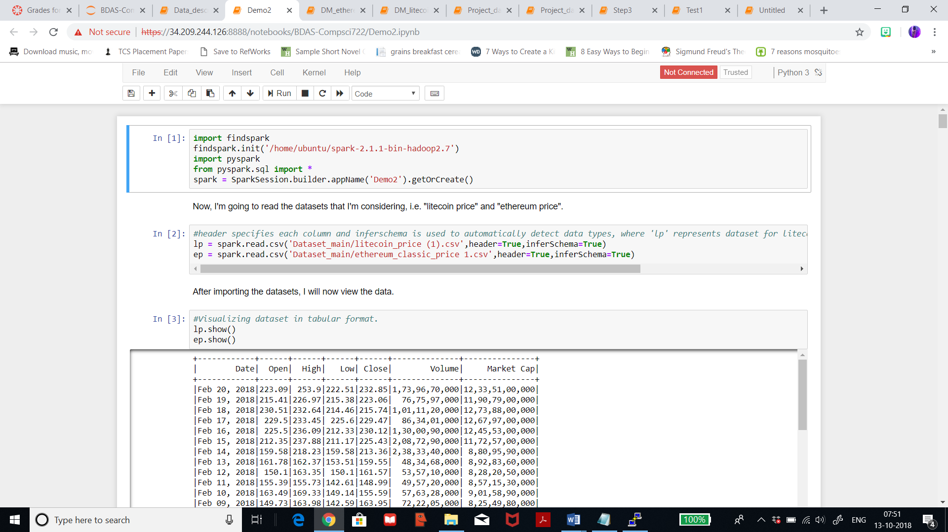

As seen above, the name of the .csv file I’ll be using is ‘litecoin_price (1)’ for litecoin dataset and ‘ethereum_classic_price 1’ for ethereum dataset.

After importing the datasets and assigning names, I visualised the data. The below table represents data from litecoin dataset.

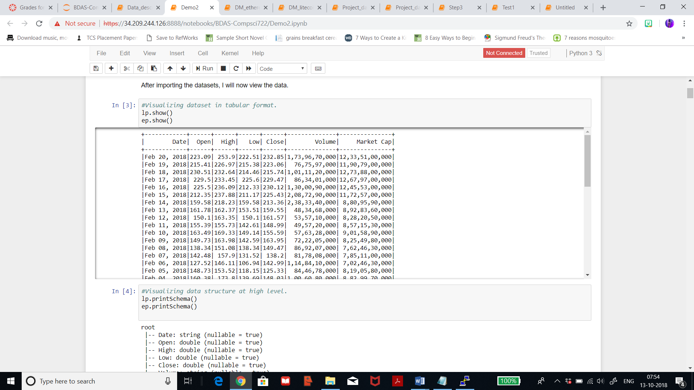

The below table represents dataset for ethereum dataset.

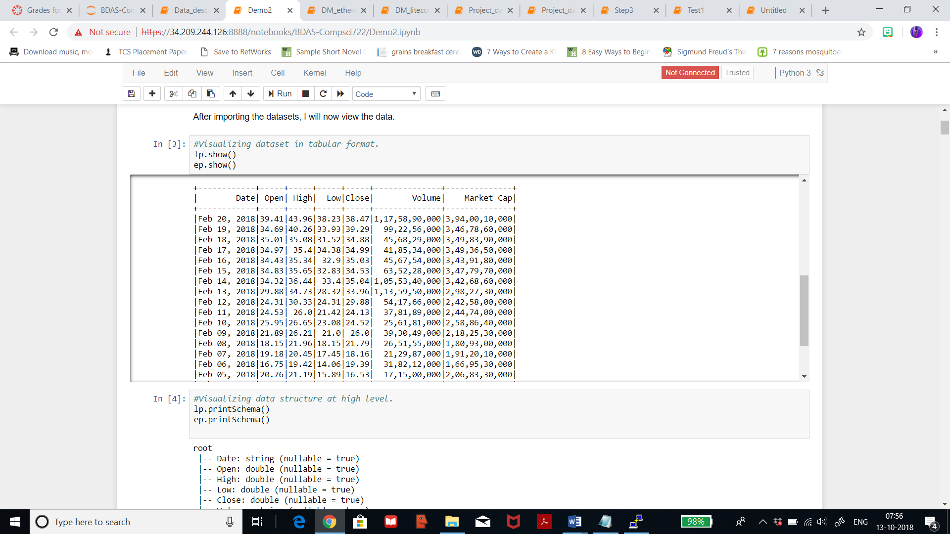

For both the datasets, only first 20 rows are seen, though there are over a thousand more rows for both the dataset. After viewing the dataset, I will now check the data types of each variable.

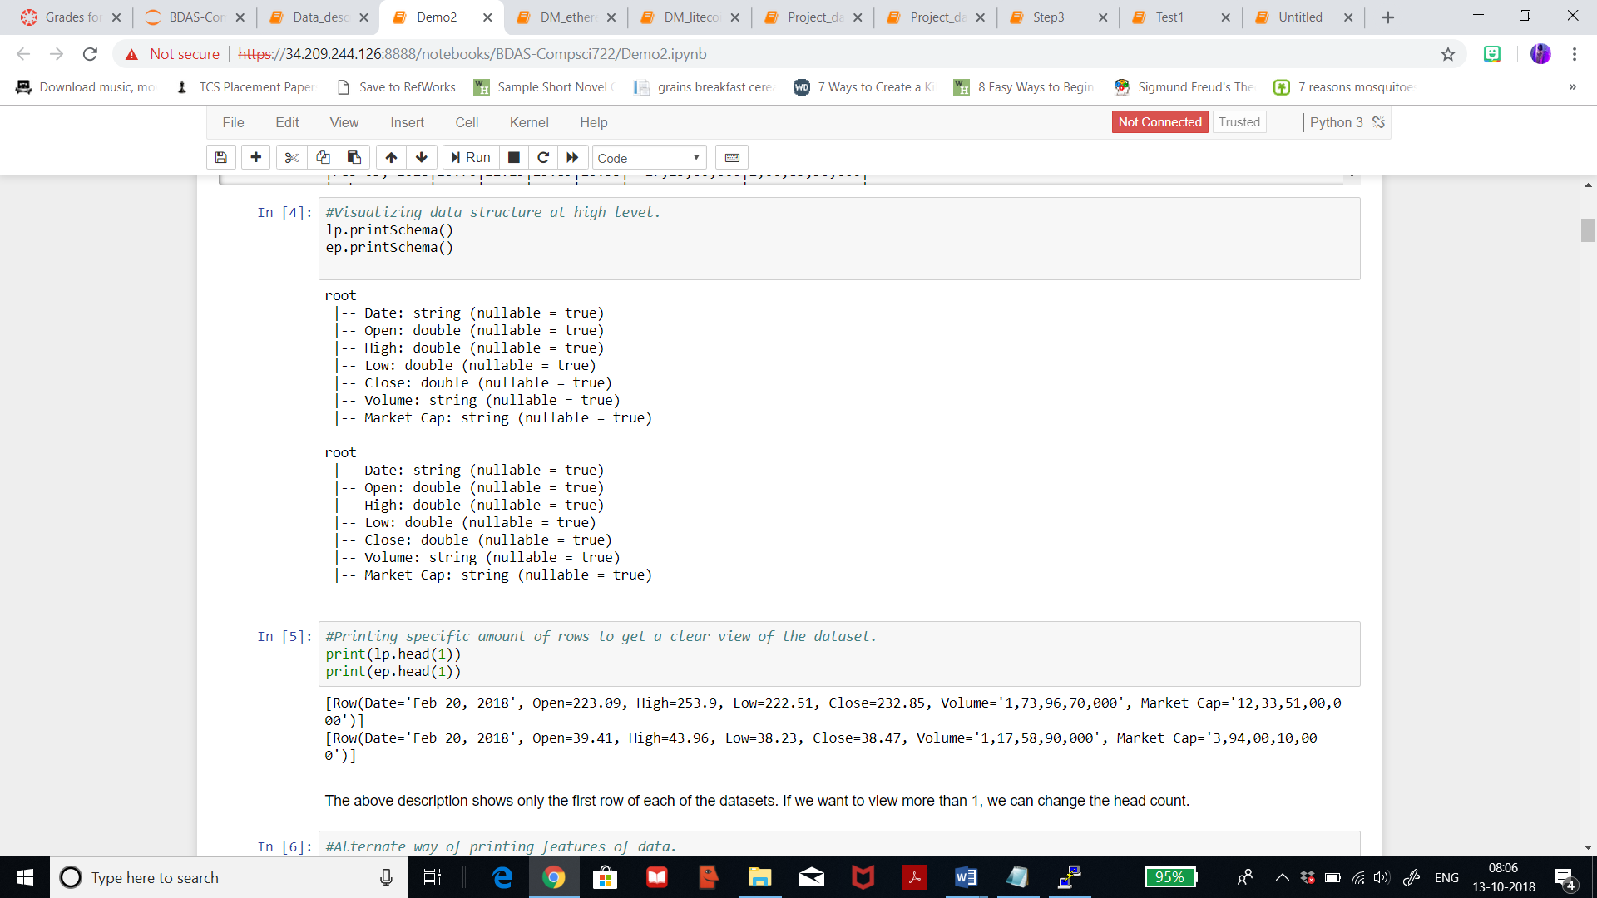

After importing and reading the dataset, I understood that for litecoin dataset:

* Date - This is the date of observation recorded. It is of the type ‘string’.
* Open - This column contains the opening price on the given day. It is of the type ‘double’.
* High - It represents the highest price on the given day. It is of the type ‘double’.
* Low - It represents the lowest price on the given day. It is also of the type ‘double’.
* Close - It represents the closing price on the given day. It is of type ‘double’.
* Volume - It represents the volume of transactions on the given day. It is of the type ‘string’.
* Market Cap – It represents the market capitalization in USD. It is of the type ‘string’.

And for ethereum dataset:

* Date - This is the date of observation recorded. It is of the type ‘string’.
* Open - This column contains the opening price on the given day. It is of the type ‘double’.
* High - It represents the highest price on the given day. It is of the type ‘double’.
* Low - It represents the lowest price on the given day. It is also of the type ‘double’.
* Close - It represents the closing price on the given day. It is of type ‘double’.
* Volume - It represents the volume of transactions on the given day. It is of the type ‘string’.
* Market Cap – It represents the market capitalization in USD. It is of the type ‘string’.

The column of ‘high’ which includes the highest price on the given day is very useful for my analysis of predicting future prices and also it could be helped to determine the market capitalization. The column of ‘volume’ of transactions and ‘market cap’ are not relevant and necessary for the result that I intend to achieve, so I can exclude that column in the dataset. Thus, major focus while analysing would be on the column of ‘high’ and ‘close’ as these two column seem very useful in predicting the result. Column names after merging would be:

* For Ethereum dataset: Date, Open_ethereum, High_ethereum, Low_ethereum, Close_ethereum, Volume_ethereum, Market_cap_ethereum
* For Litecoin dataset: Date, Open_litecoin, High_litecoin, Low_litecoin, Close_litecoin, Volume_litecoin, Market_cap_litecoin

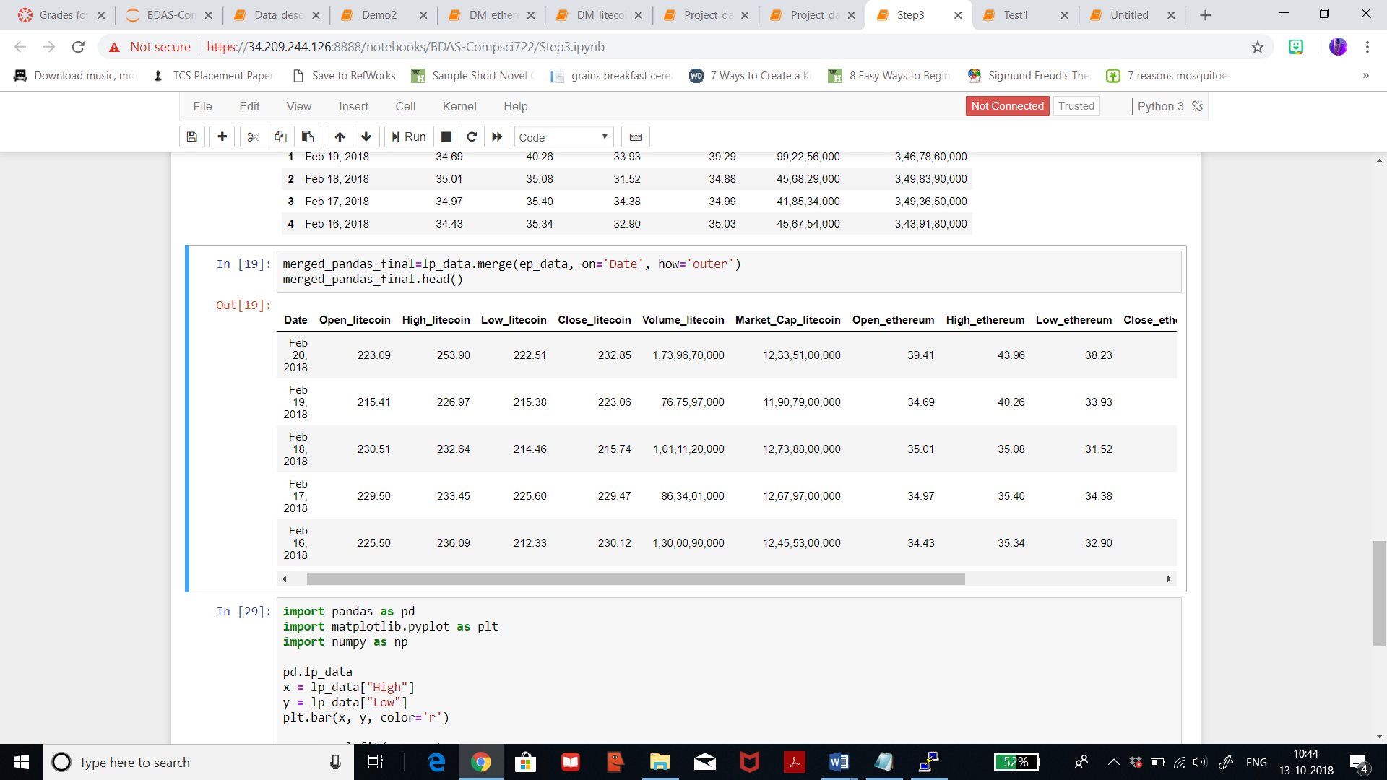

Further describing the data, I will summarise each of the dataset, thus, analysing the count, mean, standard deviation, minimum and maximum. The first table below displays the result for litecoin dataset and the second table below displays the result for ethereum dataset. As seen, the mean and standard deviation for both the datasets for the columns of ‘Date’, ‘Volume’, and ‘Market Cap’ is seen as ‘null’ since the datatype for those columns is string. Also, for both the dataset the count for the column ‘Volume’ is 1517 which clearly says that there are certain missing values which we will view in further steps.

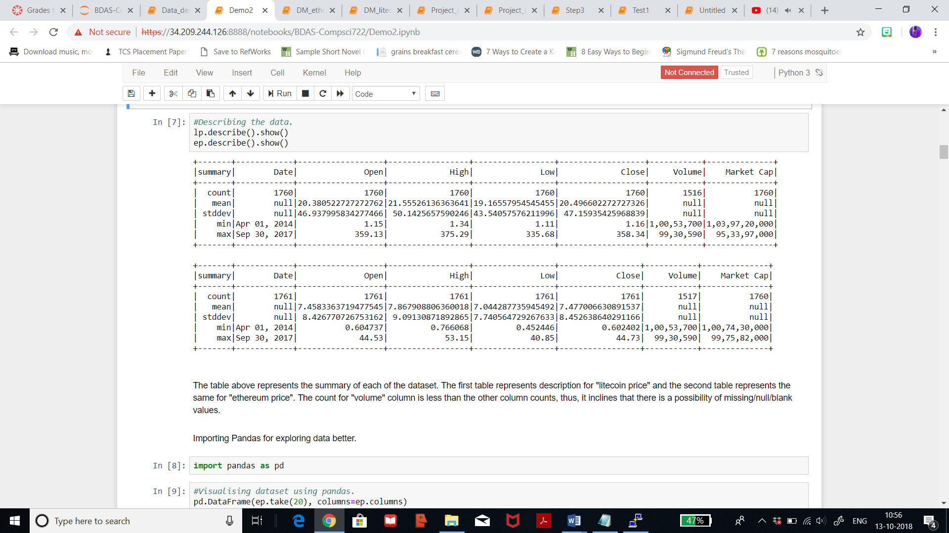

**2.3) Data exploration:**

After importing, reading, and describing the data, I believe it is better to keep backup of all the datasets and the notebooks created on Jupyter Notebook. A remote public repository is created on Github with the name ‘BDAS-Infosys722’ which will synchronize all my work done locally on Jupyter Notebook to this remote repository. The local work done on Jupyter Notebook is pushed to my Github repository by using certain commands which will be shown in later steps.

For both the datasets, I’m trying to explore options for visualizations by using libraries like matplotlib, numpy, and pandas. For exploring the data in a better format, I will import ‘pandas’ library and then view the data. Below table represents table for litecoin dataset with 20 rows. As seen in the table, the data seems to be in a better format.

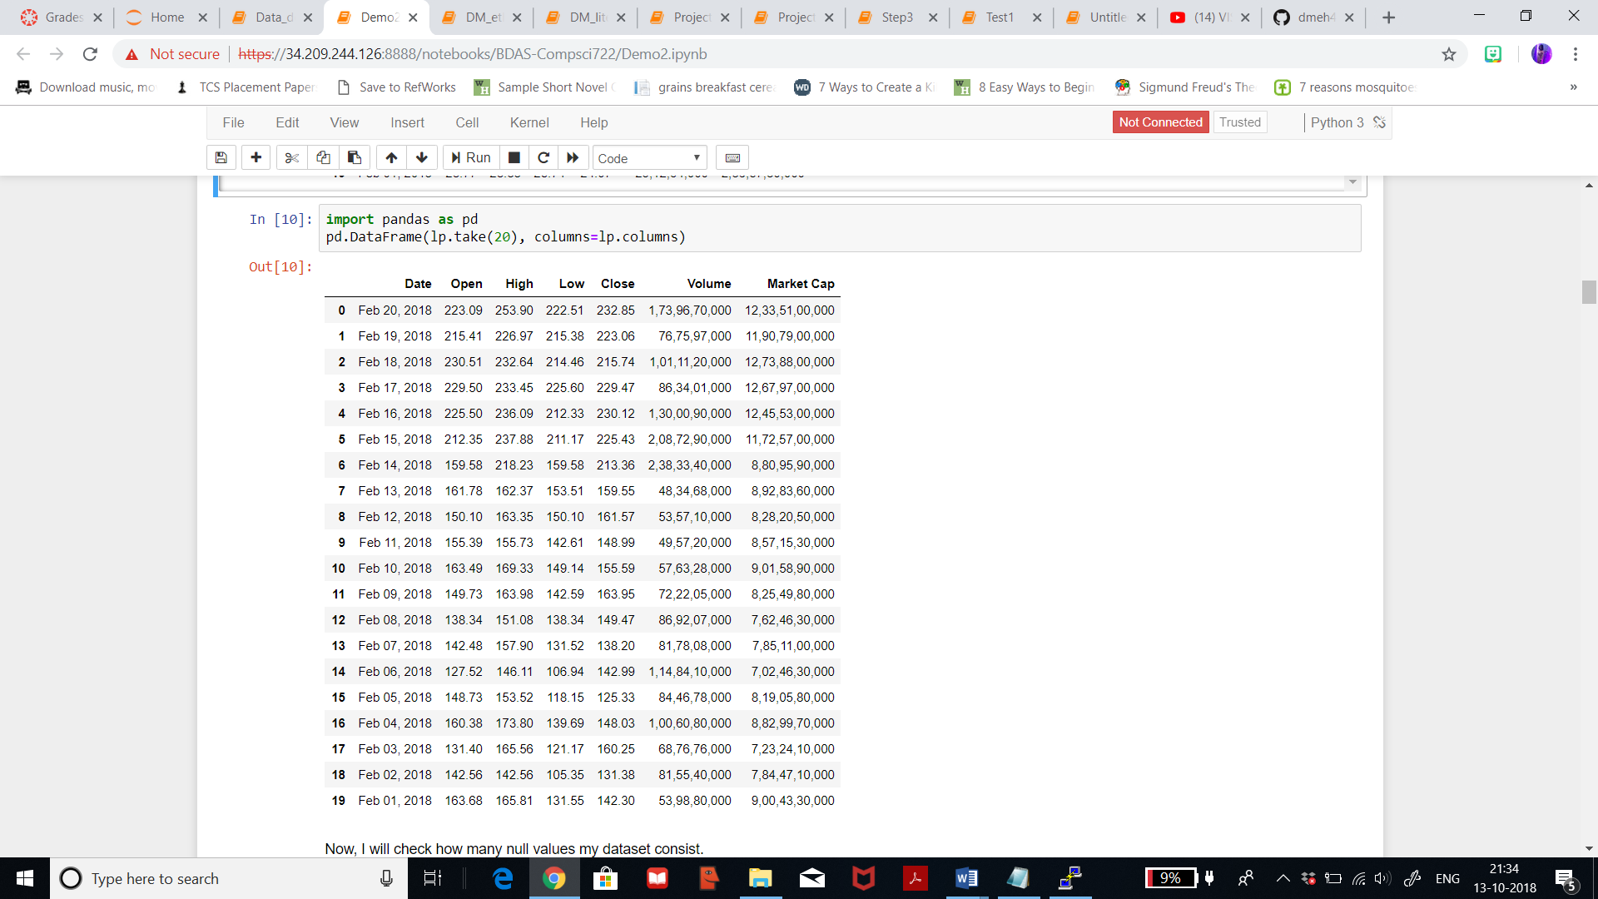

Below table represents table for litecoin dataset with 20 rows.

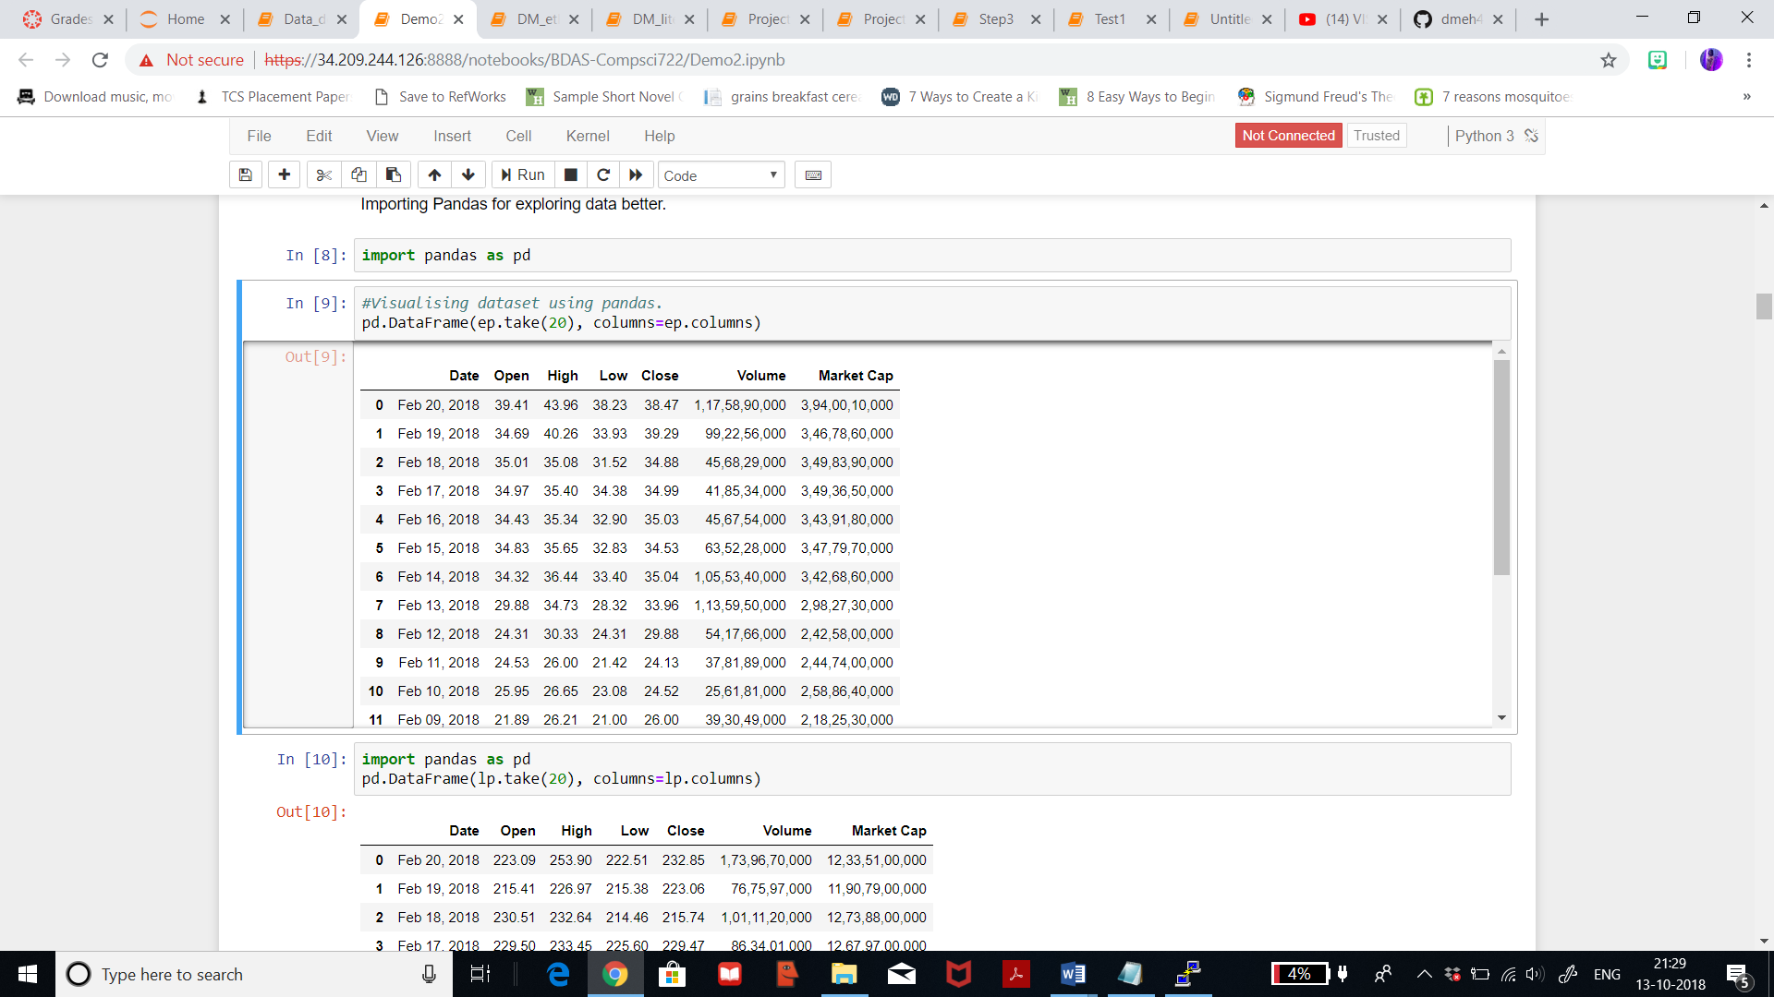

Now, I will visualise a line graph for litecoin dataset by plotting column ‘Open’ on the x axis and column ‘High’ on the y axis where the prices are counted in USD. As seen, when the ‘Open’ axis says that the price is around 150USD then the highest the price rises is 220USD. And when ‘Open’ price is about 220USD, then the highest price goes till 320USD.

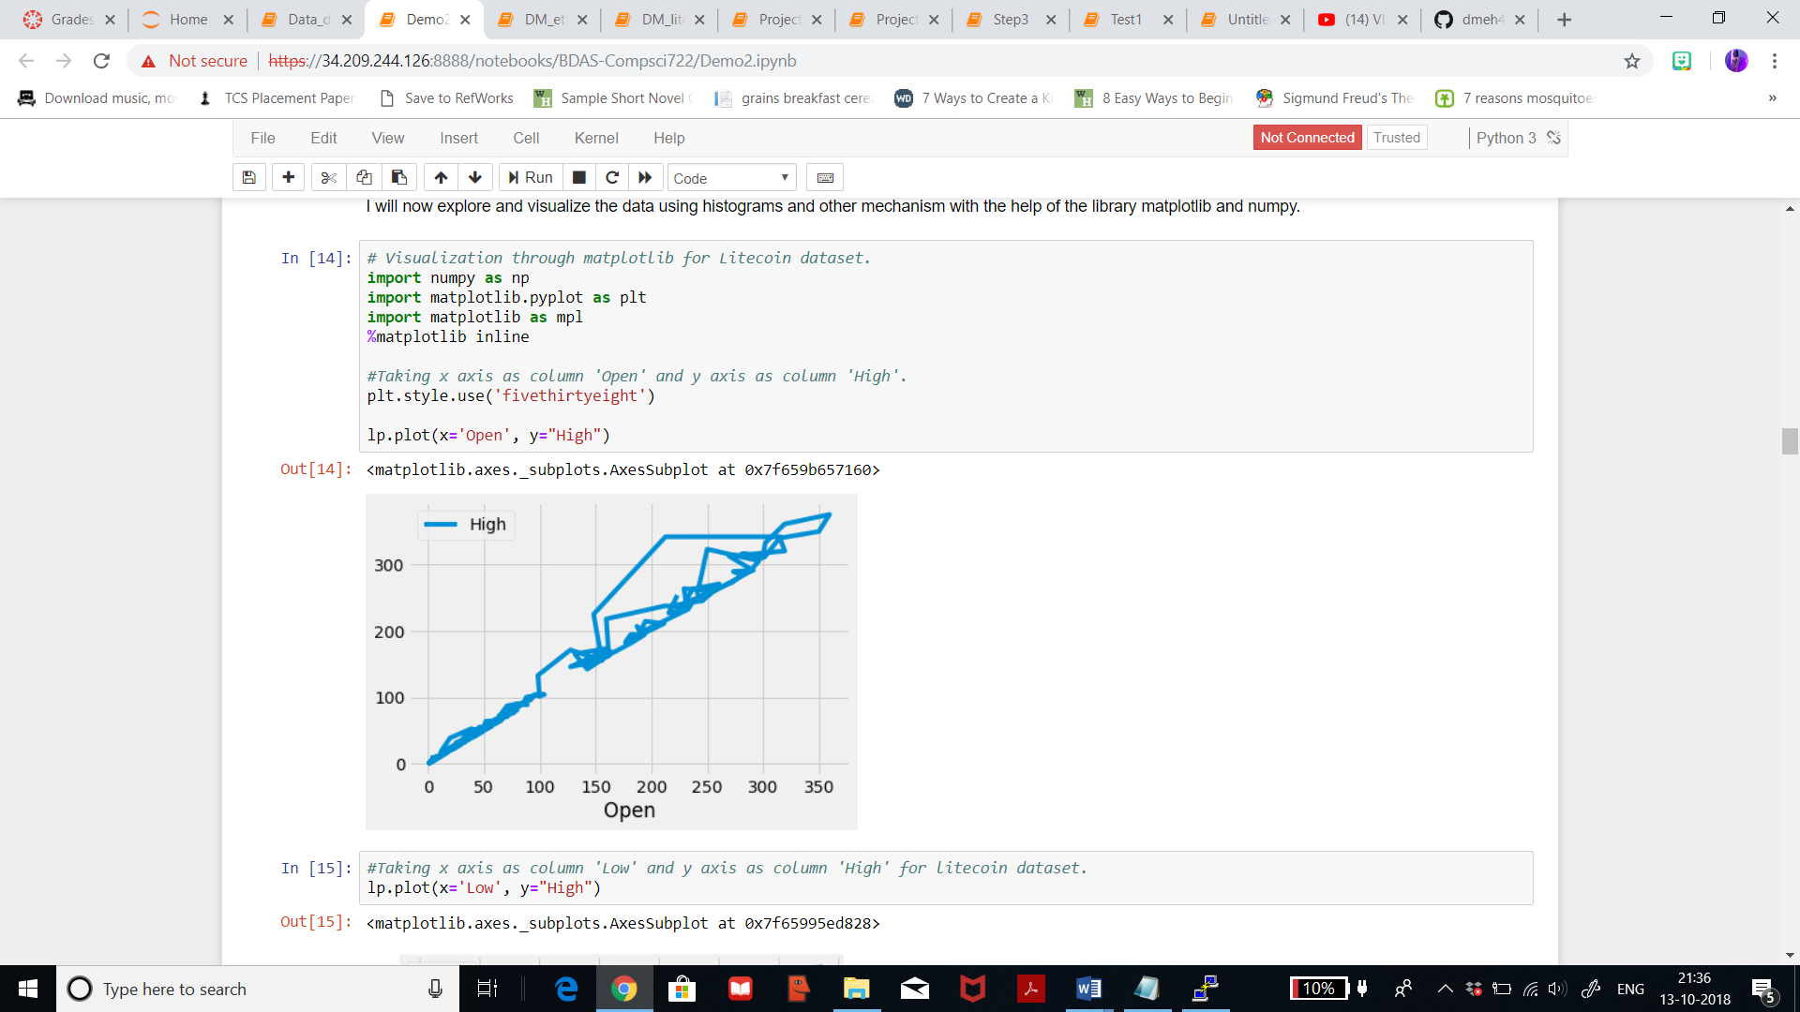

Now, in the below figure I have plotted the prices in the column ‘Low’ on the x axis and the prices in the column ‘High’ on the y axis from the litecoin dataset. It can be seen that when the price is as low as 150USD, then the highest price is 240USD. The graph doesn’t contribute to our final understanding but this is just to have a clear idea of each column in the dataset.

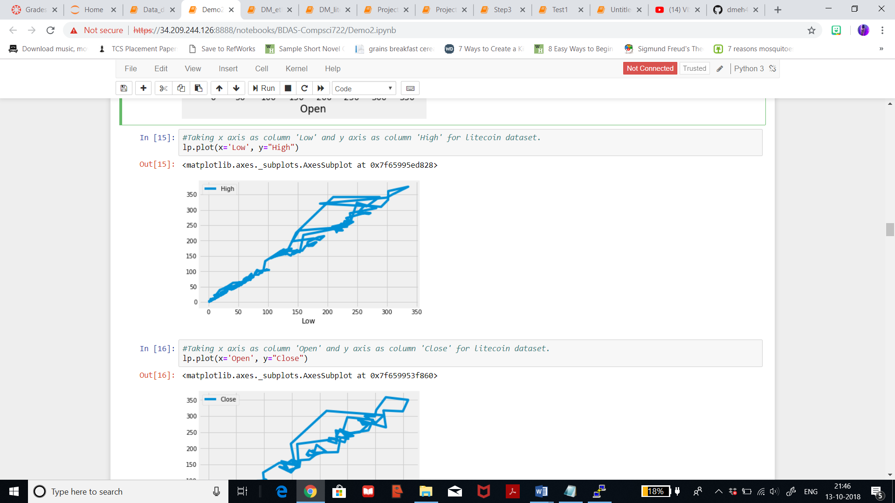

Below figure I have plotted the prices in the column ‘Open’ on the x axis and the prices in the column ‘Close’ on the y axis from the litecoin dataset. It can seen that when the price opens at 220USD, then the closing price is 320USD. When the opening price is 320USD, the the closing is 350USD.

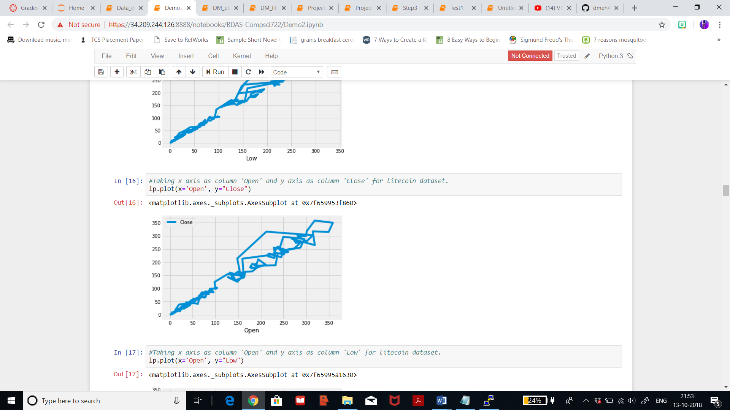

Below figure I have plotted the prices in the column ‘Open’ on the x axis and the prices in the column ‘Low’ on the y axis from the litecoin dataset. It can seen that when the price opens at 220USD, then the price is as low as 150USD. When the opning price is 320USD then the prices plunge till 170USD.

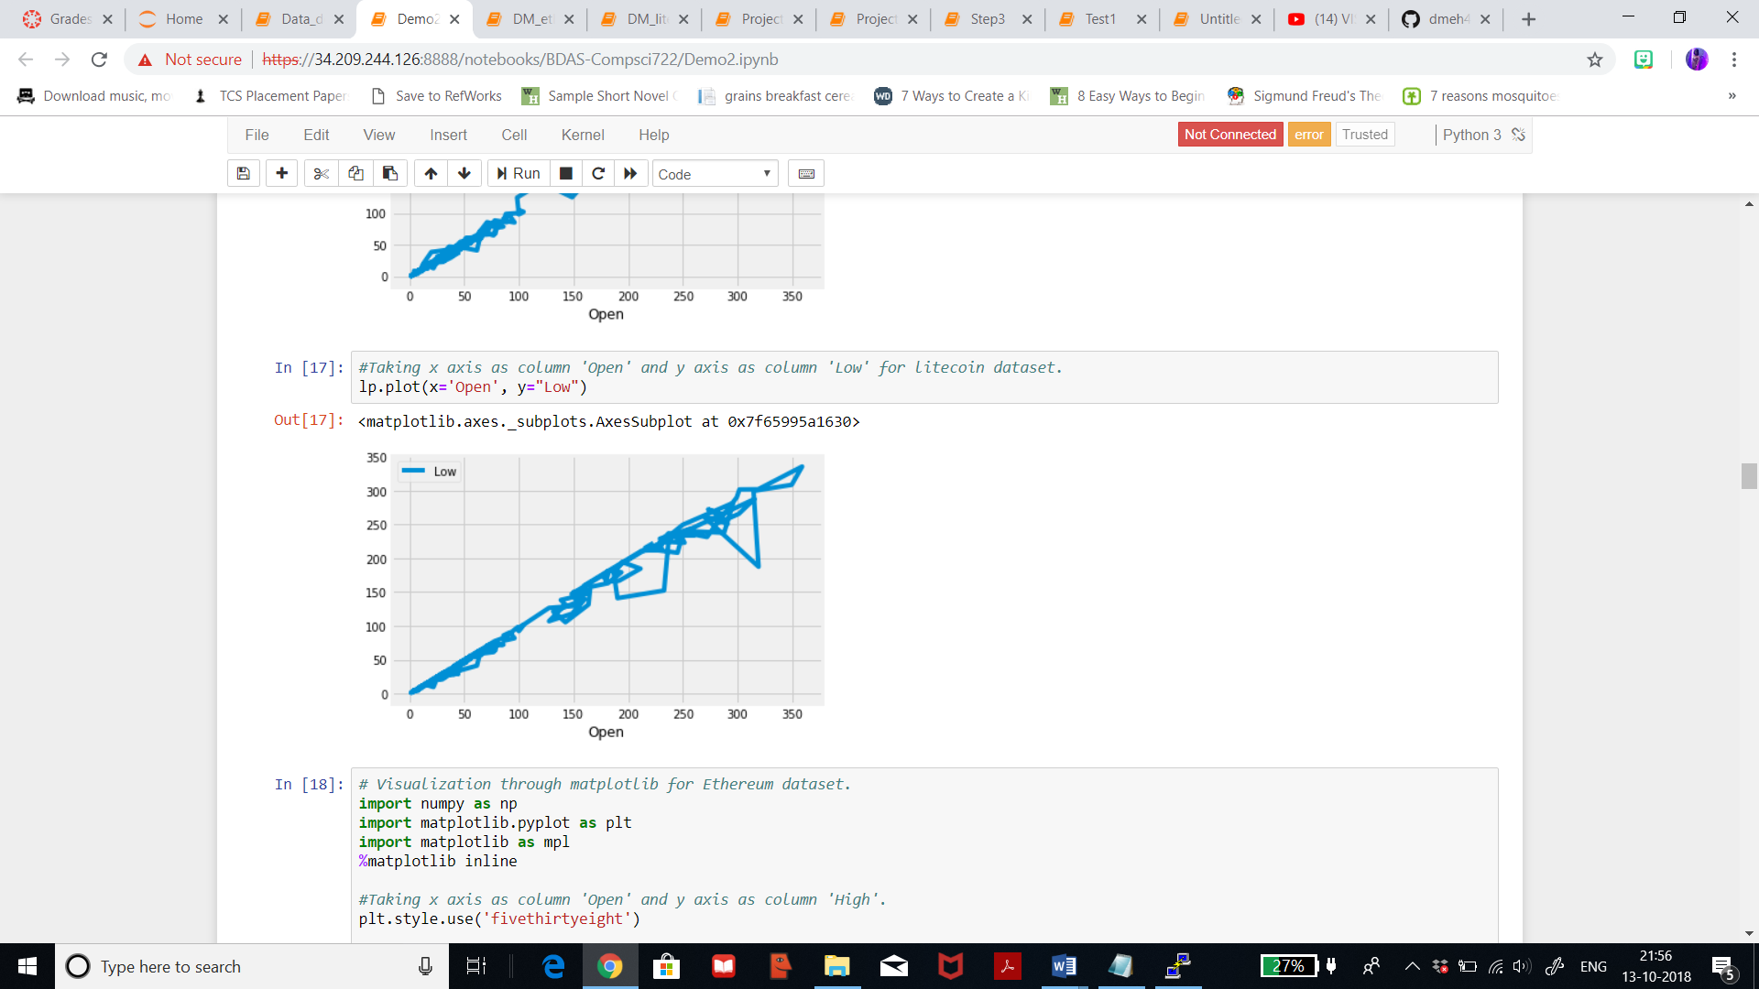

Now , visualising for ethereum dataset. Below figure I have plotted the prices in the column ‘Open’ on the x axis and the prices in the column ‘High’ on the y axis from the ethereum dataset. It can seen that when the price opens at 20USD, then the price is as high as 40USD and on some days the price just fluctuates between 20-25USD. When the price open at 40USD, then the prices rises above 50USD.

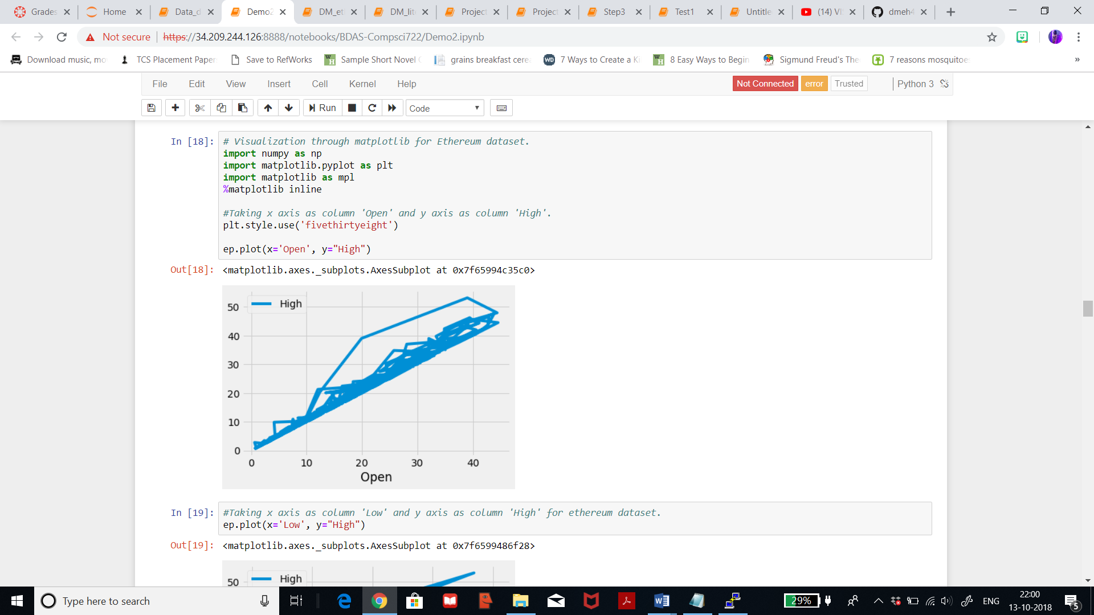

Below figure I have plotted the prices in the column ‘Low’ on the x axis and the prices in the column ‘High’ on the y axis from the ethereum dataset. It can seen that when the price is as low as 19USD, then the price is as high as 40USD and on some days the price just fluctuates between 20-25USD. When the price is as low as 39USD then the prices rises till 52USD.

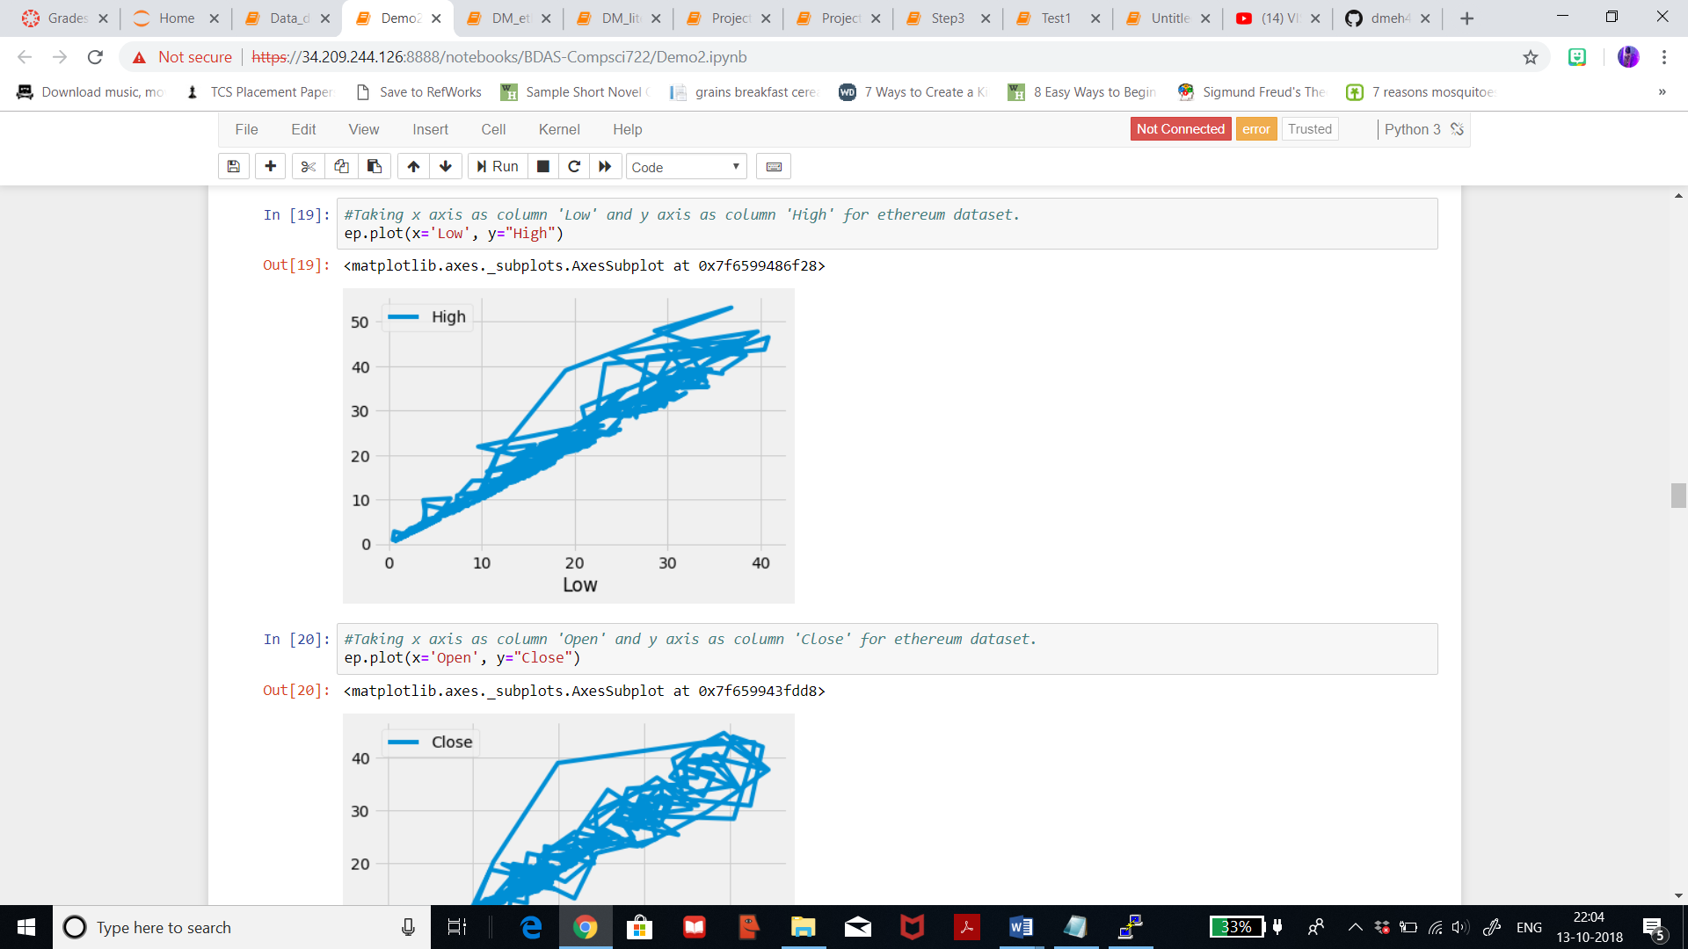

Below figure I have plotted the prices in the column ‘Open’ on the x axis and the prices in the column ‘Close’ on the y axis from the ethereum dataset. It can seen that when the price opens at 20USD, then the price closes at 40USD and on some days the price just fluctuates between 10-20USD.

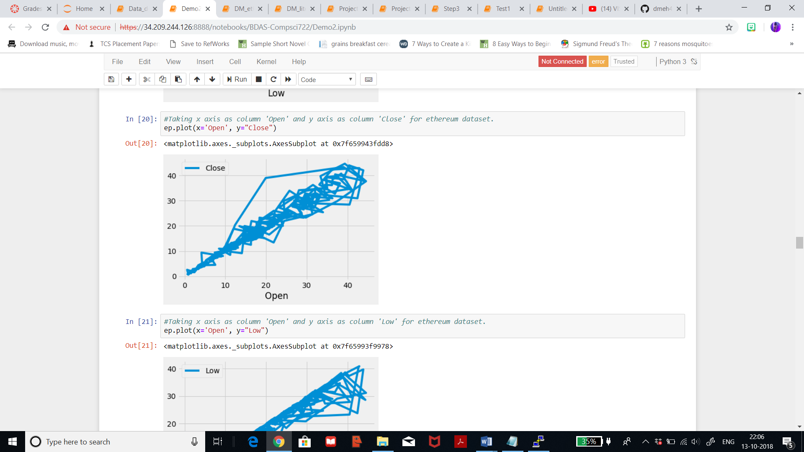

Below figure I have plotted the prices in the column ‘Open’ on the x axis and the prices in the column ‘Low’ on the y axis from the ethereum dataset. It can seen that when the price opens at around 23USD, then the price plunges as low as 10USD and on some days the price just fluctuates between 15-20USD. We can see that when the price opens at 40USD and 42USD, then the price is as low as 22USD, and on few days the price is as low as 30USD and on few days it closes on 40USD but there is a pointer difference.

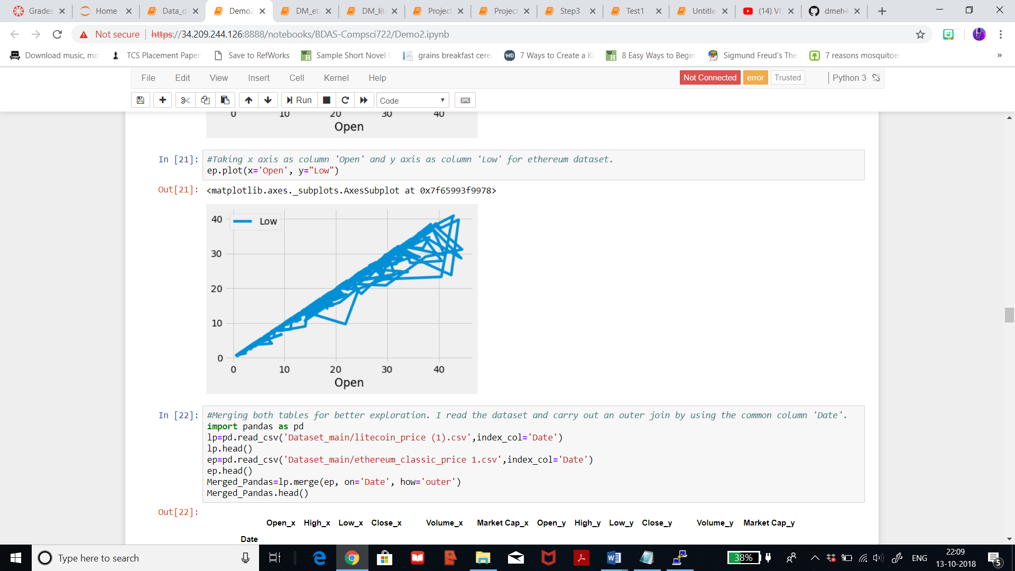

As seen below, I have merged the datasets of litecin and ethereum and then visualised the data. The column names with the prefix _x represents litecoin dataset and column names with the prefix _y represents ethereum dataset. Merging is further explained in detail in the step 3.4.

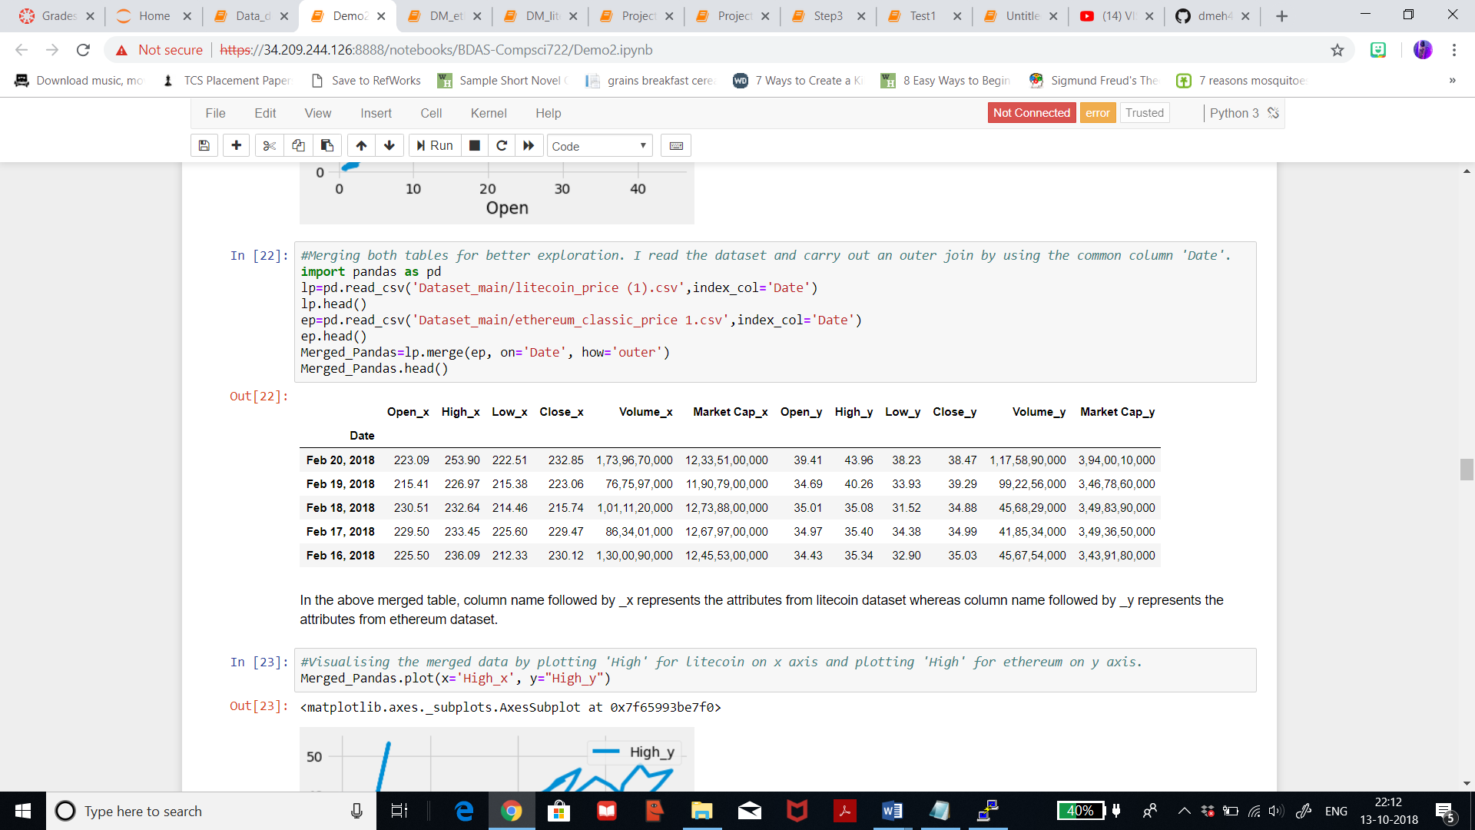

I’ve visualised the merged dataset by plotting the column ‘High’ from litecoin dataset on the x axis and the column ‘High’ from ethereum dataset on the y axis. I wanted to compare high prices for both litecoin and etehreum, and we can see that when the price for litecoin is as high as 400USD, the price of ethereum is 49USD. Also, when the price for litecoin is as high as 280USD, the price for ethereum is around 49USD. I can conclude that litecoin price is ever fluctuating while ethereum stays constant for a particular amount of time.

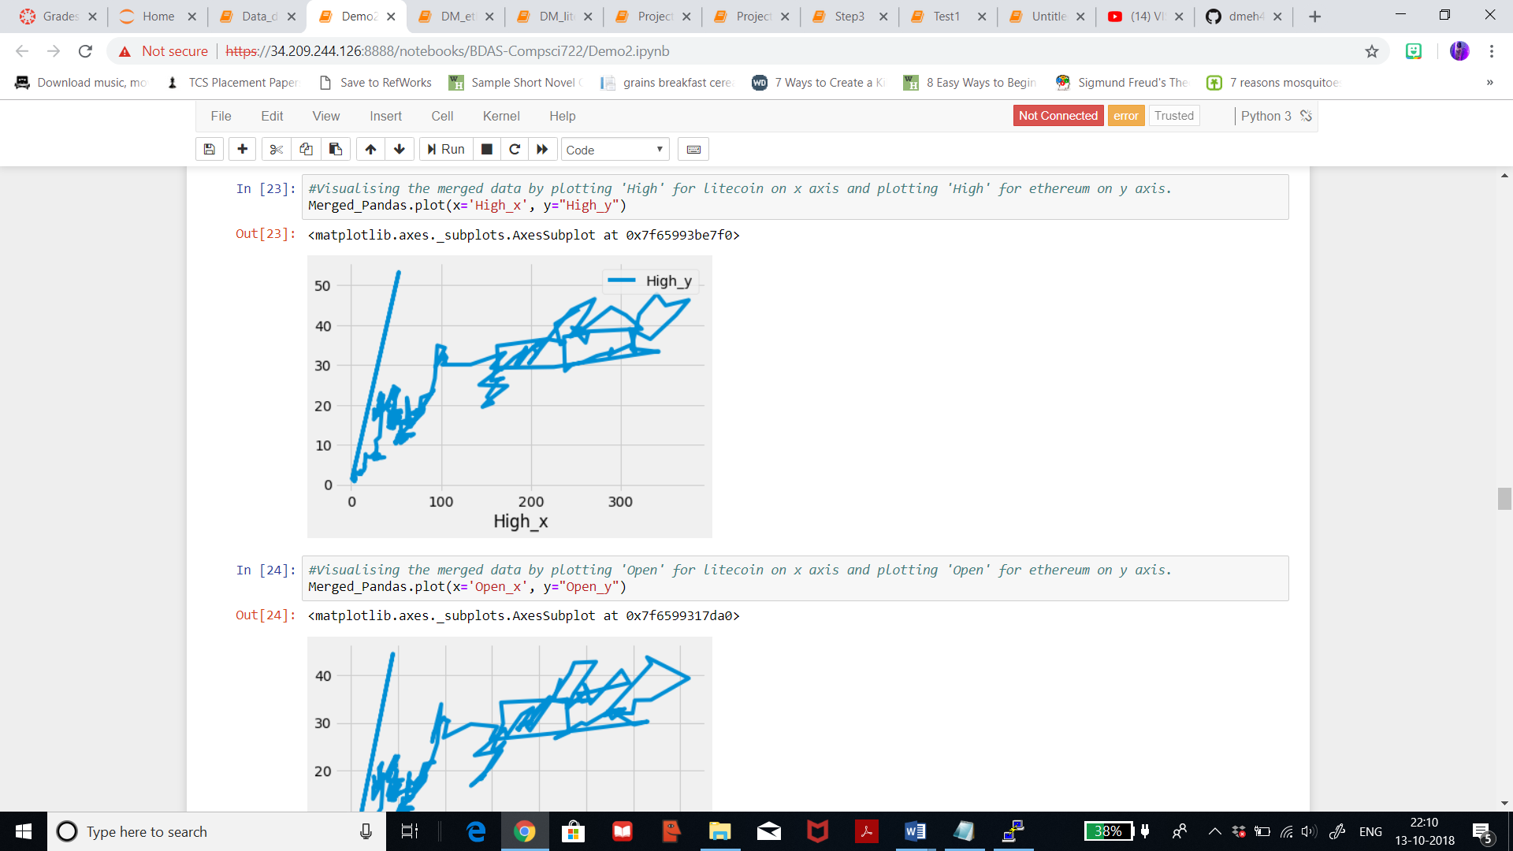

Now, I’ve visualised the merged dataset by plotting the column ‘Open’ from litecoin dataset on the x axis and the column ‘Open’ from ethereum dataset on the y axis. I wanted to compare opeining prices for both litecoin and etehreum, and we can see that when the price for litecoin opens at 360USD, the opening price of ethereum is 40USD. From the line graph it can be seen that the opening price for ethereum stays stable for a period of time and increases gradually.

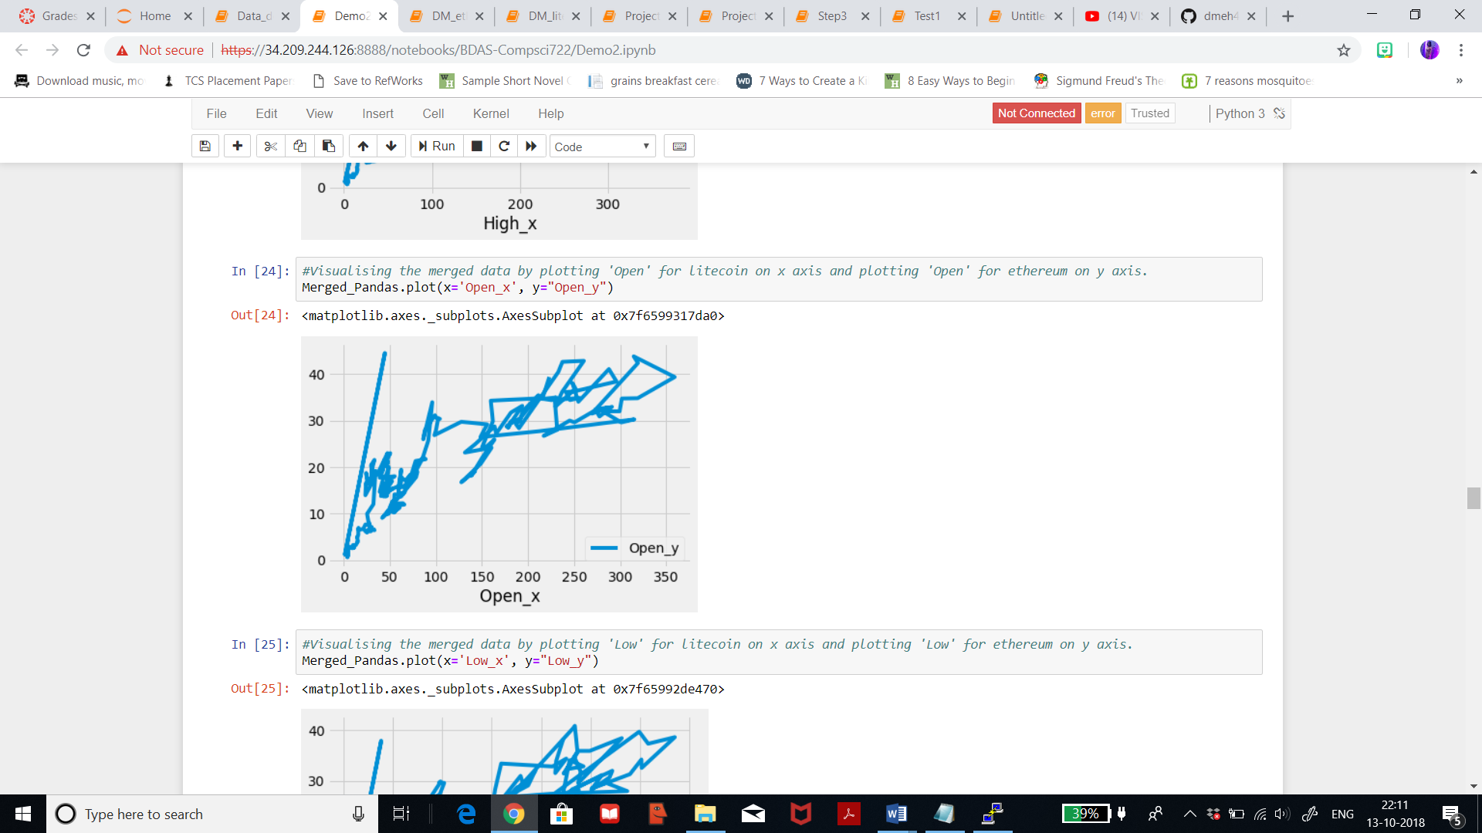

After visualising the opeining prices, I’ve visualised the merged dataset by plotting the column ‘Low’ from litecoin dataset on the x axis and the column ‘Low’ from ethereum dataset on the y axis. I wanted to compare low prices for both litecoin and etehreum, and we can see that when the price for litecoin is as low as 110USD, the price of ethereum is 15USD. When the price is for litecoin is as low as 340USD, the price for ethereum is 39USD. This line graph is not very essential for my final analysis.

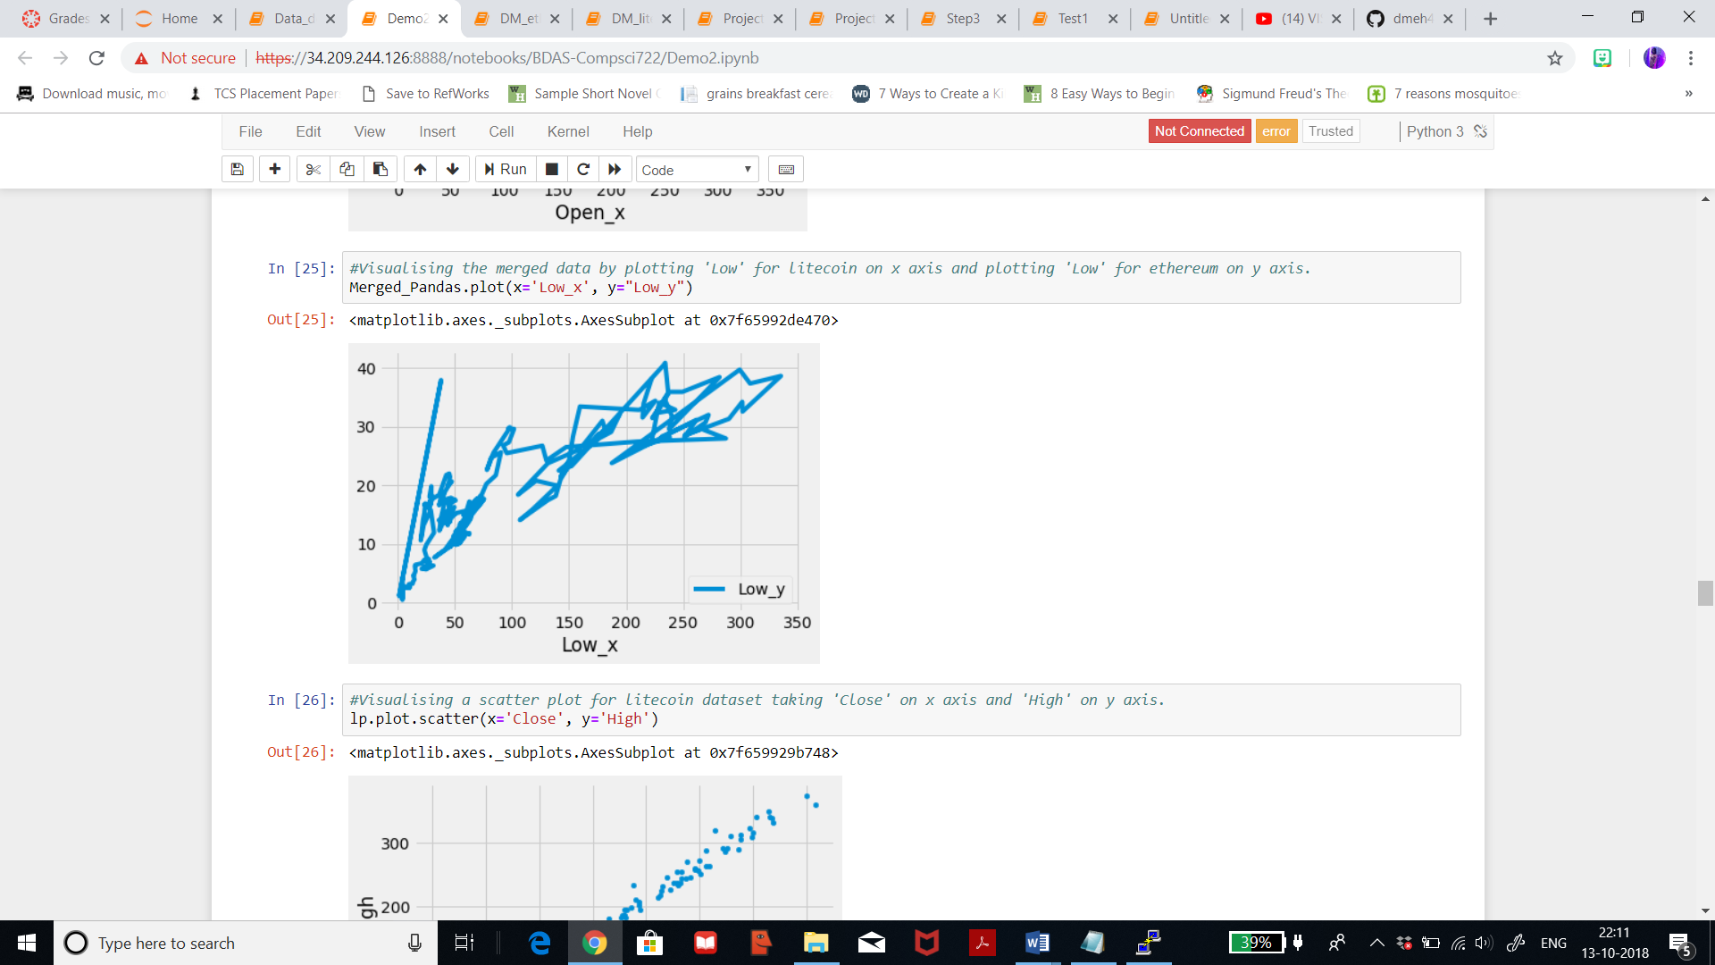

I’m now visualising a scatter plot for the dataset of litecoin by plotting the column ‘Close’ on the x axis and the column ‘High’ on the y axis. We can see that when the price for litecoin is high as 350USD, it closed on the same price. When the high prices are between 200-240USD, the closing price is 190USD. From this, we can say that the closing price is always the same or somewhere around the high price.

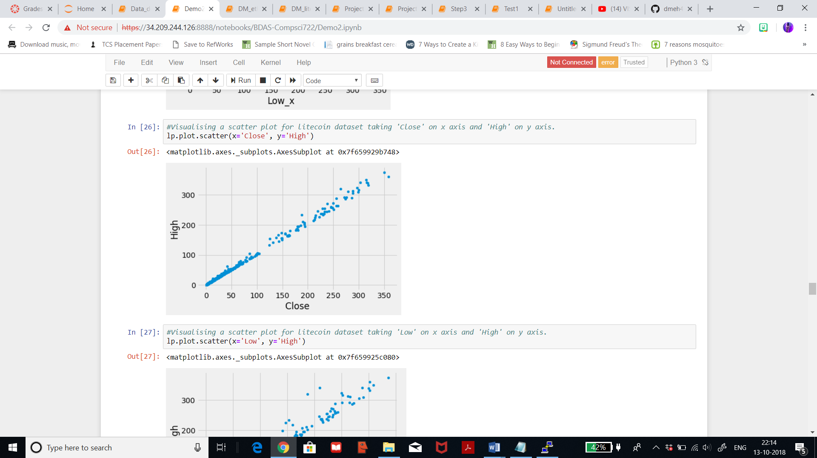

Now visualising a scatter plot for the dataset of litecoin by plotting the column ‘Low’ on the x axis and the column ‘High’ on the y axis. As seen when the price is as high as 330USD, the price then plunges till 220USD. But, we can see that when the price goes till 350USD, the price plunges only in decimal and stays the same.

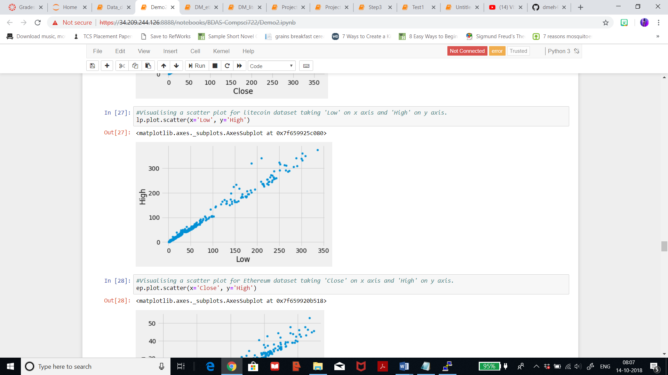

I’m now visualising a scatter plot for the dataset of ethereum by plotting the column ‘Close’ on the x axis and the column ‘High’ on the y axis. We can see that when the price for ethereum is high as 45USD, it closed on the same price. Also, when the high price was 52USD, the closing was 45USD. The scattered line is going upward in a continuous manner, which signifies a positive trend.

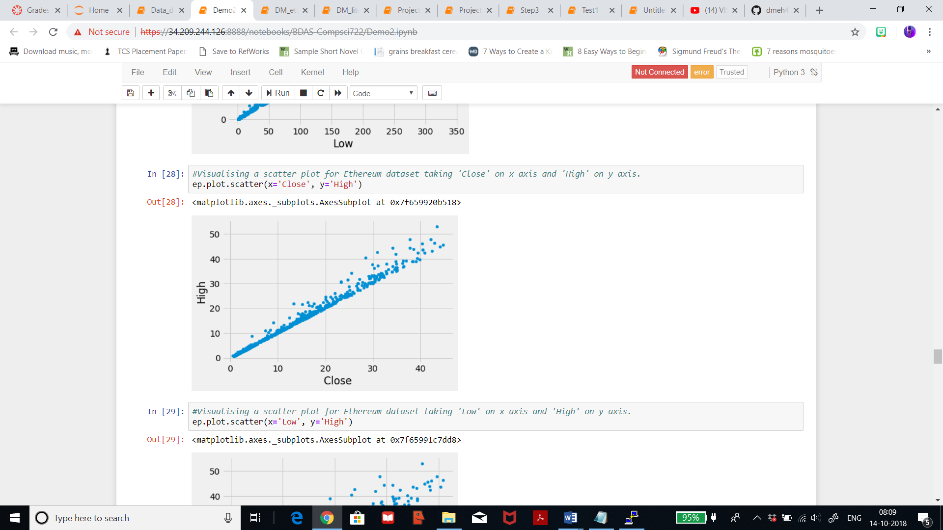

I’m now visualising a scatter plot for the dataset of ethereum by plotting the column ‘Low’ on the x axis and the column ‘High’ on the y axis. We can see that when the price for ethereum is as low as 40USD, the price then goes as high as 45USD on the same price. When the price goes as high between 30-40USD, the price plunges till 30USD.

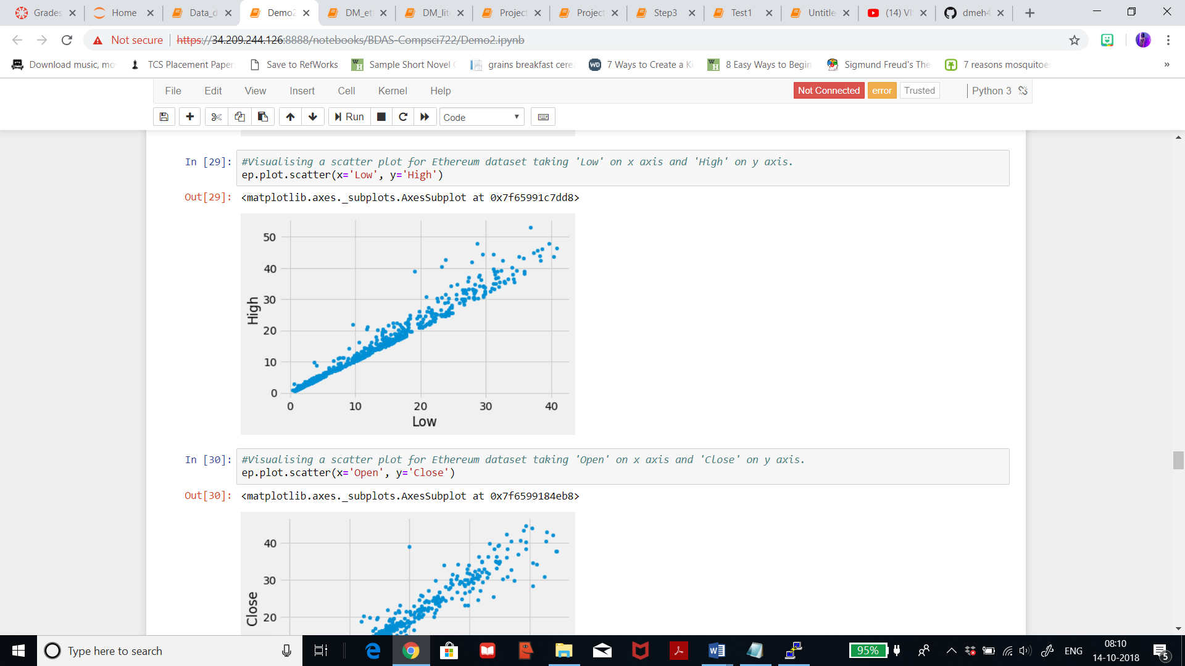

I’m now visualising a scatter plot for the dataset of ethereum by plotting the column ‘Open’ on the x axis and the column ‘Close’ on the y axis. We can see that when the price for ethereum is openeing at 40USD, it closed between 29-42USD. And when the price opens at 30USD, the closing price has scatters ranging from 22-32USD. We can say that the open price stays constant but the closing prices ranges widely.

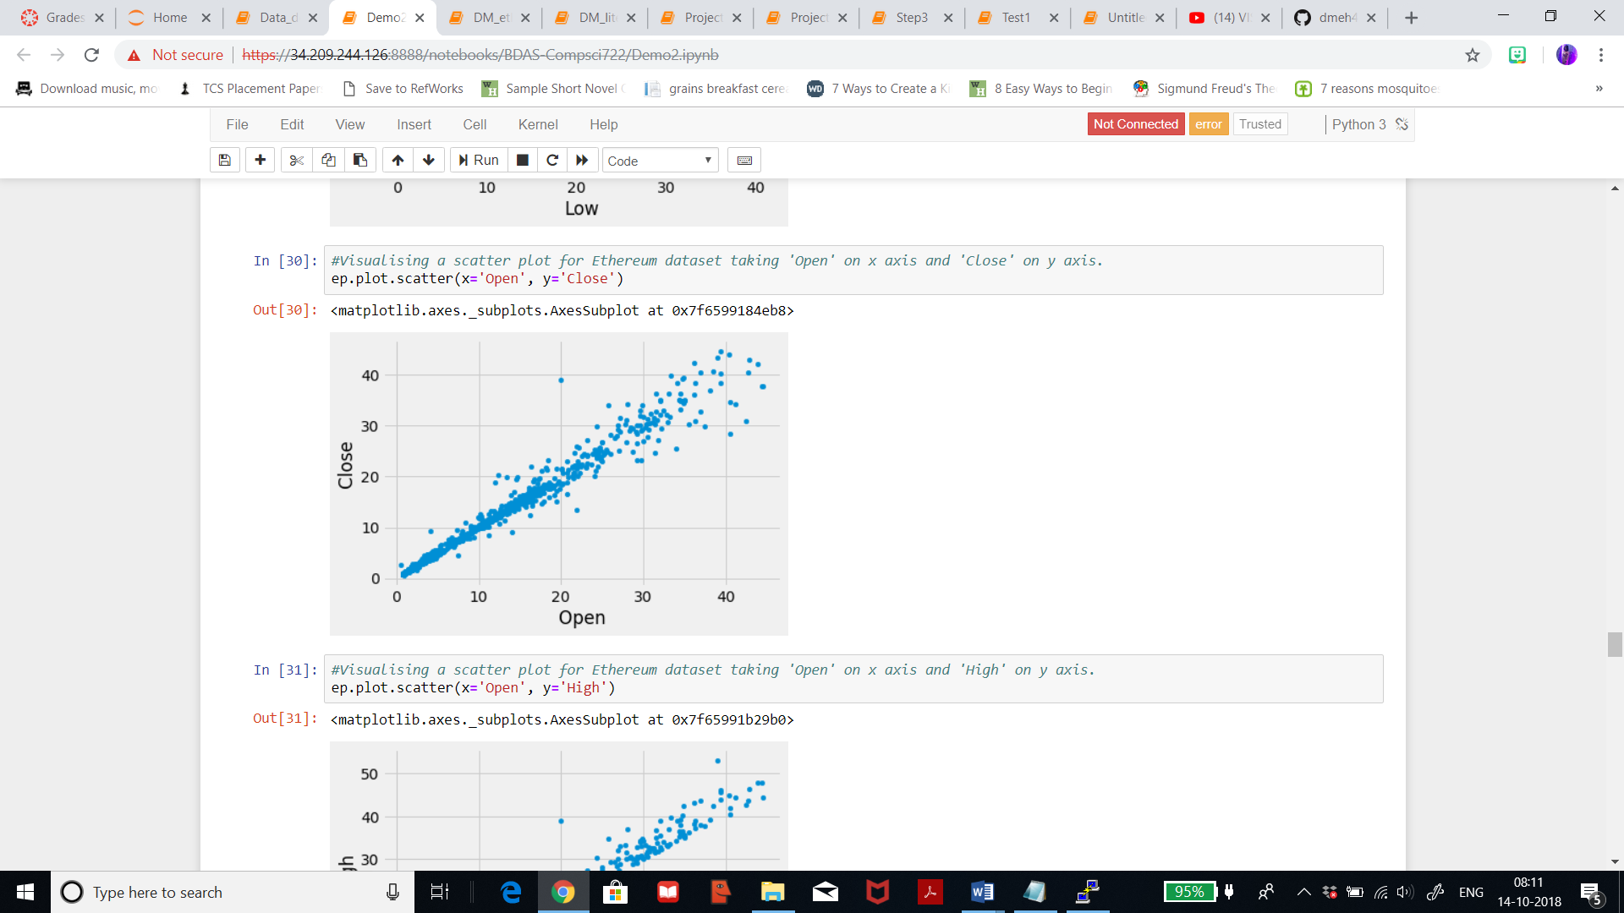

I’m now visualising a scatter plot for the dataset of ethereum by plotting the column ‘Open’ on the x axis and the column ‘High’ on the y axis. We can see that when the price for ethereum opens at 20USD, the high price ranges from 20-24USD and on few days the price was around 40USD. When the price opens at 39USD, the highest price was 52USD. It can be seen that the high prices grow gradually and on a steady and stable pace unlike litecoin. We see a linear relationship which proves that it will be very beneficial to solve this regression problem.

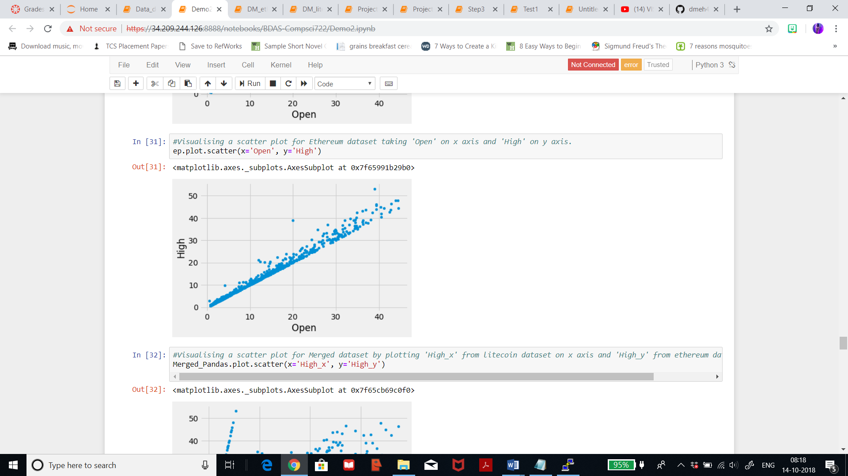

Earlier I visualised a line graph for the merged dataset, now I’ve visualised a scatter plot for the merged dataset by plotting the column ‘High’ from litecoin dataset on the x axis and the column ‘High’ from ethereum dataset on the y axis. I wanted to compare high prices for both litecoin and etehreum, and we can see that when the price for litecoin is as high as 400USD, the price of ethereum is 49USD. Also, when the price for litecoin is at the initial phase around 0, the price for ethereum grows in a linear line up till 52USD. I can conclude that litecoin price is ever fluctuating while ethereum stays constant for a particular amount of time and the prices for both have a difference of around 100USD.

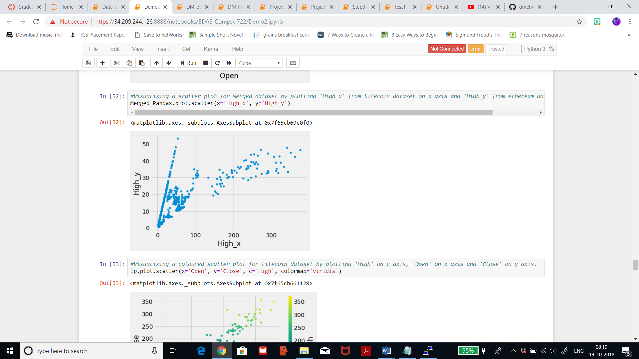

Below, I’ve visualised a colored scatter plot for litecoin dataset by plotting ‘High’ on c axis, ‘Open’ on x axis and ‘Close’ on y axis. It can be seen that when the high prices range from 200-250USD, the price opens between 200-250USD, and closes between the same range. When the price was as high as 350USD, the opening price was 340USD, and the closing was 350USD. Thus, there is not such a difference between the closing and opening and the high prices.

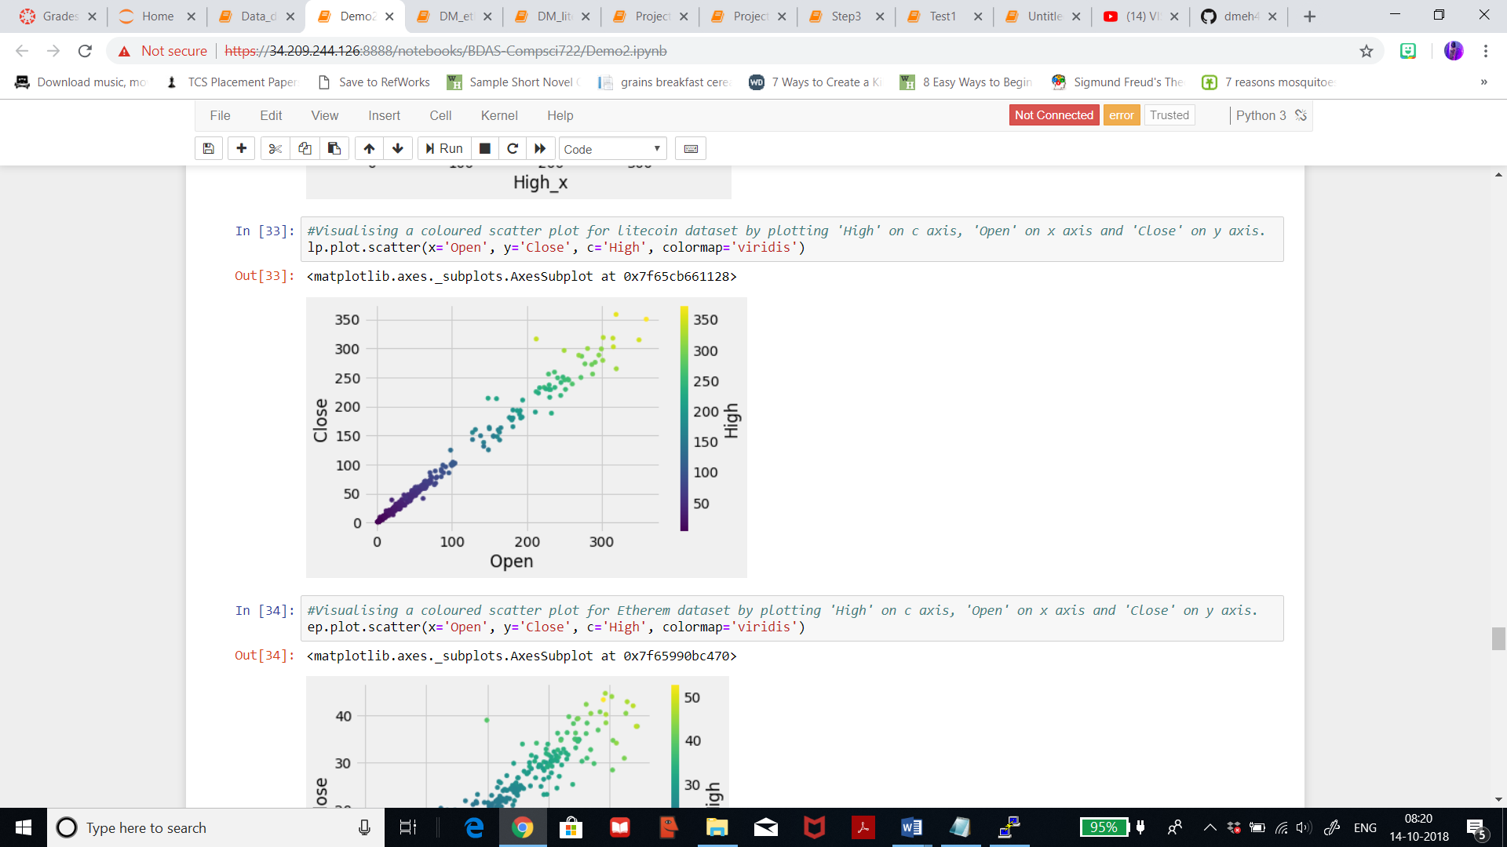

Below, I’ve visualised a colored scatter plot for ethereum dataset by plotting ‘High’ on c axis, ‘Open’ on x axis and ‘Close’ on y axis. It can be seen that there are a bunch of scatters between closing 10-15USD. When the price is as high as 50USD, the opening price was 39USD, and the closing was 42 USD. Thus, there is quite a difference between the opening, closing and high prices.

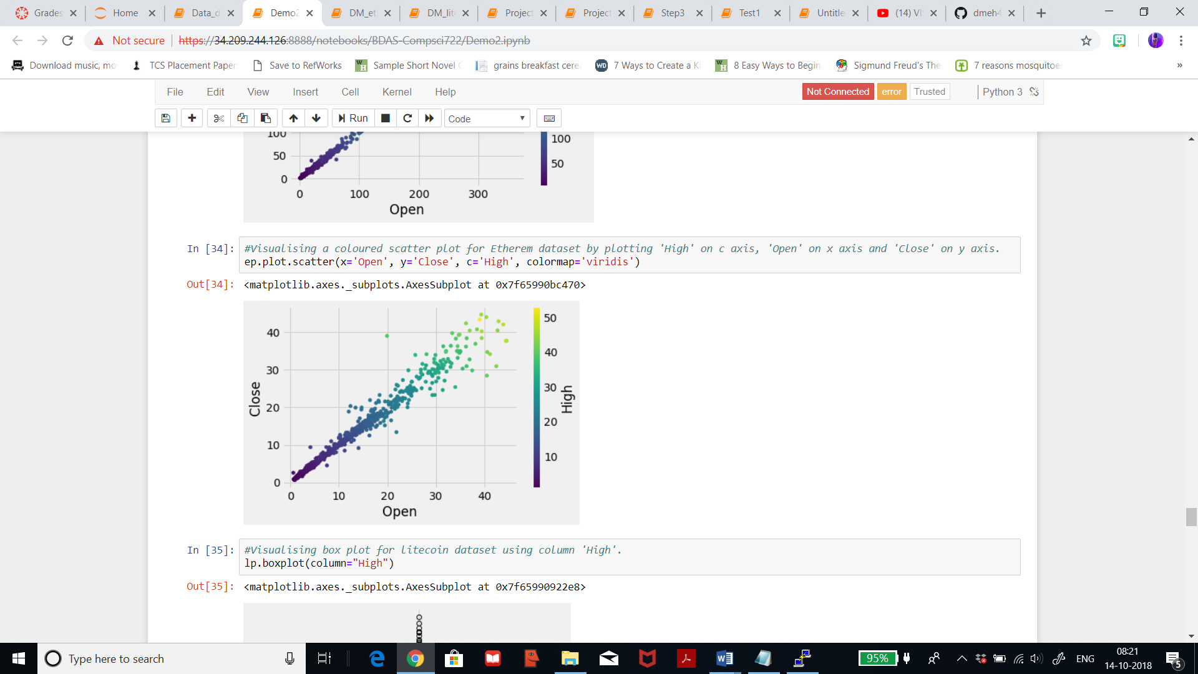

Below, I’ve visualised a box plot for litecoin dataset which will help me display a standardized way for the distribution of data in a continuous feature. In the figure it can be seen that the high price variabilikty is low and also the outliers are less.

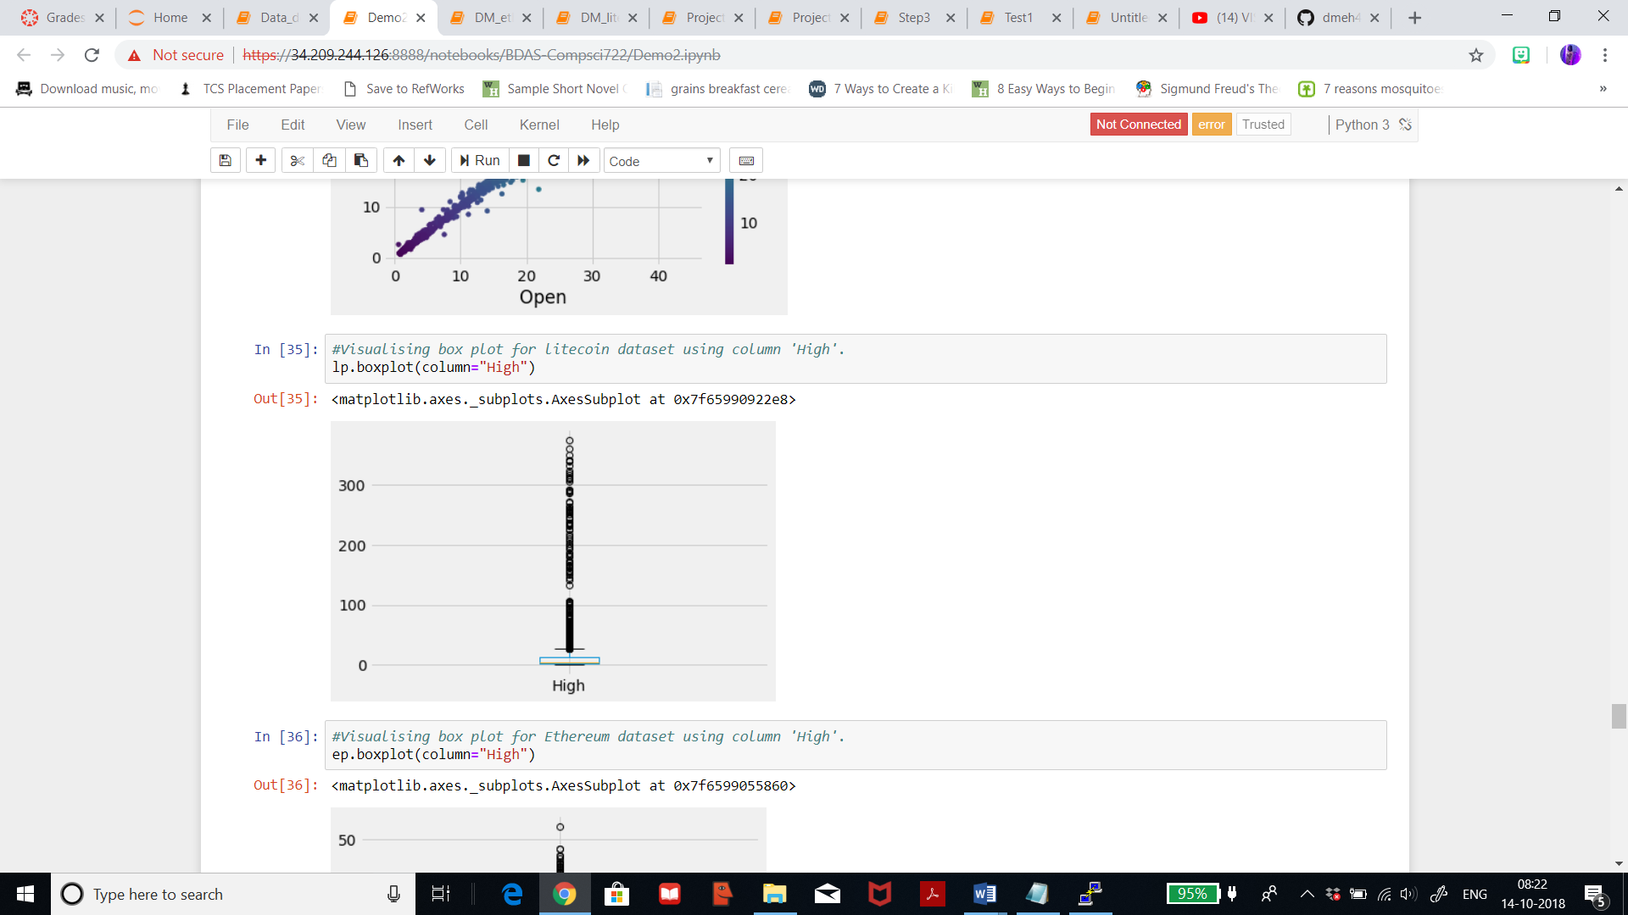

Below, I’m visualising box plot for ethereum dataset where it can be seen that there is high variability of the high prices and there a few outliers.

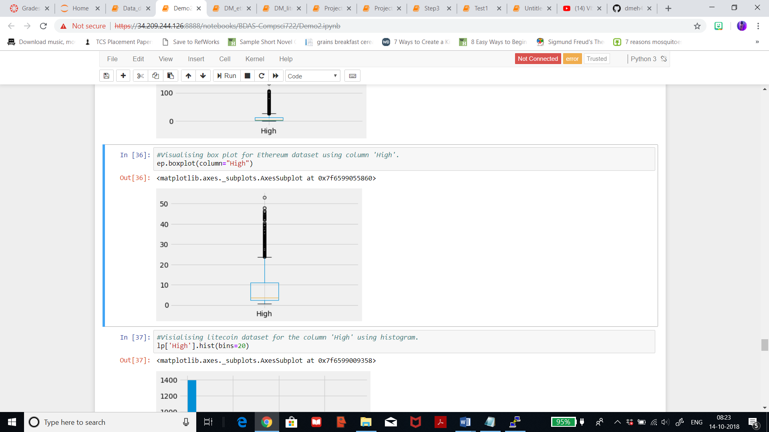

Below, is the bar representation for ethereum dataset, with ‘High’ on x axis and ‘Low’ on y axis. I’m trying to visualisation the same combination as previous but only with a different method. Thus, the understanding remains the same as above.

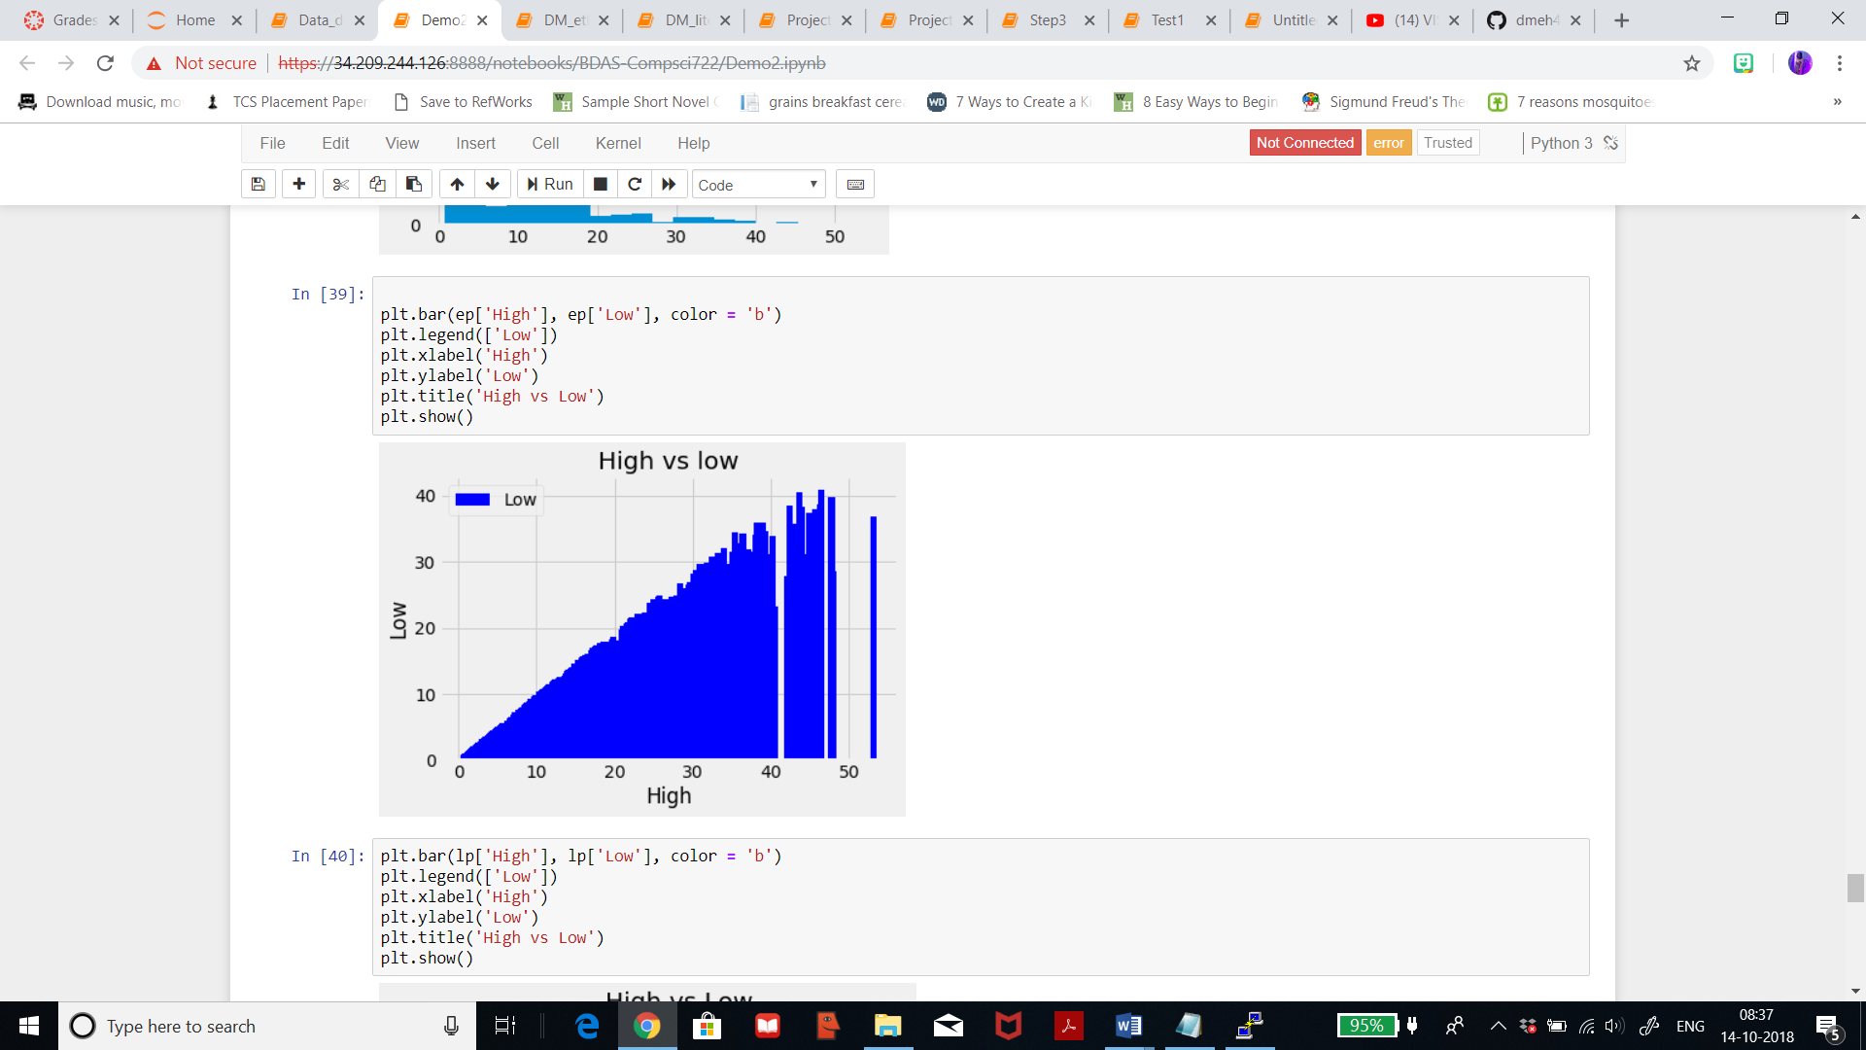

Below, is the bar representation for litecoin dataset, with ‘High’ on x axis and ‘Low’ on y axis.

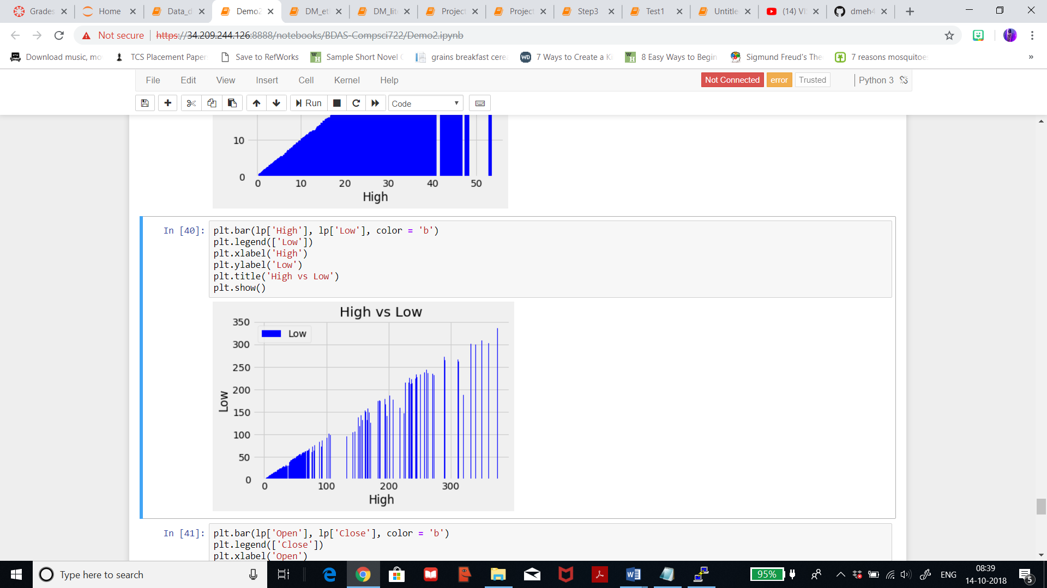

**2.4) Data Quality:**

After visualising and exploring the data, let us chcek the quality. To check the quality, I initially described the data to analyse the mean, standard deviation and count. Seen below, the summary for litecoin dataset and we can see that the count is 1760, mean for ‘High’ column id 21.55, and the minimum is 1 and maximum is 375. We can see that there is a ditribution of data with 25%, 50%, and 75% for each of the variable.

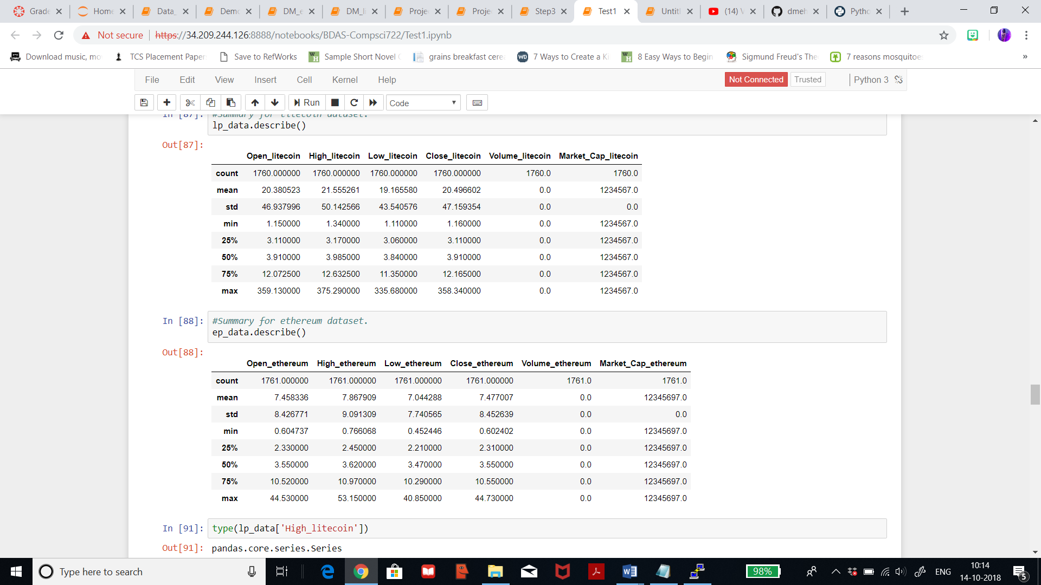

Below, is the summary for ethereum dataset which has a count of 1761 and mean for ‘High’ is 7.86 which is quite less than that of litecoin. The standard deviation is 9 while that of litecoin was 50. Also, we can see that there is a ditribution of data with 25%, 50%, and 75% for each of the variable.



Now, let us check for null or missing values. As seen below, the dataset of litecoin has 244 missing or null values in the column ‘Volume’. I will deal with null values in step 3.2.

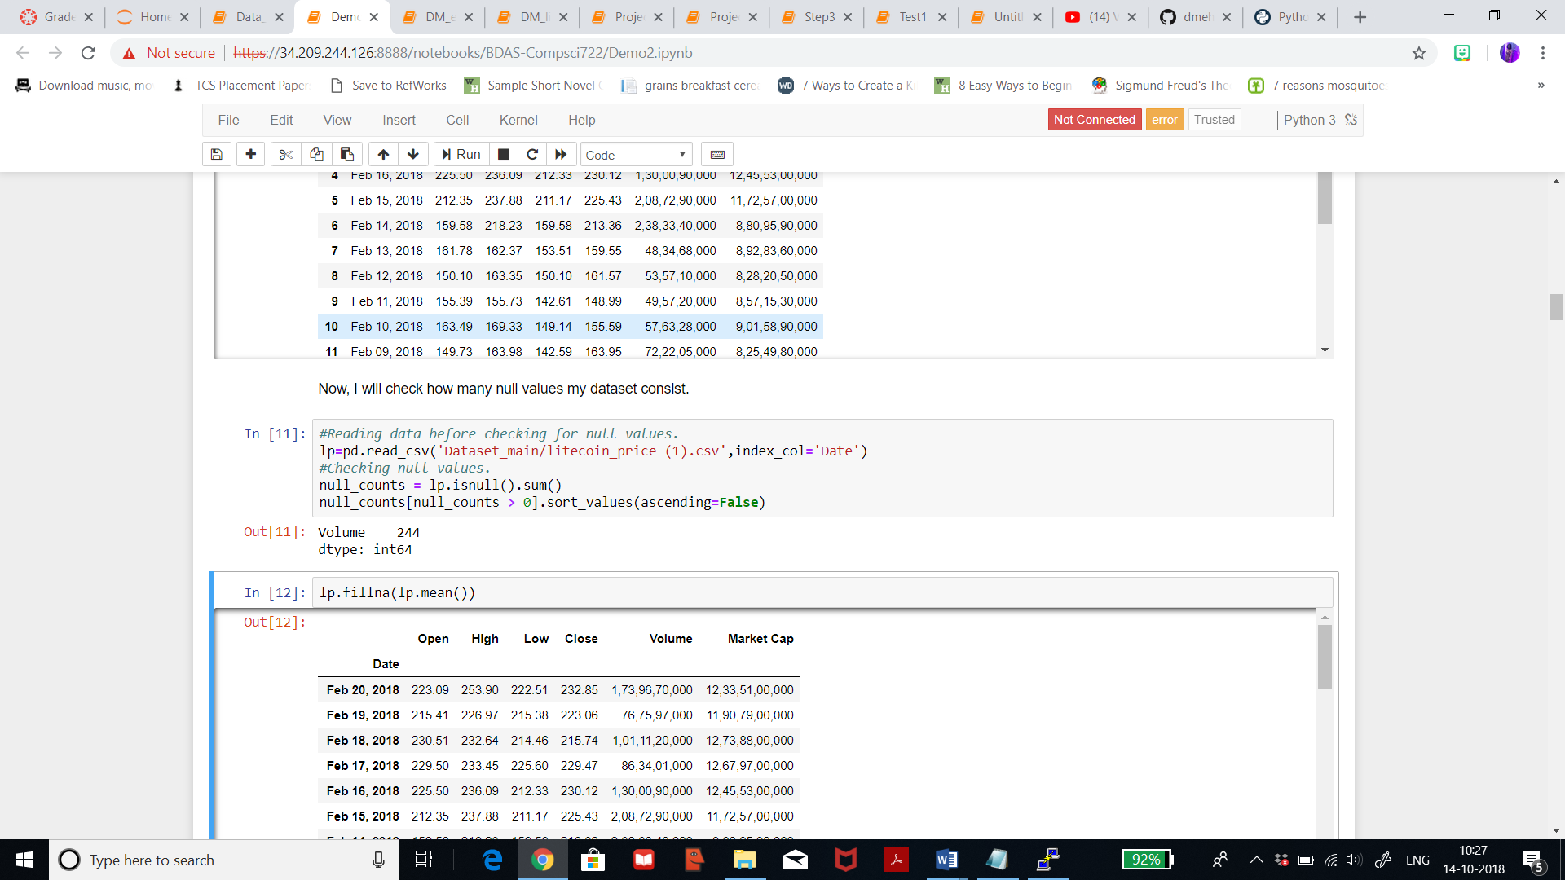

Now, I will check the same for ethereum dataset. As seen, there are 244 null values in ‘Volume’ column again and one null value in the ‘Market Cap’ column which I will deal with in later steps.

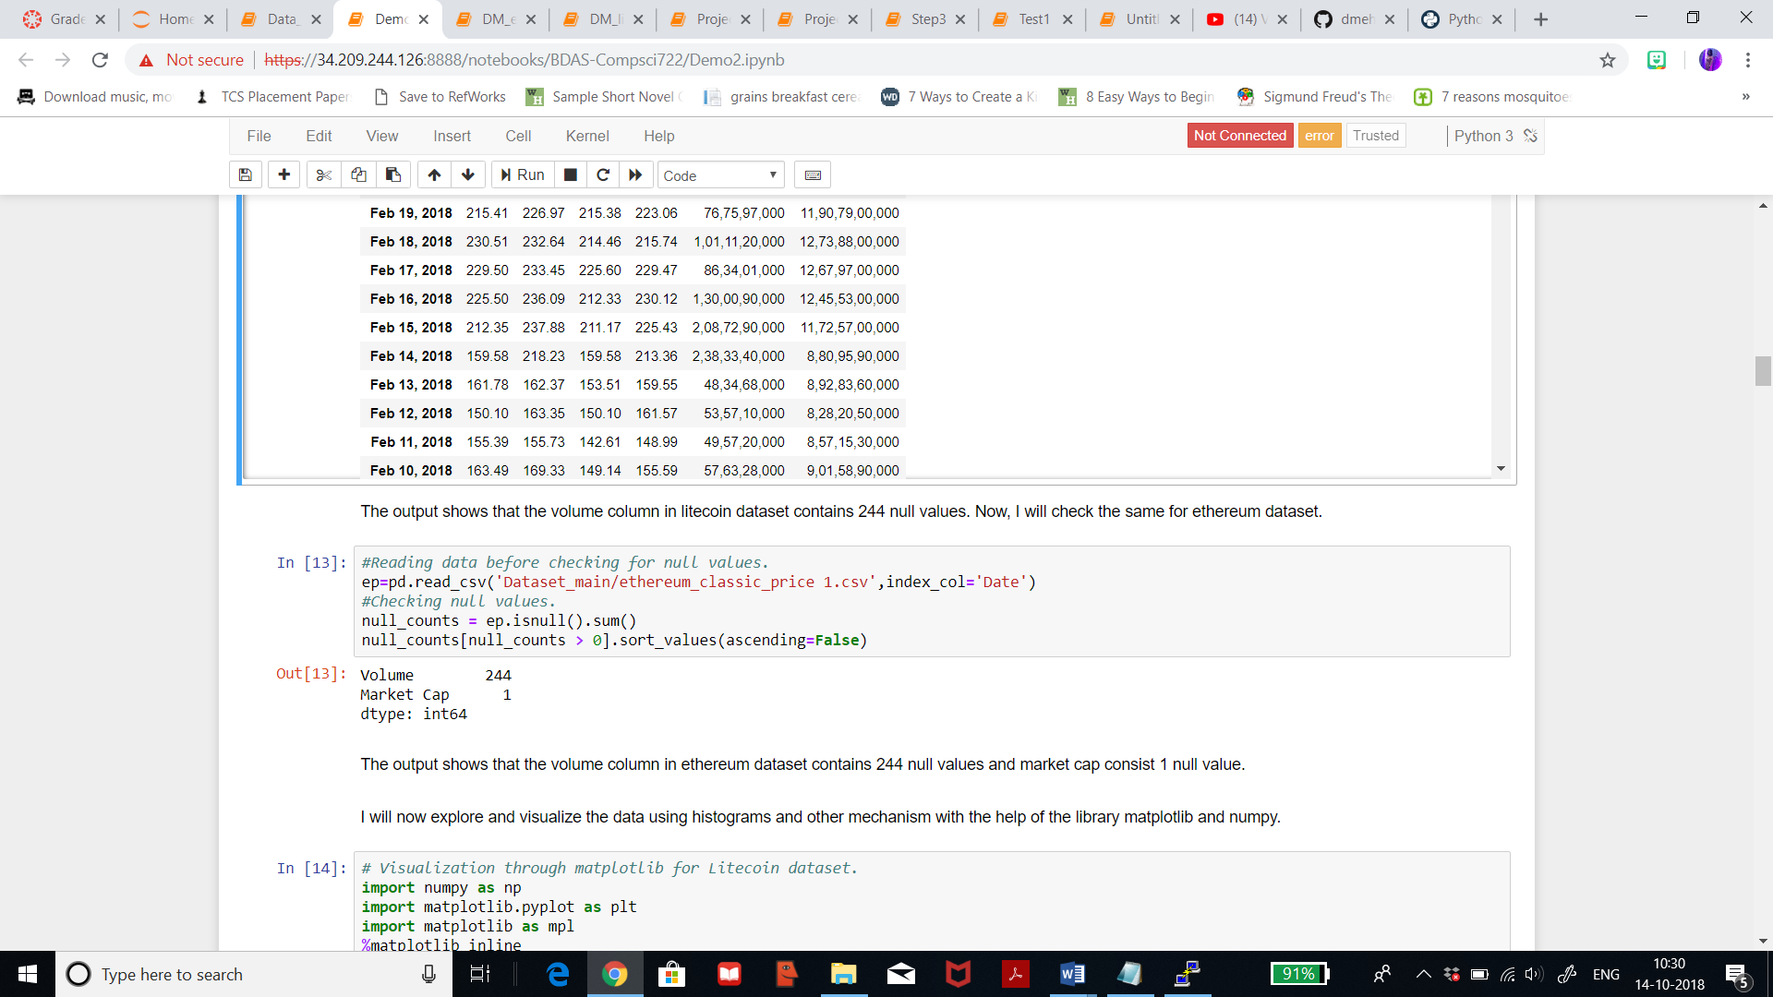

Also, I have changed the column names for better understanding between the columns from litecoin and ethereum.

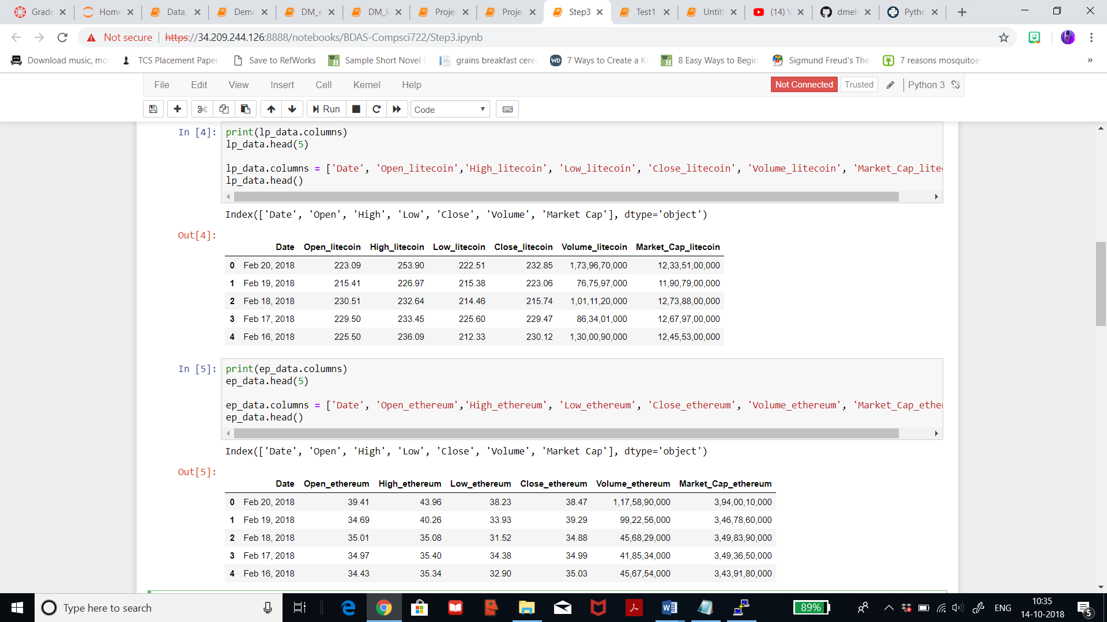

1. **Data Understanding**

3.1) **Data Preparation**: Since I’ve 7 columns and few columns aren’t relevant for my projected result so few columns will be excluded from this step onwards. By using ‘.loc’ function of the pandas library, I will limit my columns of use just to reduce the size of the dataset by excluding not needed columns. The columns ‘Volume_ethereum’, and ‘Market_Cap_ethereum’ from Ethereum dataset and ‘Volume_litecoin’, and ‘Market_Cap_litecoin’ from Litecoin dataset. These columns are not necessary to use since their use won’t give us significant output. Date column is excluded from Ethereum dataset since dates from both dataset are same so another column with same dates is not needed. The accuracy is the prediction models presented in the further steps did not change in any specific way. Also, by excluding these columns would not hamper the quality of my result. Without excluding columns analysis was done only later when the estimated results were generated. If moving from the excluded dataset back to the original dataset can cause data from the test set for the excluded columns dataset to leak into the development set for the original dataset. Thus, only results obtained on the excluded columns dataset are explained in this paper. The below table represents the table of litecoin dataset after selection of relevant columns. Thus, after selection of relevant modules litecoin dataset has 1760 rows and 5 columns.

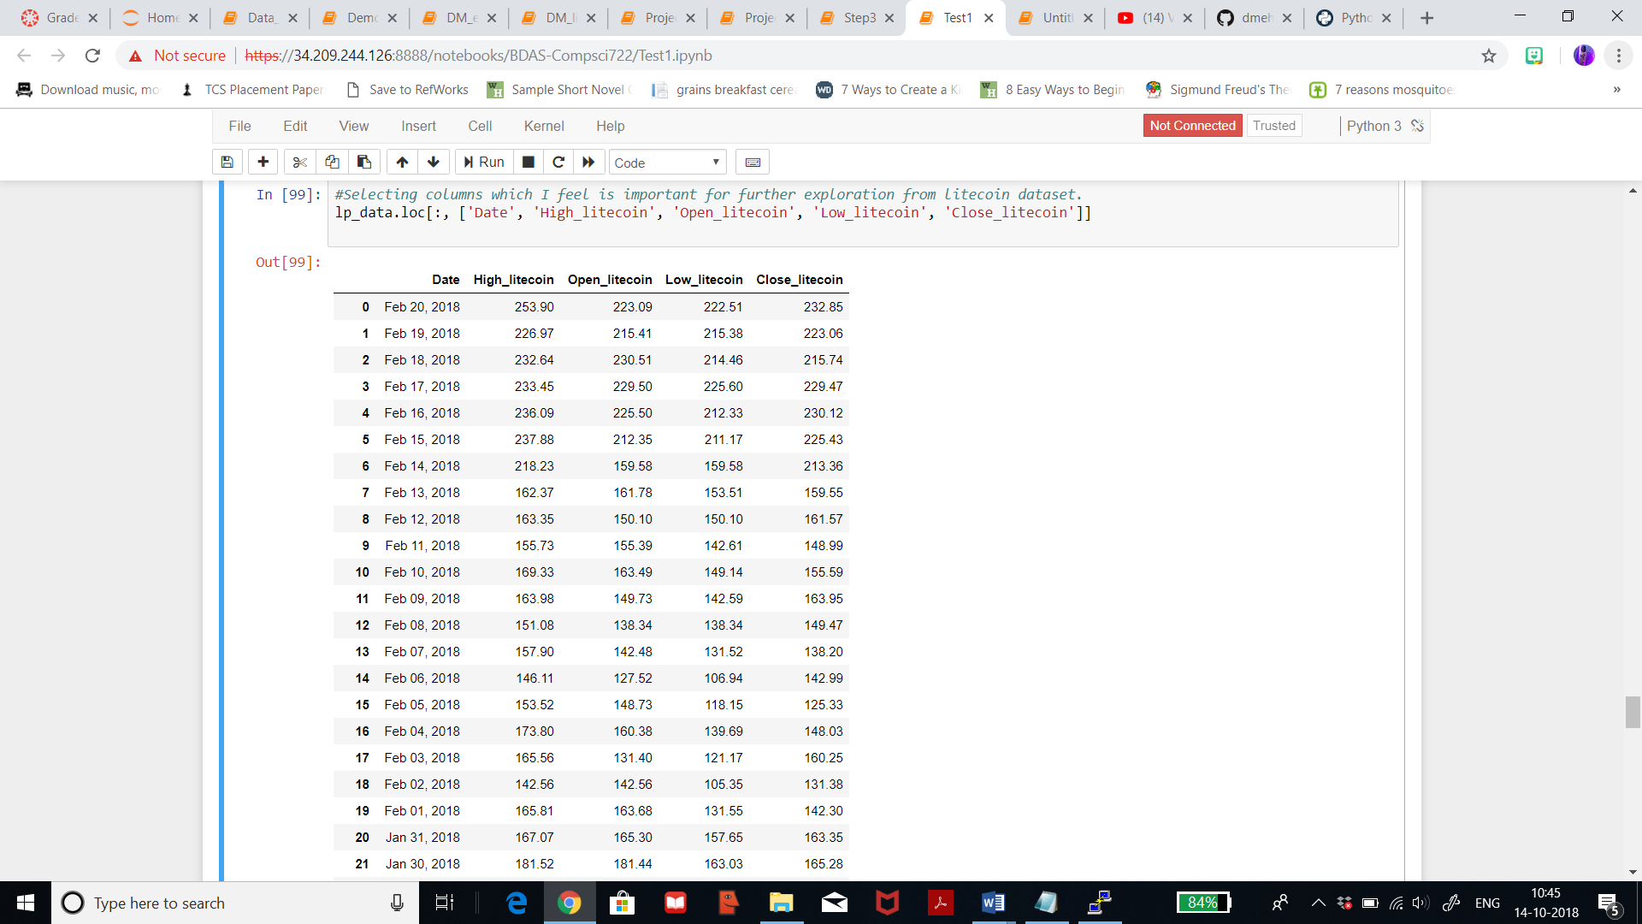

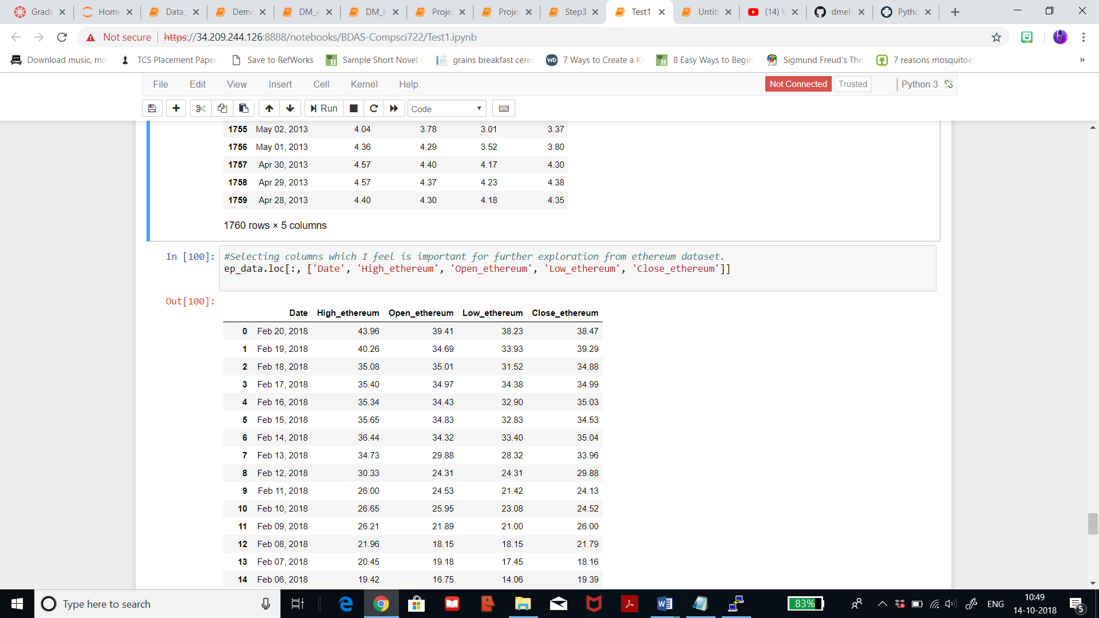

The below table represents the table of ethereum dataset after selection of relevant columns. Thus, after selection of relevant modules ethereum dataset has 1761 rows and 5 columns.

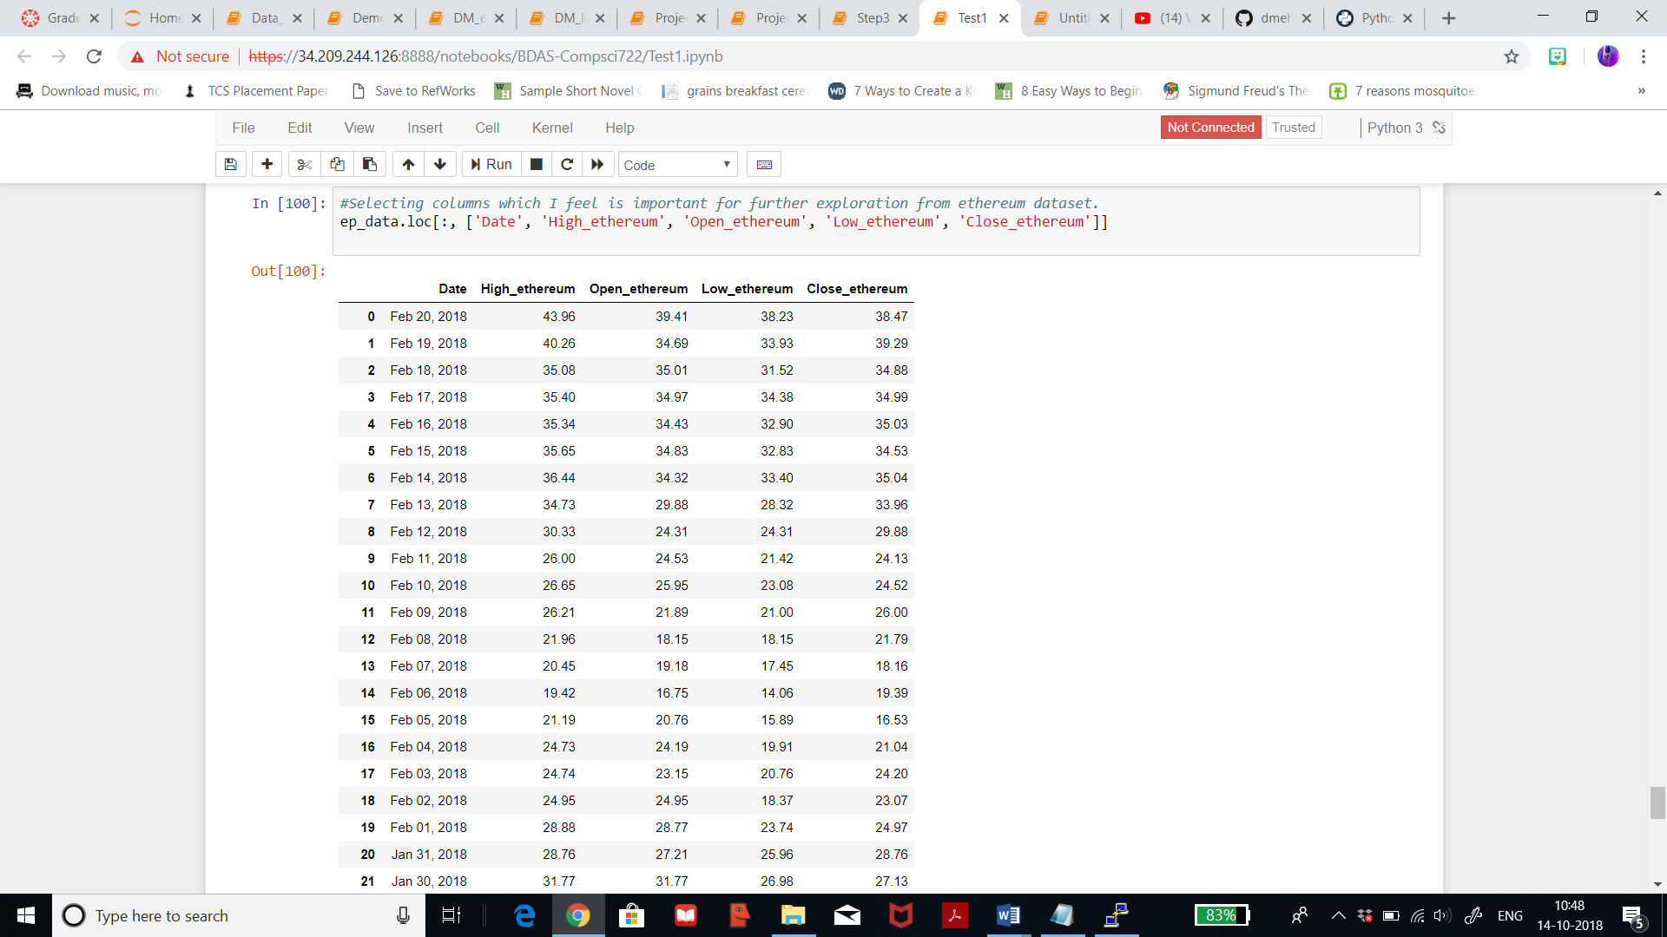

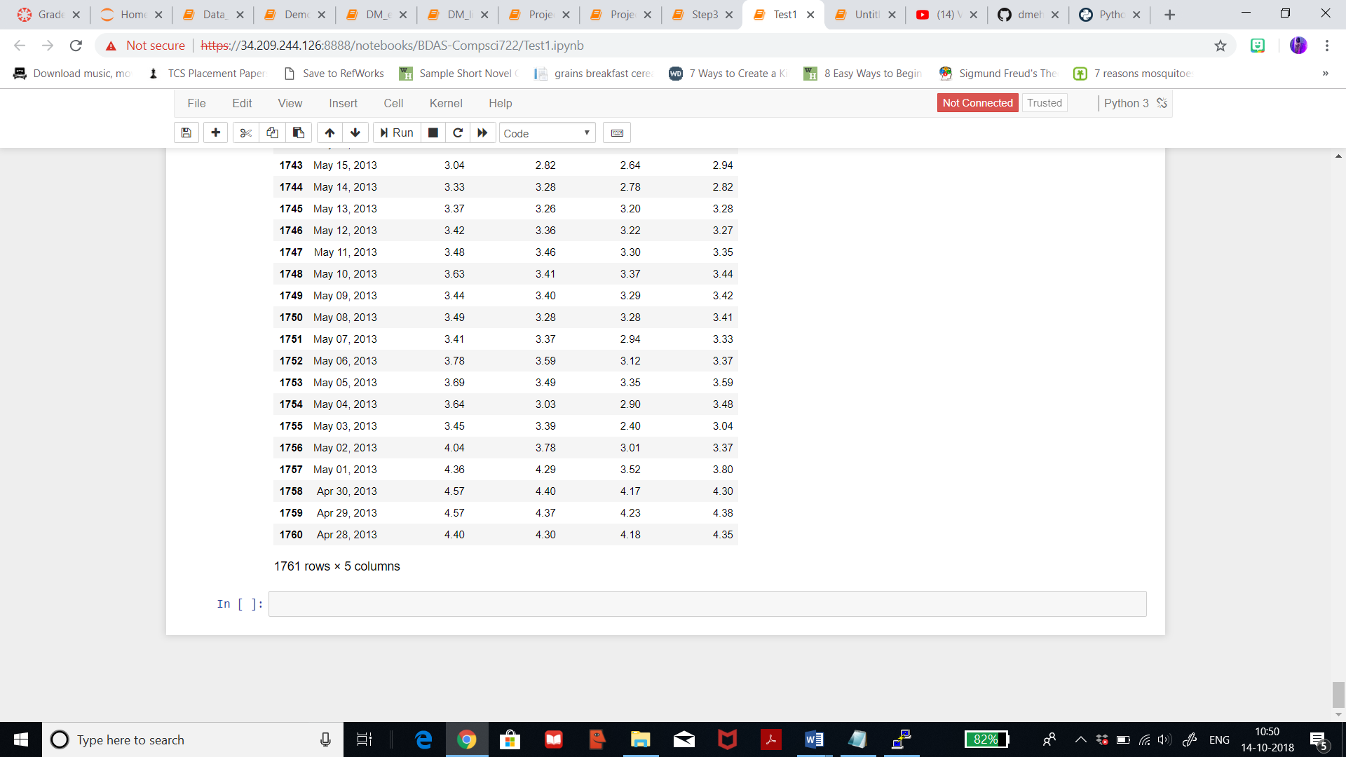

3.2) **Clean Data**: This step plays a very important role in the model. When anyone downloads data from internet, there are found to be many errors, missing/blank values, coding error or bad metadata. These issues are to be rectified before performing further steps. After summarizing the dataset, I came across about 244 missing/blank values in my ‘volume’ column from the dataset, which means that certain volume of transaction hadn’t been recorded and included here. Thus, I can replace these missing values with mean, placeholder or other value, or by completely removing those rows/columns or by replacing with a statistical value. For my dataset, in the last stack I had used two combinations, i.e, by replacing those blank values with ‘using MICE’ and ‘using Probabilistic PCA’ in Microsoft Azure. Replacing with MICE mean replacing with Multiple Imputations by Chained Euqations. Each variable is modeled conditionally using other variables in the data before filling the missing values. MICE stimulates the process of generating the data and the probability distribution of data.

In this stack, I will try substituting null values with ‘N/A’ and see how it will affect my predictions and also I will construct new data on the basis of this substitution. I will be using ‘fill’ function to replace those values. Below I’m substituting the null values in the column ‘Volume’ with ‘N/A’ for litecoin dataset.

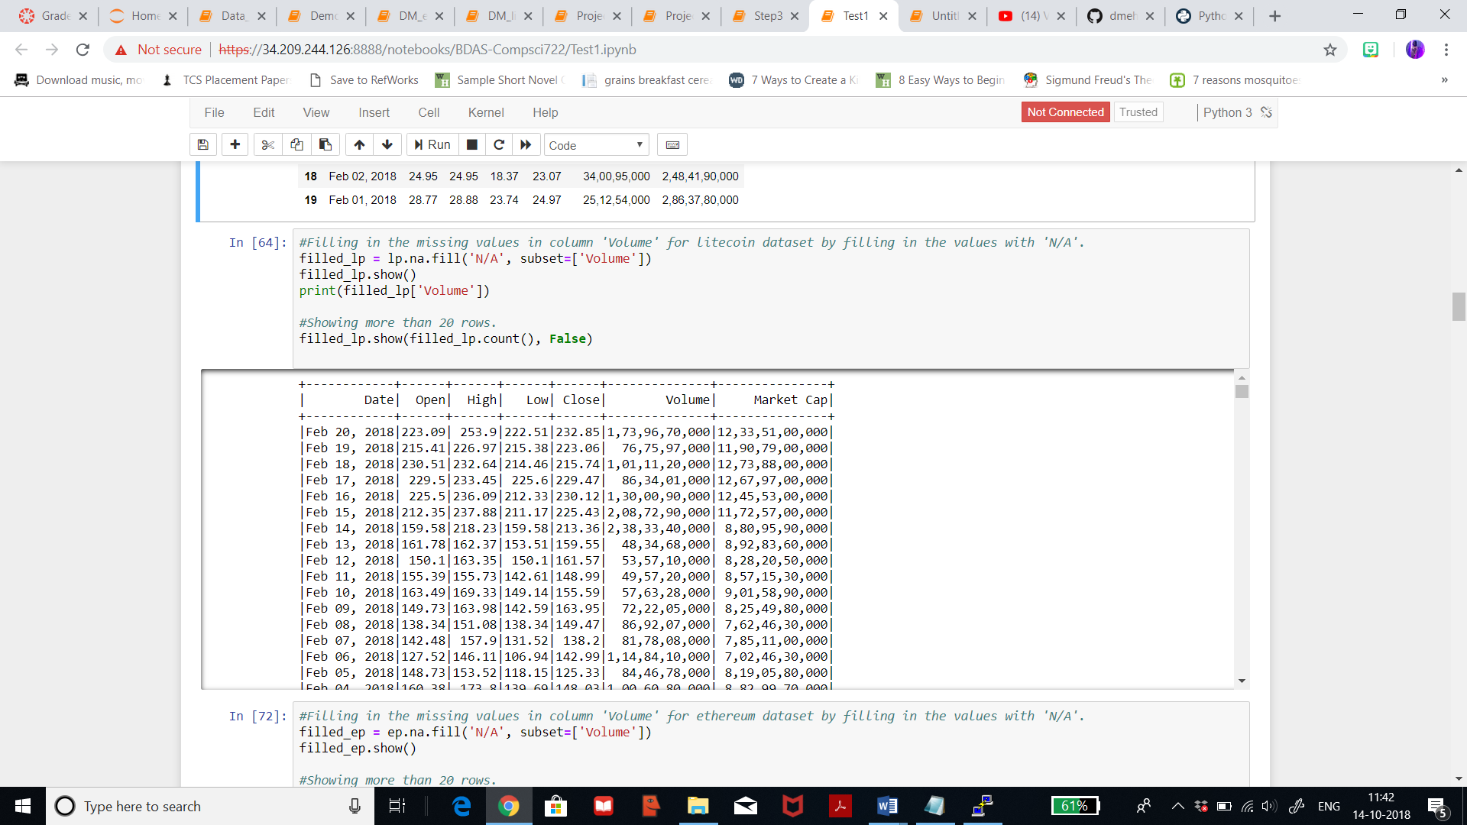

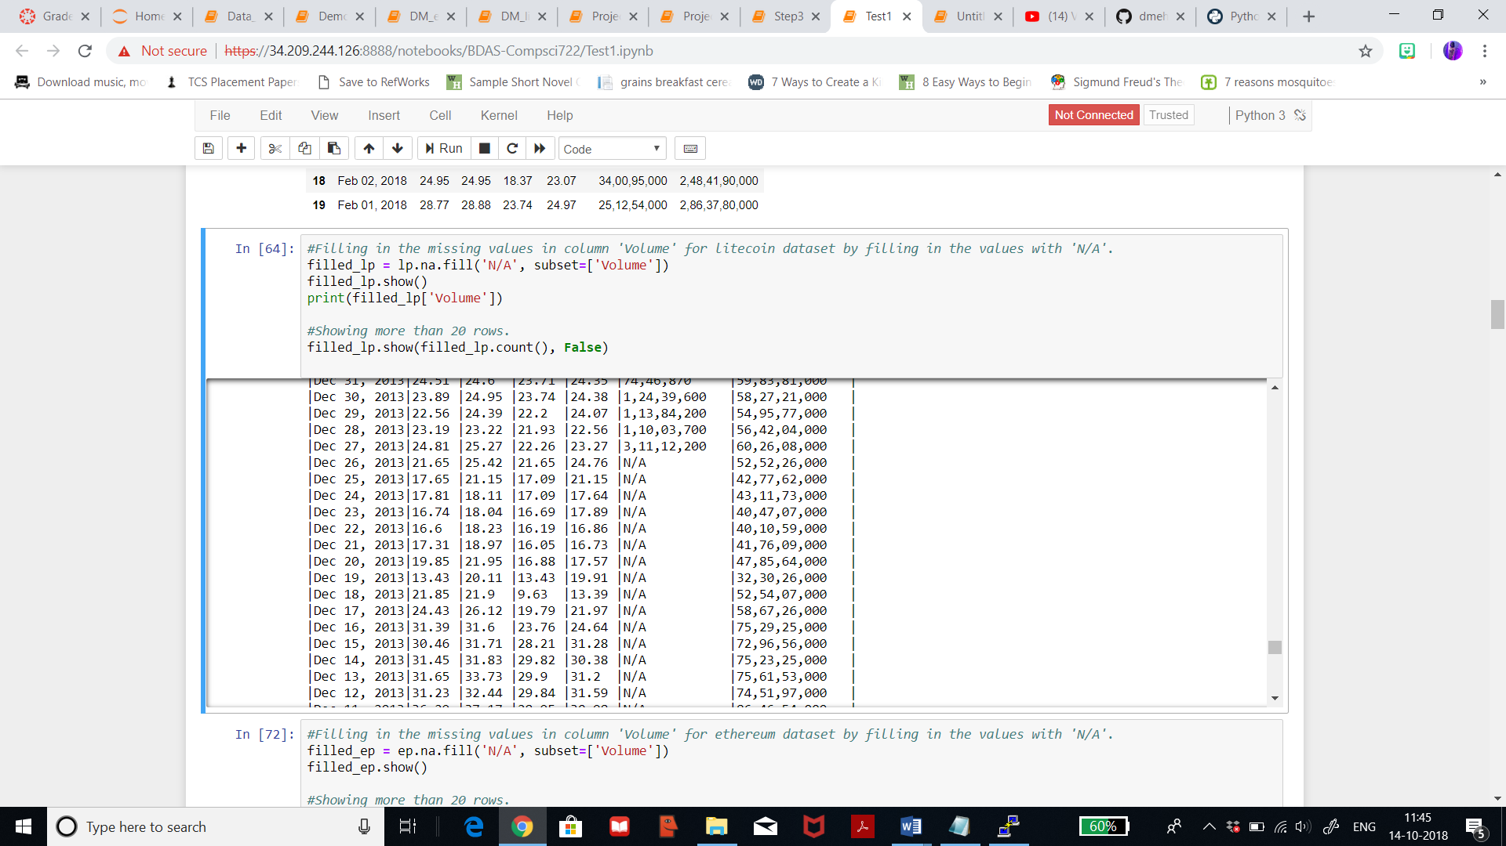

Now I’m substituting the null values in the columns ‘Volume’ and ‘Market Cap’ with ‘N/A’ for ethereum dataset.

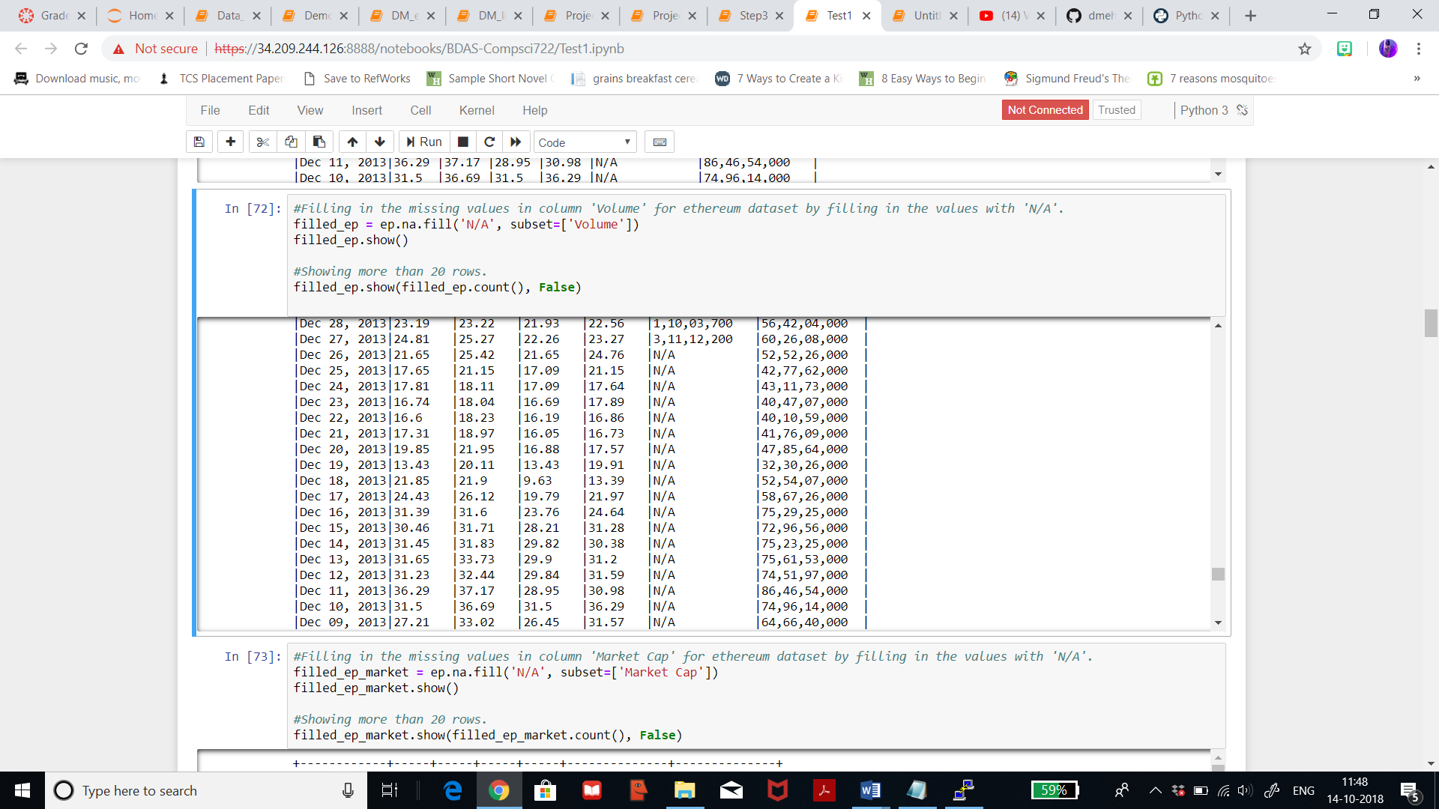

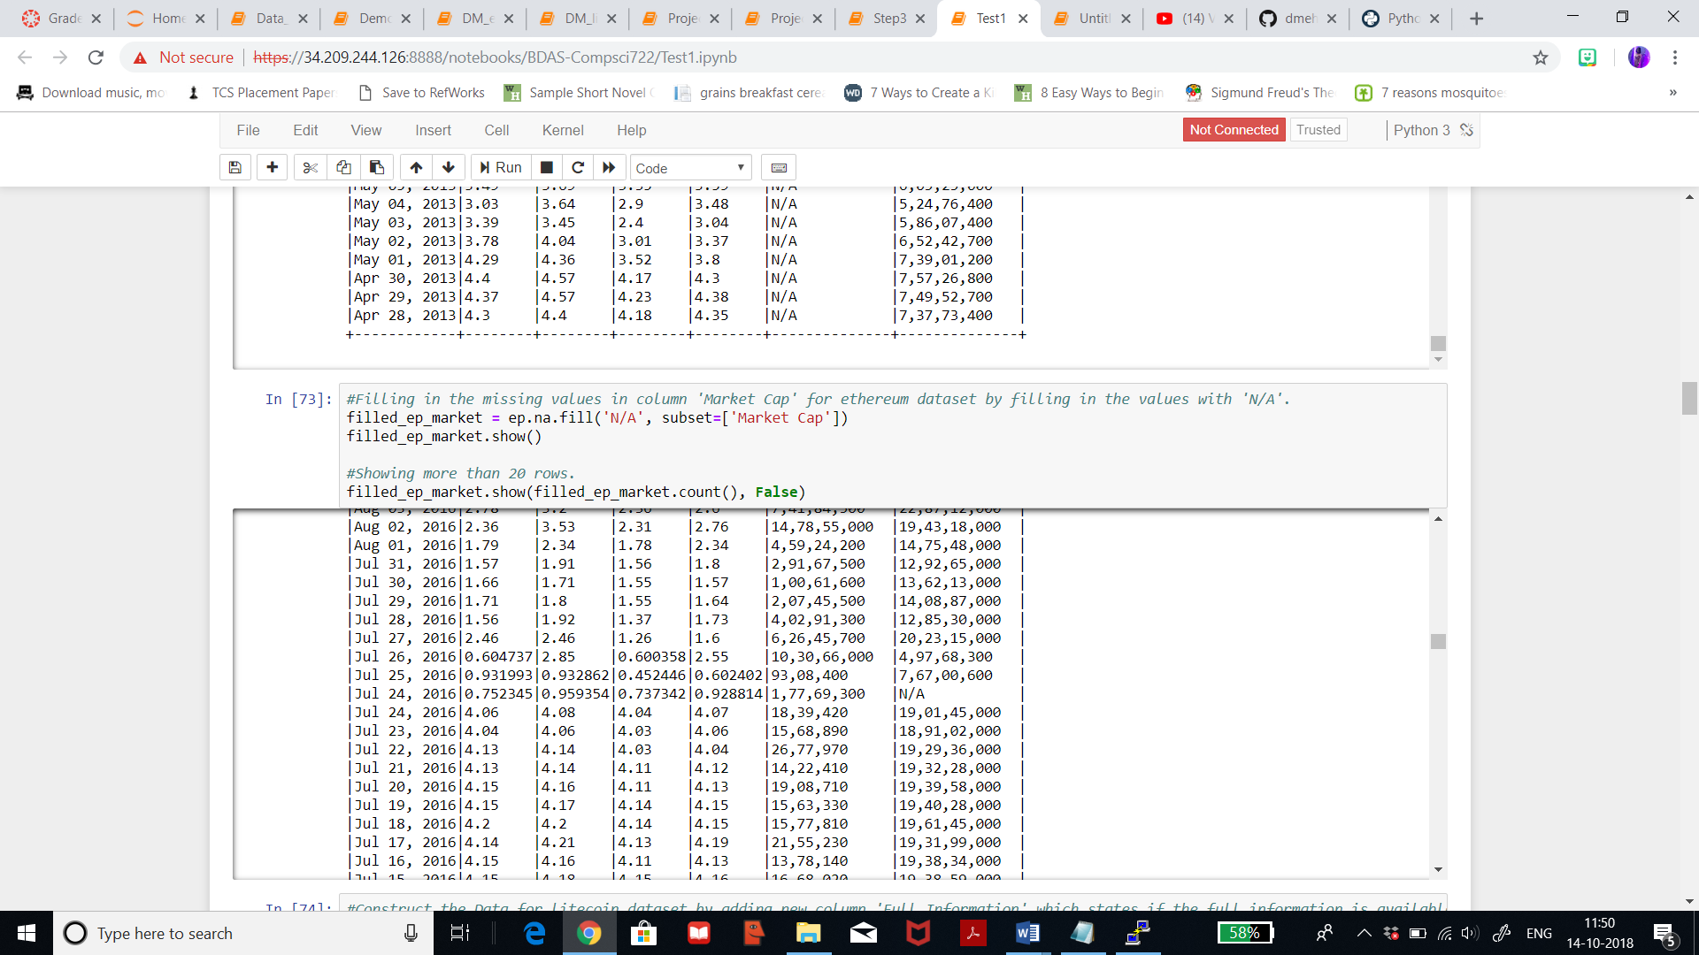

3.3) **Construct new data**: Constructing new data means creating new column or characteristics or generating new records. Normalization of the data is not suitable for my dataset since the datatype of each column will be changed in step 3.5. Missing attributes have already been dealt with by replacing null values with ‘N/A’ in the last step. Now, I will construct new column with the name ‘Full Information’ which will state if all records are available for each attribute. If all records are available then the column would return ‘True’ and if there are any ‘N/A’ values then the column will return ‘False’. By constructing this new column, we can get a clear view if record is fully available or not. Below figure shows construction of new data for the dataset litecoin where we can see that if an attribute has ‘N/A’ then the new column returns ‘False’.

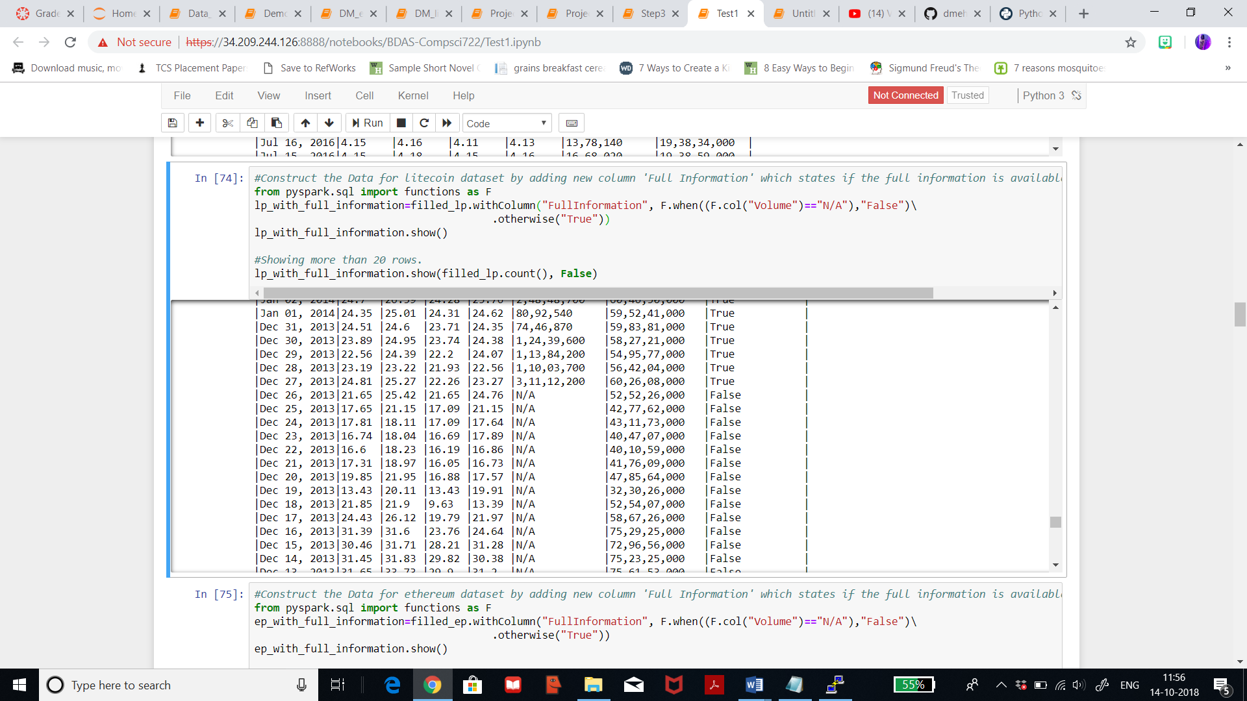

Below figure shows construction of new data for the dataset ethereum where we can see that if an attribute has ‘N/A’ then the new column returns ‘False’ and for the rest if all values are available then it returns ‘True’.

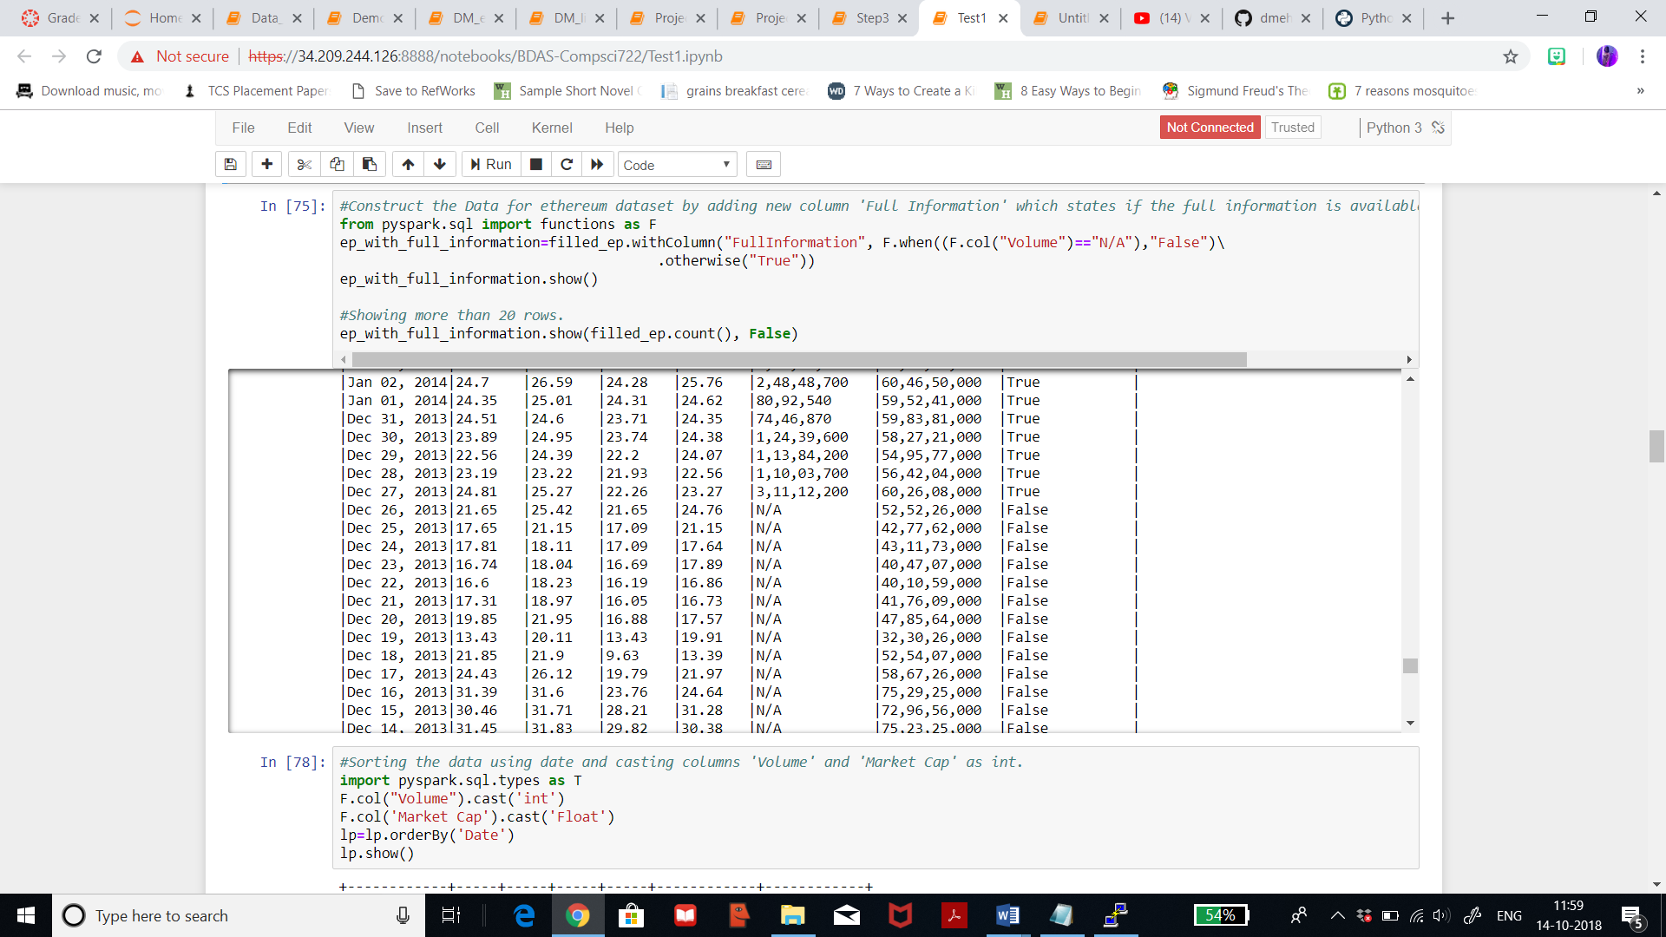

3.4**) Integrating Data**: Integrating data means appending or joining multiple datasets, thus, forming a single table with column names from both dataset. Since, I’m using two datasets I will merge these two datasets by using ‘merge’ function with an outer join. Thus, I will be combining two datasets of similar value type but different attributes by using same key identifier, in my case is ‘Date’ column, for each record. Following is the result data, where columns from litecoin dataset are named following with ‘_litecoin’ and the columns from ethereum dataset are named following with ‘_ethereum’. These names will be then changed in step 3.5 and relevant columns were selected in step 3.1.

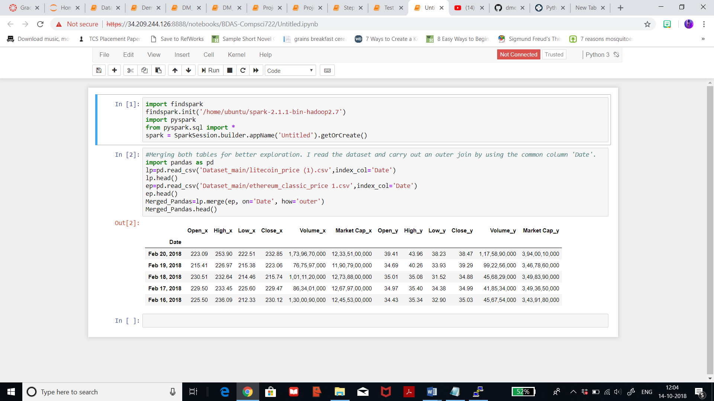

3.5) **Format Data:**

Formatting data means sorting or formatting the data to achieve it’s prefrred datatypes or formatting column names accordingly. Bad metadata basically means mistakes in column name or the spelling of the column names. This means I’m going to select the column names that I want to rename such that it is easy for the audience to differenciate after joining two datasets.

Now the columns joined from Ethereum dataset are named the column name following with _Ethereum and columns joined from Litecoin dataset are named the column name following with _Litecoin. Only the name of the column ‘Date’ would remain the same since date is common for both the datasets.

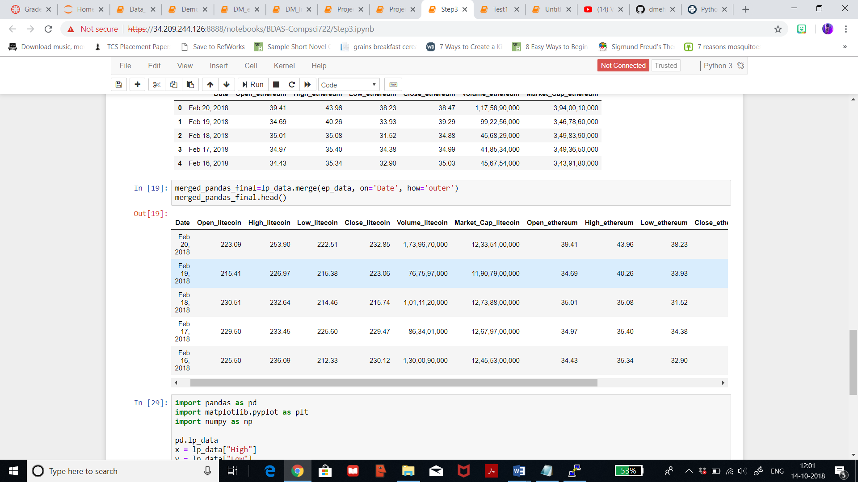

Now, I will change the data type for the columns ‘Volume’ and ‘Market Cap’ from both the datasets from object to int type. I will use the function ‘cast’ to do the same. Also, I will try sorting the column ‘Date’ alphabetically and numerically and analyse the output.

Below is the result for litecoin dataset. We can see that the month ‘April’ has been listed first and dates are ranging from the year 2014, 2015, 2016, and 2017.

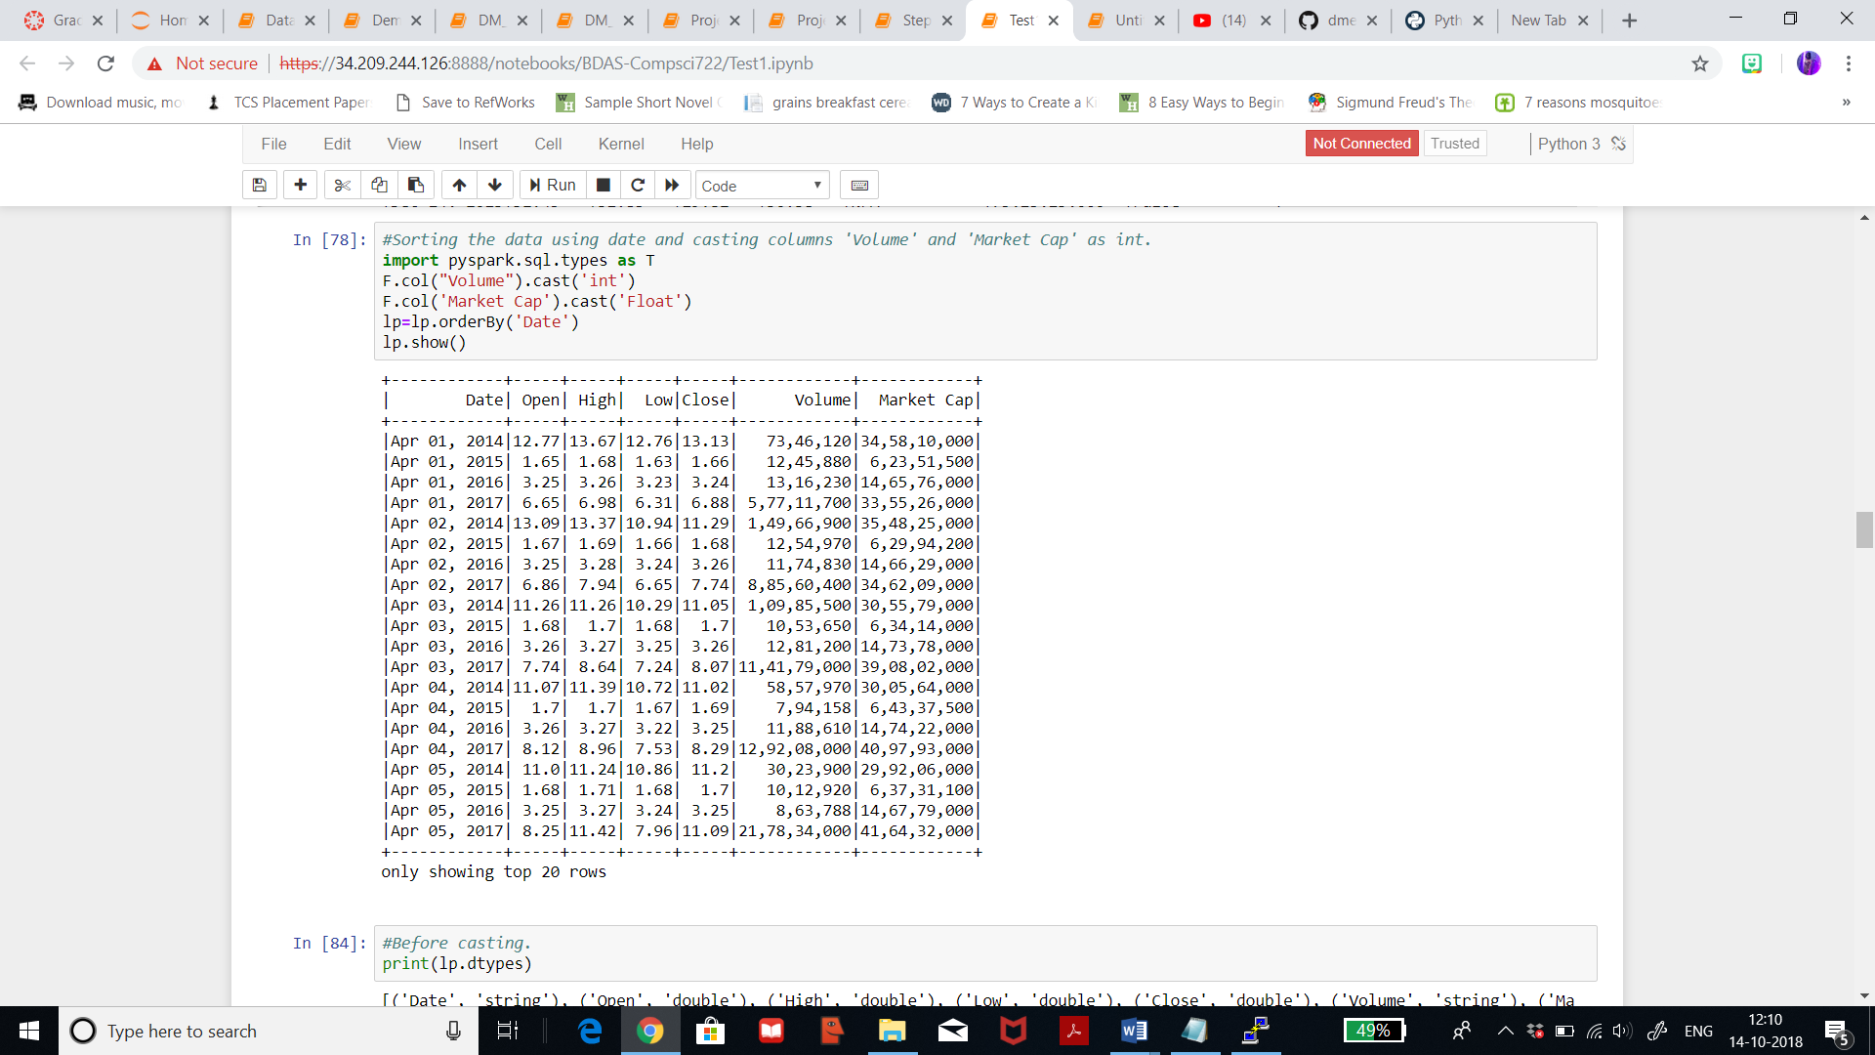

Below figure shows the result for the dataypes before casting and after casting. The datatype for ‘Volume’ and ‘Market Cap’ is int64 now.

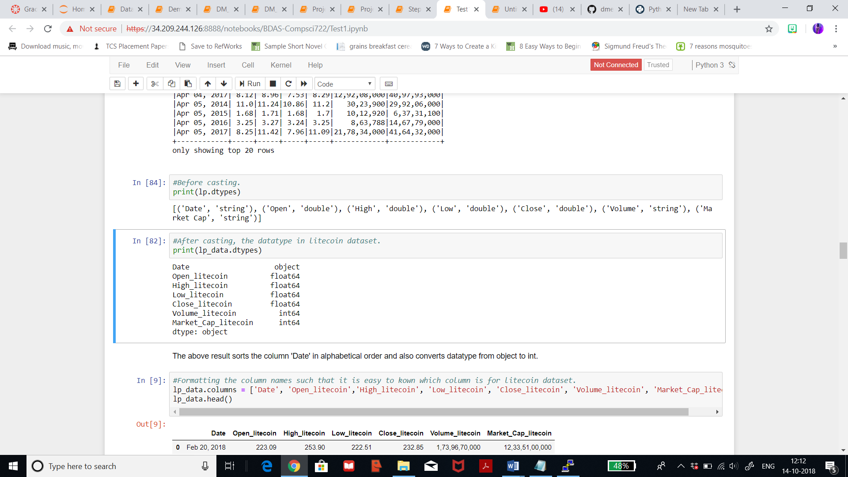

Below is the result for ethereum dataset. We can see that the month ‘April’ has been listed first and dates are ranging from the year 2014, 2015, 2016, and 2017.

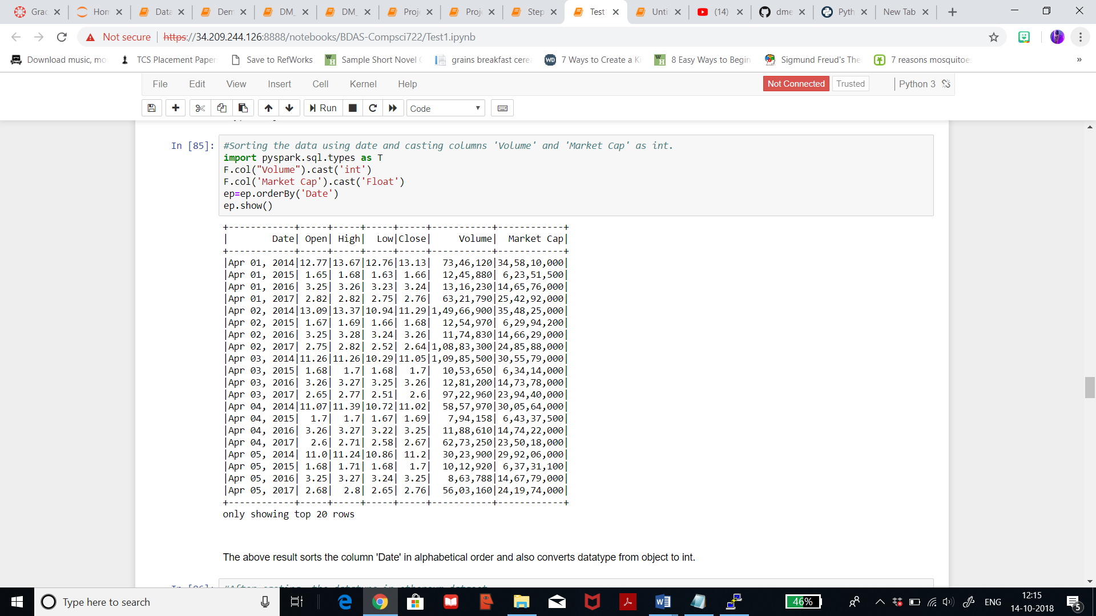

Below figure shows the result for the dataypes after casting. The datatype for ‘Volume’ and ‘Market Cap’ is int64 now.

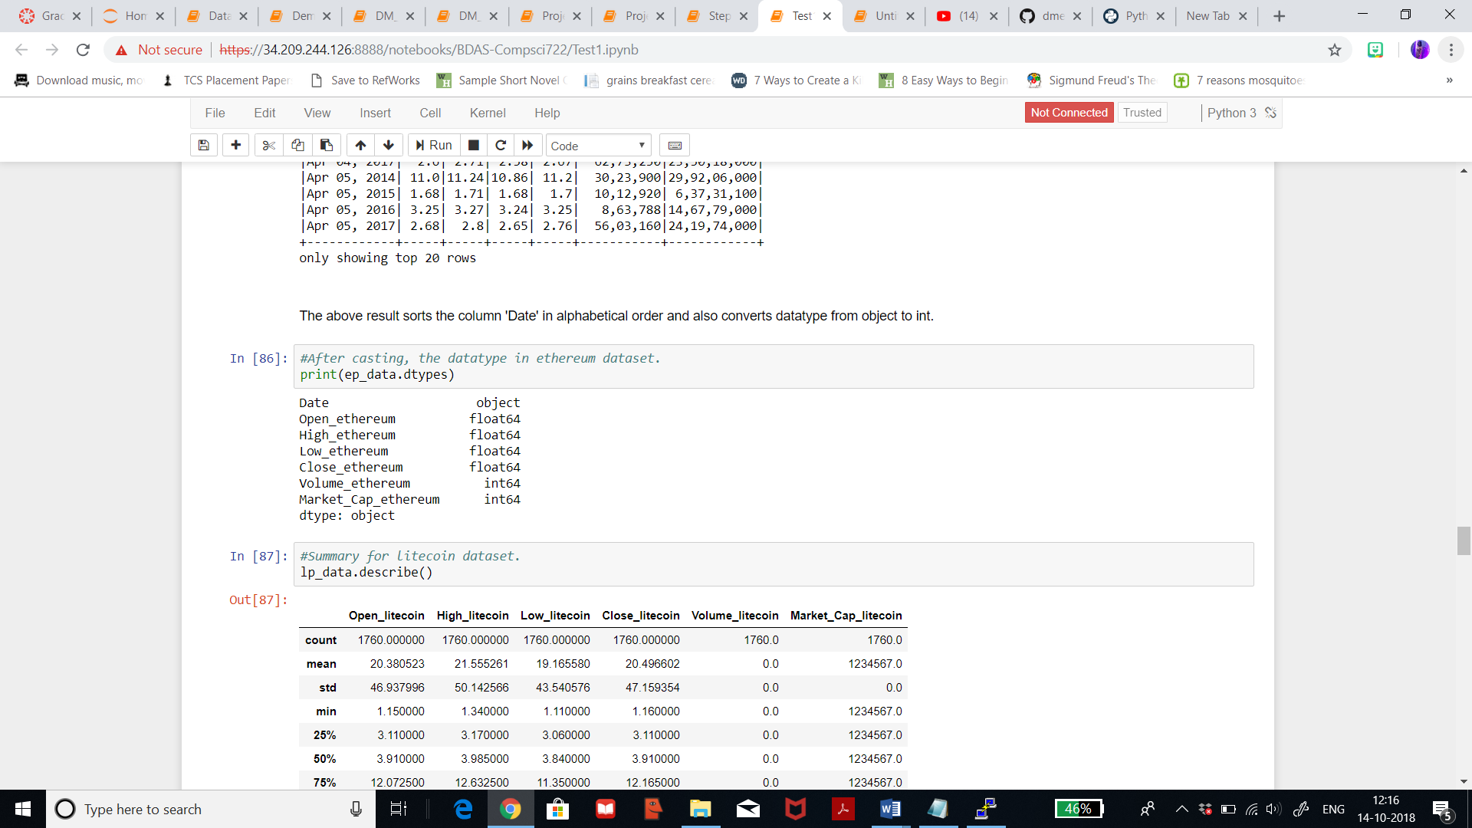

1. **Reduce and Project Data:**

4.1) **Reduce Data**: This step is useful because after cleaning, merging and editing the data, it is now time to apply statistical tests to inputs in order to determine which columns are more predictive of the output. This would be achieved by using ‘VectorAssembler’ tool. VectorAssembler is a transformer that combines a given list of columns into a single vector column. It is useful for combining raw features and features generated by different feature transformers into a single feature vector, in order to train machine learning models like logistic regression and decision trees. There are various types of feature transformation which will help in reducing the data.

* Tokenizer: Is the process of taking text (such as a sentence) and breaking it into individual terms (usually words). This is useful for classification.
* StopWordsRemover: Are words which should be excluded from the input, typically because the words appear frequently and don’t carry as much meaning.
* N-gram: An [n-gram](https://en.wikipedia.org/wiki/N-gram) is a sequence of n tokens (typically words) for some integer n.
* Binarizer: Is the process of thresholding numerical features to binary (0/1) features
* PCA: Is a statistical procedure that uses an orthogonal transformation to convert a set of observations of possibly correlated variables into a set of values of linearly uncorrelated variables called principal components.
* PolynomialExpansion: Is the process of expanding your features into a polynomial space, which is formulated by an n-degree combination of original dimensions.
* Discrete Cosine Transform(DCT): Transforms a length NN real-valued sequence in the time domain into another length N real-valued sequence in the frequency domain.
* StringIndexer: Encodes a string column of labels to a column of label indices.
* IndexToString: Symmetrically to StringIndexer, IndexToString maps a column of label indices back to a column containing the original labels as strings.
* OneHotEncoder:  Is a stateless transformer, it is not usable on new data where the number of categories may differ from the training data.
* OneHotEncoderEstimator: Can transform multiple columns, returning an one-hot-encoded output vector column for each input column.
* VectorIndexer: Helps index categorical features in datasets of Vectors.
* Interaction: Is a Transformer which takes vector or double-valued columns, and generates a single vector column that contains the product of all combinations of one value from each input column.
* Normalization: Is a Transformer which transforms a dataset of Vector rows, normalizing each Vector to have unit norm.
* VectorAssembler: Is a transformer that combines a given list of columns into a single vector column.
* StandardScalar: Transforms a dataset of Vector rows, normalizing each feature to have unit standard deviation and/or zero mean.
* MinMaxScalar: Transforms a dataset of Vector rows, rescaling each feature to a specific range (often [0, 1]).
* MaxAbsScalar: Transforms a dataset of Vector rows, rescaling each feature to range [-1, 1] by dividing through the maximum absolute value in each feature.
* Bucketizer: Transforms a column of continuous features to a column of feature buckets, where the buckets are specified by users.
* ElementwiseProduct: ElementwiseProduct multiplies each input vector by a provided “weight” vector, using element-wise multiplication.
* SQLTransformer: SQLTransformer implements the transformations which are defined by SQL statement.
* VectorSizeHint: Applying this transformer to a dataframe produces a new dataframe with updated metadata for inputCol specifying the vector size.
* QuantileDiscretizer: It takes a column with continuous features and outputs a column with binned categorical features
* Imputer: The Imputer transformer completes missing values in a dataset, either using the mean or the median of the columns in which the missing values are located.

From this whole variety of transformation, I’m using ‘VectorAssembler’ because it is useful for combining raw features and features generated by different feature transformers into a single feature vector. OneHotEncoder is also useful but I wanted to analyse the results by using ‘VectorAssembler’. Below figure shows the use of **VectorAssembler** for litecoin dataset by selecting only few columns. It gives me the features after I’ve selected my target ‘High’. It also returns DenseVector on with 4 variations on the basis of ‘High’ which are quite close to the ‘High’ price.

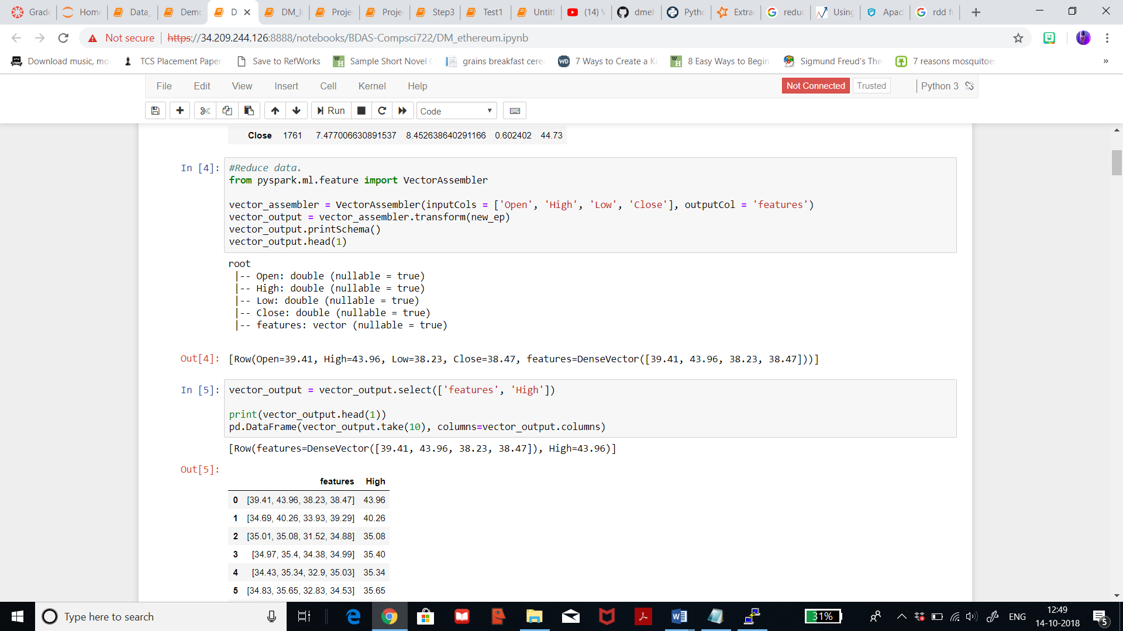

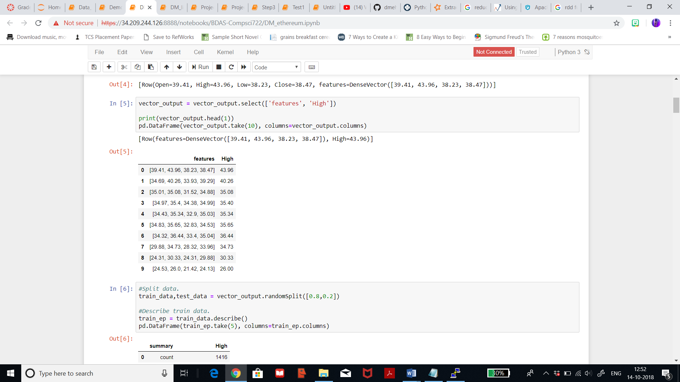

Applying the same method for ethereum dataset. Below figure shows the use of VectorAssembler for ethreum dataset by selecting only few columns. It gives me the features after I’ve selected my target ‘High’. It also returns DenseVector on with 4 variations on the basis of ‘High’ which are quite close to the ‘High’ price.

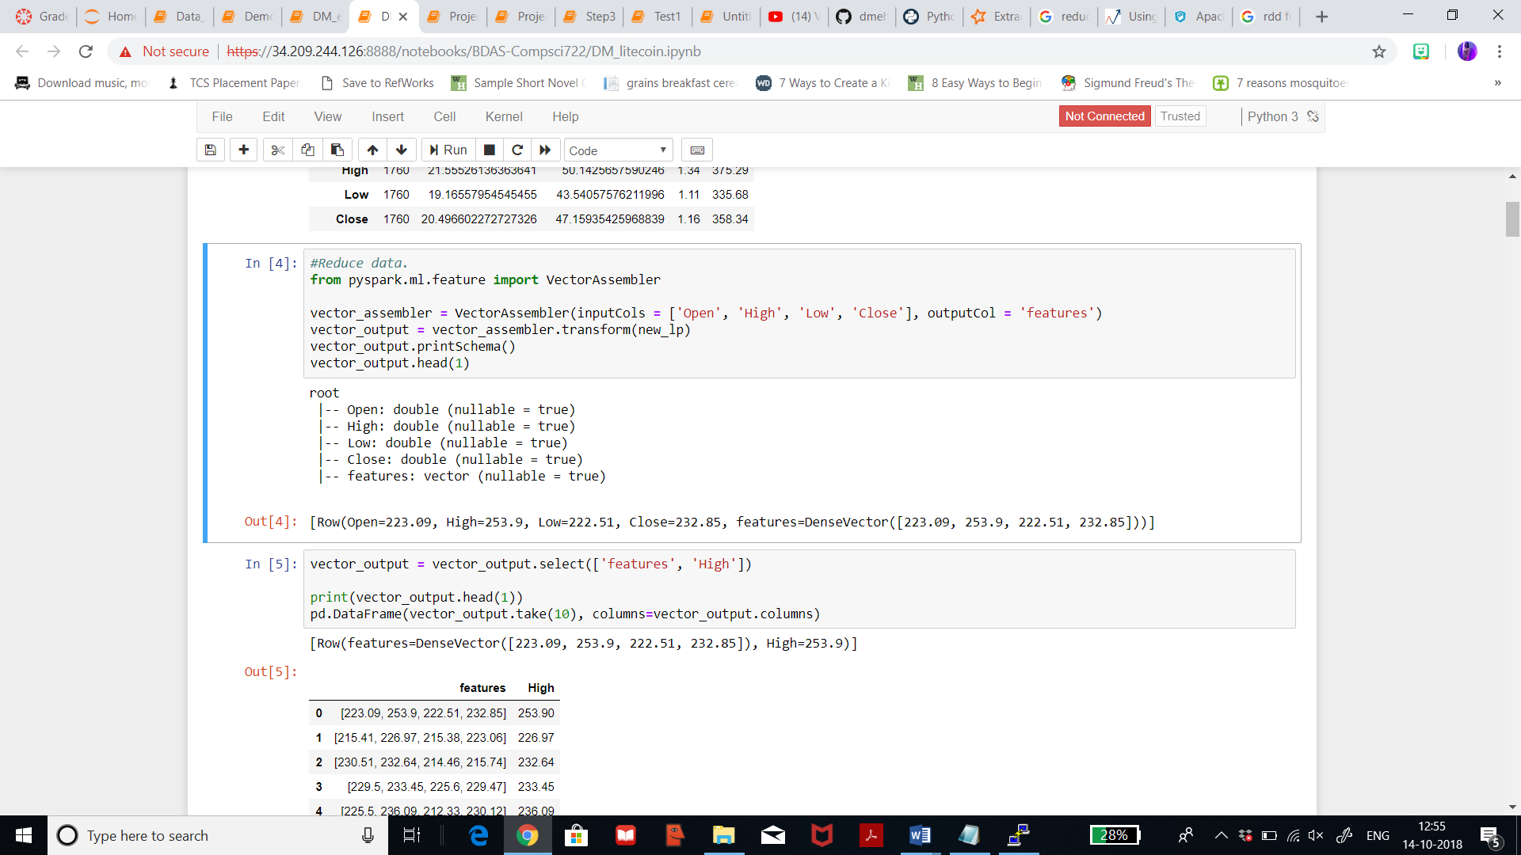

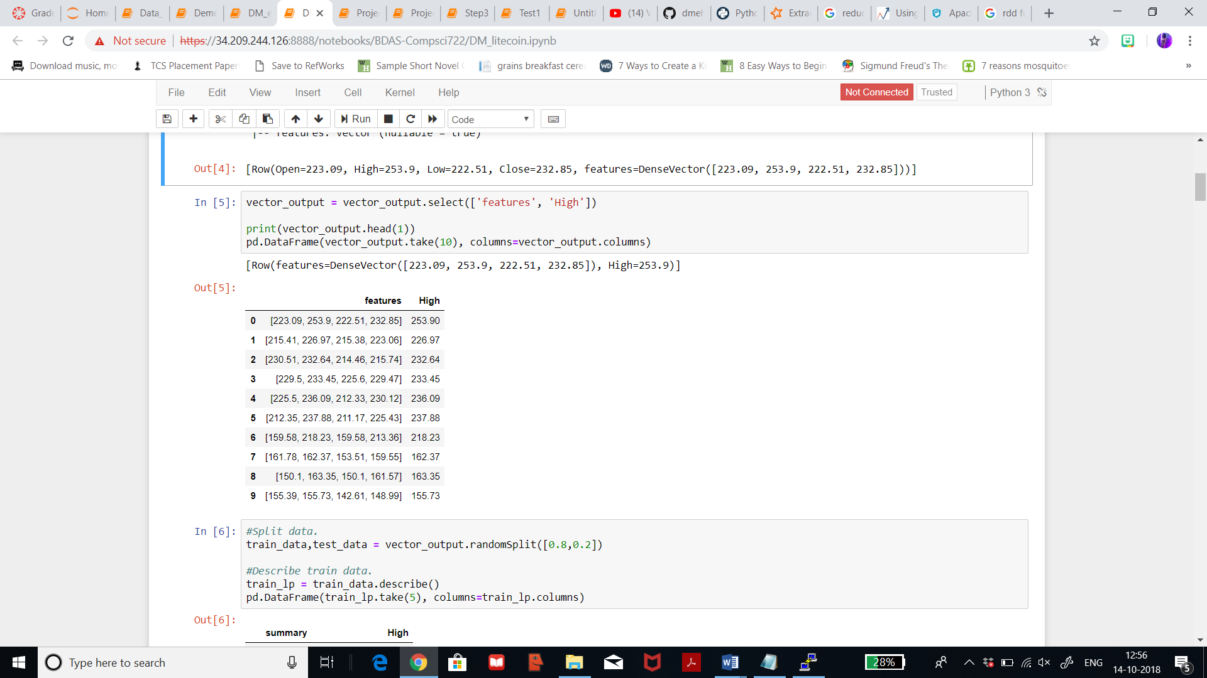

4.2) **Project Data**: This step helps to apply statistical transformations after selecting the best feature. These transformations help in analysing the attributes in the dataset statistically, by taking log of the distribution. Below visualization represented for the column ‘high’ from the both dataset shows the log of the distribution with 50 bins. The lower blue shaded portion depicts the probability density. The probability density has highest frequency of about 1.2 of getting the price as high as about 125 (in log) for ethereum dataset.

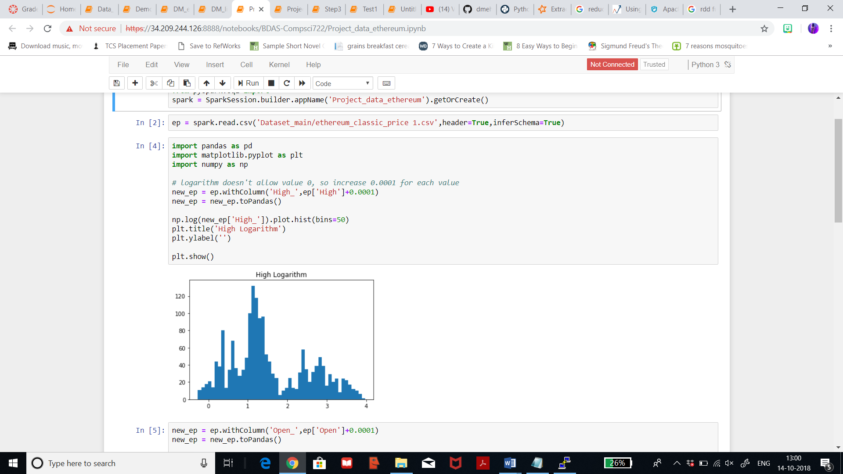

Below visualization represented for the column ‘open’ from ethereum dataset shows the log of the distribution with 50 bins. The lower blue shaded portion depicts the probability density. The probability density has highest frequency of about 1.2 of getting the price as high as about 125 (in log) for ethereum dataset.

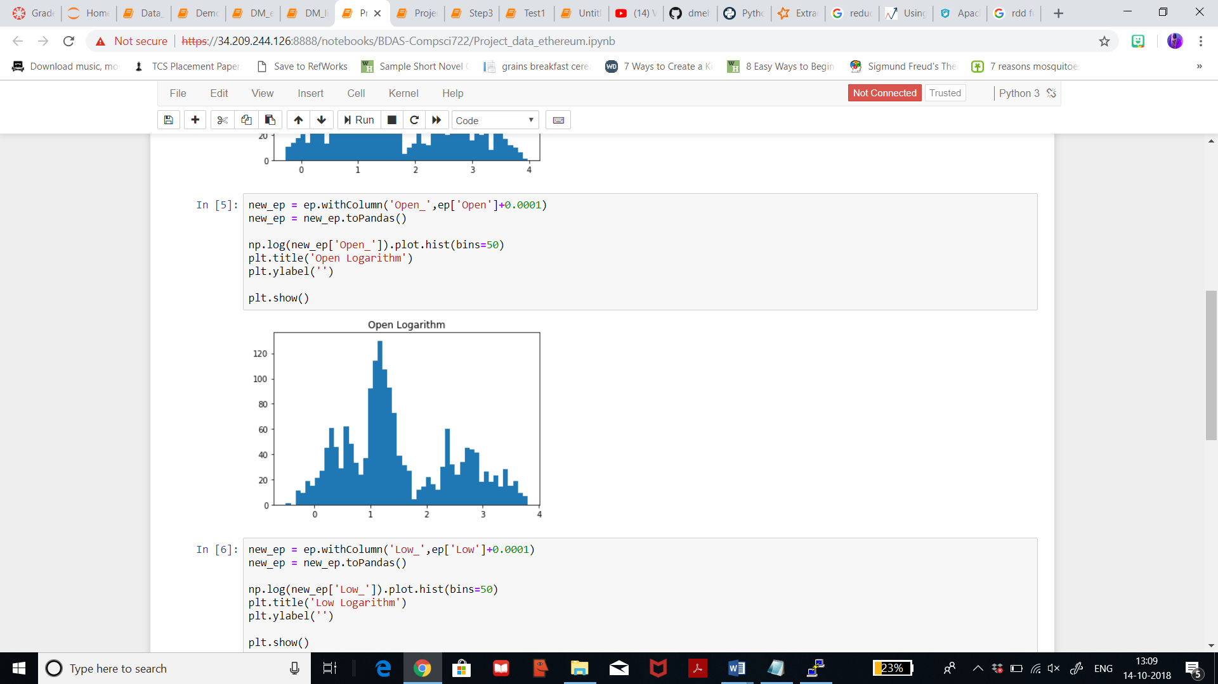

Below visualization represented for the column ‘low’ from ethereum dataset shows the log of the distribution with 50 bins. The lower blue shaded portion depicts the probability density. The probability density has highest frequency of about 1.2 of getting the price as high as about 140 (in log) for ethereum dataset.

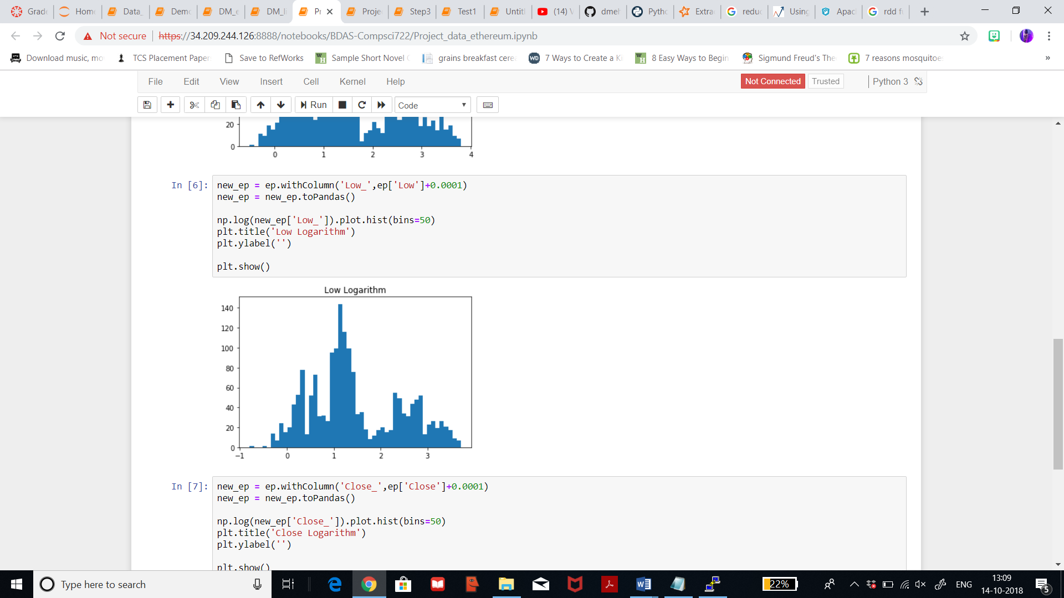

Below visualization represented for the column ‘open’ from ethereum dataset shows the log of the distribution with 50 bins. The lower blue shaded portion depicts the probability density. The probability density has highest frequency of about 1.2 of getting the price as high as about 125 (in log) for ethereum dataset.

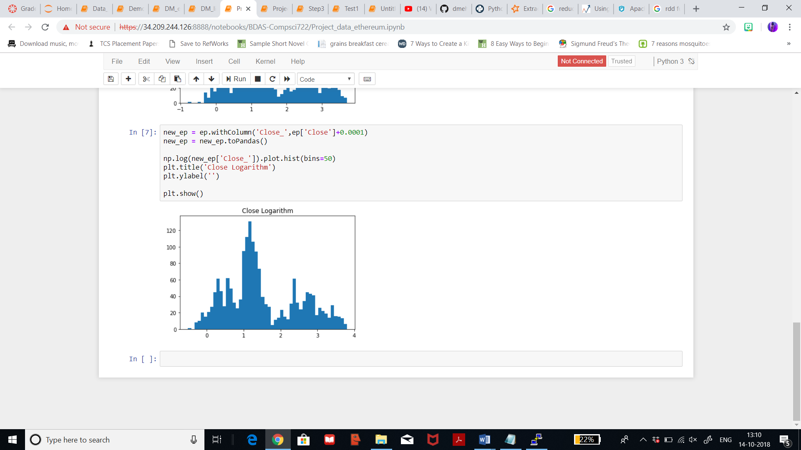

Considering Litecoin dataset, below visualization represented for the column ‘high’ that shows the log of the distribution with 50 bins. The lower blue shaded portion depicts the probability. The probability density shows that the frequency of high prices of about 300(in log) is approximately 1.5.

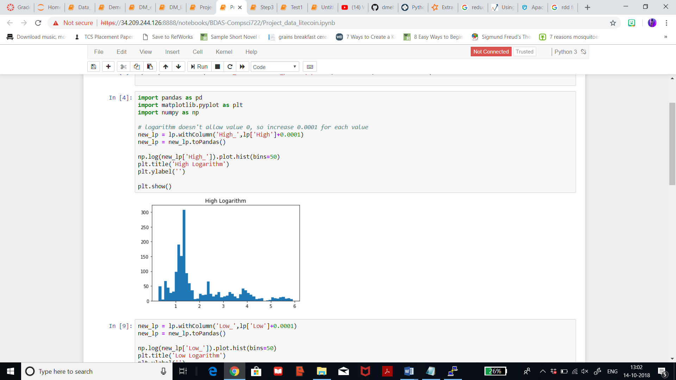

Considering Litecoin dataset, below visualization represented for the column ‘low’ that shows the log of the distribution with 50 bins. The lower blue shaded portion depicts the probability. The probability density shows that the frequency of low prices of about 50(in log) is approximately 2.5 and low price of 320(in log) is around 1.5 times.

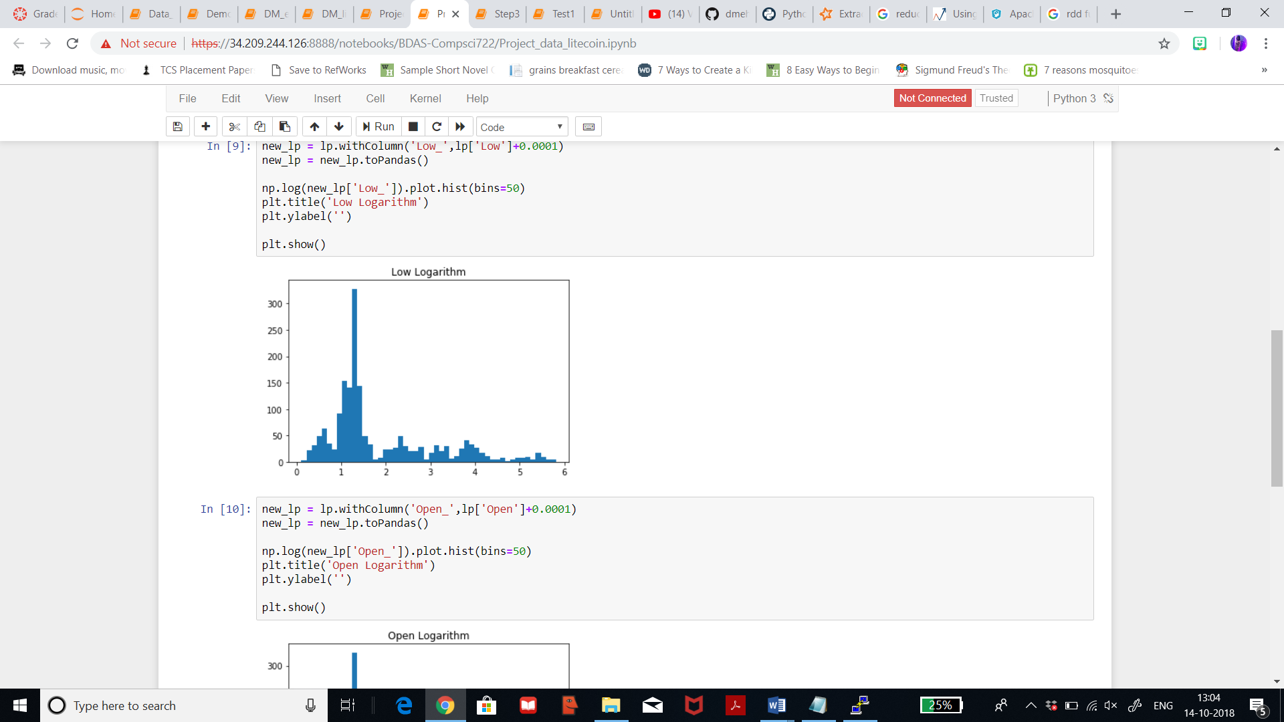

Considering Litecoin dataset, below visualization represented for the column ‘open’ that shows the log of the distribution with 50 bins. The lower blue shaded portion depicts the probability. The probability density shows that the frequency of opening prices of about 300(in log) is approximately 1.5 and price of 50(in log) is about 0.5 times.

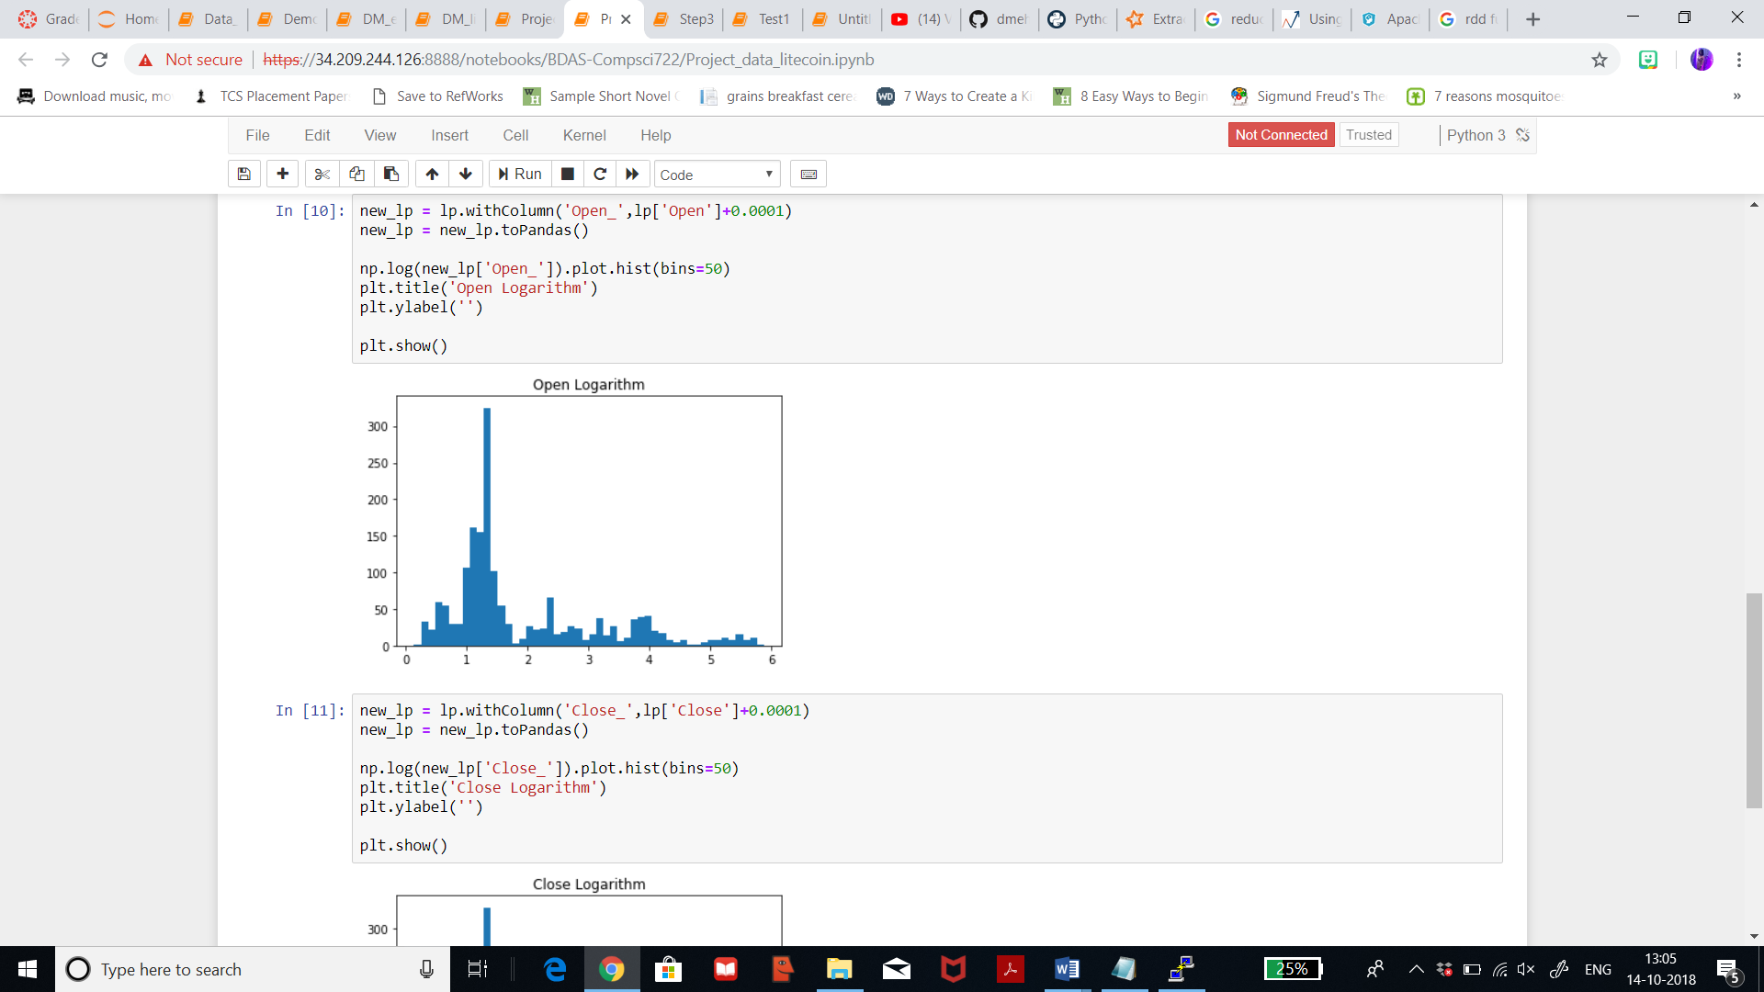

Considering Litecoin dataset, below visualization represented for the column ‘close’ that shows the log of the distribution with 50 bins. The lower blue shaded portion depicts the probability. The probability density shows that the frequency of closing prices of about 300(in log) is approximately 1.5 and closing price of 55(in log) is about 2.5times.

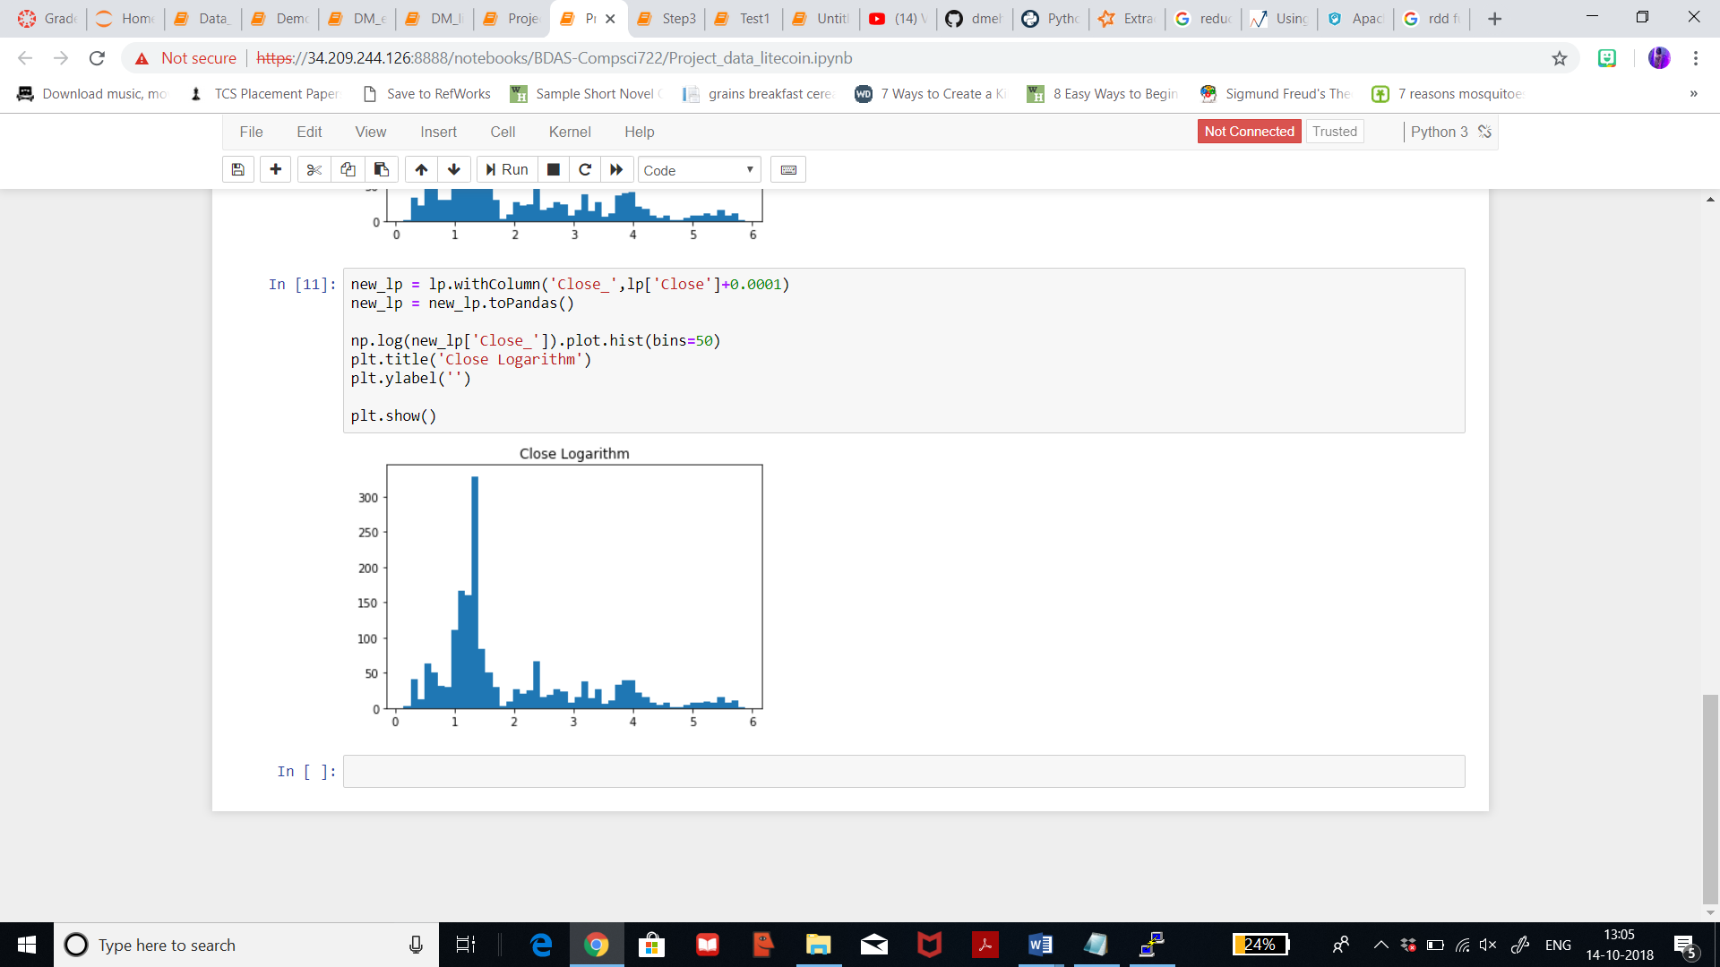

1. **Modelling:**

5.1) **Match and discuss Data mining methods**: Machine learning gives technical basis for data mining. Machine learning can be divided into supervised learning and unsupervised learning. Supervised learning means modelling of dataset with target variables. If target attribute is continuous then a regression model is to be applied. Whereas unsupervised learning is about modelling of datasets with unknown output which puts similar attributes in clusters. After splitting the data, into two parts of 80% and 20%, which represent the training set and the test set, respectively. The splitting of data can be done by various ways by random split. By using random split method, it clearly fits by objective as it has stratified splitting option and also option for setting random seed. Thus, I will split my dataset using rows with 80% training set and 20% test set and discuss more about this in step 6.

5.2) **Data Mining Method Selection**:

There are various data mining tecniques like:

* **Regression**: Regression analysis is a set of statistical processes for estimating the relationships among variables. It includes many techniques for modeling and analyzing several variables, when the focus is on the relationship between a dependent variable and one or more independent variables.
* **Classification**: It is the problem of identifying to which of a set of categories a new observation belongs, based on a training set of data containing observations whose category membership is known.
* **Clustering**: It is a task of grouping a set of objects in such a way that objects in the same group (called a cluster) are more similar to each other than to those in other groups (clusters). It is an unsupervised learning technique, and does not require any target variable to train data on.

My goal is to predict future high prices for both the datasets and to compare the analysis and concluding which currency is stable to invest in. Thus, my target is known so I will be using supervised learning technique which gives me the option of selecting from various methods from Regression. Regression is best suited to achieve my goal since regression is best for predicting values for numeric datatype. You can predict someone’s height by using height function as target and much more. Whereas classification is used for classifying a particular set of information into groups. I have to predict future prices, thus using high price column as target I can use Regression and it’s various algorithm to achieve my goal.

1. **Exploratory Analysis and selection of Model:**
   1. **Exploratory Analysis and Discussion:**

An important task in ML is model selection, or using data to find the best model or parameters for a given task. This is also called tuning. Tuning may be done for individual Estimators such as LogisticRegression, or for entire Pipelines which include multiple algorithms, featurization, and other steps. As Regression is selected to be the best method to achieve my goal, let us look the algorithms and it’s various functionalities it offers. At a high level, these model selection tools work as follows:

* split the input data into separate training and test datasets.
* For each (training, test) pair, they iterate through the set of ParamMaps: For each ParamMap, they fit the Estimator using those parameters, get the fitted Model, and evaluate the Model’s performance using the Evaluator.
* They select the Model produced by the best-performing set of parameters.

With PySpark, there are multiple methods that can be used in Regression such as:

* Gradient Boosted Regression Tree:  [Gradient-Boosted Trees (GBTs)](http://en.wikipedia.org/wiki/Gradient_boosting) are ensembles of [decision trees](http://spark.apache.org/docs/latest/ml-classification-regression.html#decision-trees). GBTs iteratively train decision trees in order to minimize a loss function and uses both continuous and categorical features.
* Decision Tree Regression: This creates a regression model based on ensemble of decision trees.
* Random Forest Regression: This method create a regression model that can help in predicting values. Random forests combine many decision trees in order to reduce the risk of overfitting.
* Linear Regression: Linear regression attempts to establish a linear relationship between one or more independent variables and a numeric outcome, or dependent variable.
* Generalized Linear Regression: [generalized linear models](https://en.wikipedia.org/wiki/Generalized_linear_model)(GLMs) are specifications of linear models where the response variable Yi follows some distribution from the [exponential family of distributions](https://en.wikipedia.org/wiki/Exponential_family).
* Survival Regression: In spark.ml, we implement the [Accelerated failure time (AFT)](https://en.wikipedia.org/wiki/Accelerated_failure_time_model) model which is a parametric survival regression model for censored data. It describes a model for the log of survival time, so it’s often called a log-linear model for survival analysis.
* Isotonic Regression: Isotonic regression is a [monotonic function](http://en.wikipedia.org/wiki/Monotonic_function) best fitting the original data points. Training returns an IsotonicRegressionModel that can be used to predict labels for both known and unknown features. The result of isotonic regression is treated as piecewise linear function.

**6.2 & 6.3) Selection of Algorithm based on discussion and analysis:**

Survival Regression won’t quite fit my objective since I want to predict the future prices for the currency and survival is used for censored values which seems different from my goal. Thus, the remaining options seem very strong in predicting the prices.

Gradient boosted Regression tree seems to be the quite interesting from them all since it minimizes loss and also uses both continuous and categorical features. This method is very useful in predicting prices which totally fits my objective as I want to predict future high prices. Thus, the column ‘high’ would be my target. Whereas linear regression models attempt to predict the value of a numeric variable using the estimate of mean but if you wish to predict the range or distribution of the target variable. Techniques such as Isotonic regression and Generalised linear regression have been developed for this purpose. Thus, I would be running Linear Regression, and then analysing the result set. Then I would iterate using Decision Tree Regression and then using Gradient boosted regression tree. I would love to analyse other model but the given time is limited.

**7) Executing Model and Searching patterns:**

**7.1) Splitting Data:**

The data is split using rows into **80% and 20%** used for training and testing data purpose. The trained model is used for the prediction process. The training set and test set is divided with the ratio of 80-20% because my dataset consists more than 1000 rows so 80-20 ratio is the best and well suited figure as it’s robust and the benchmark. Below table represents splitting of data for litecoin dataset.

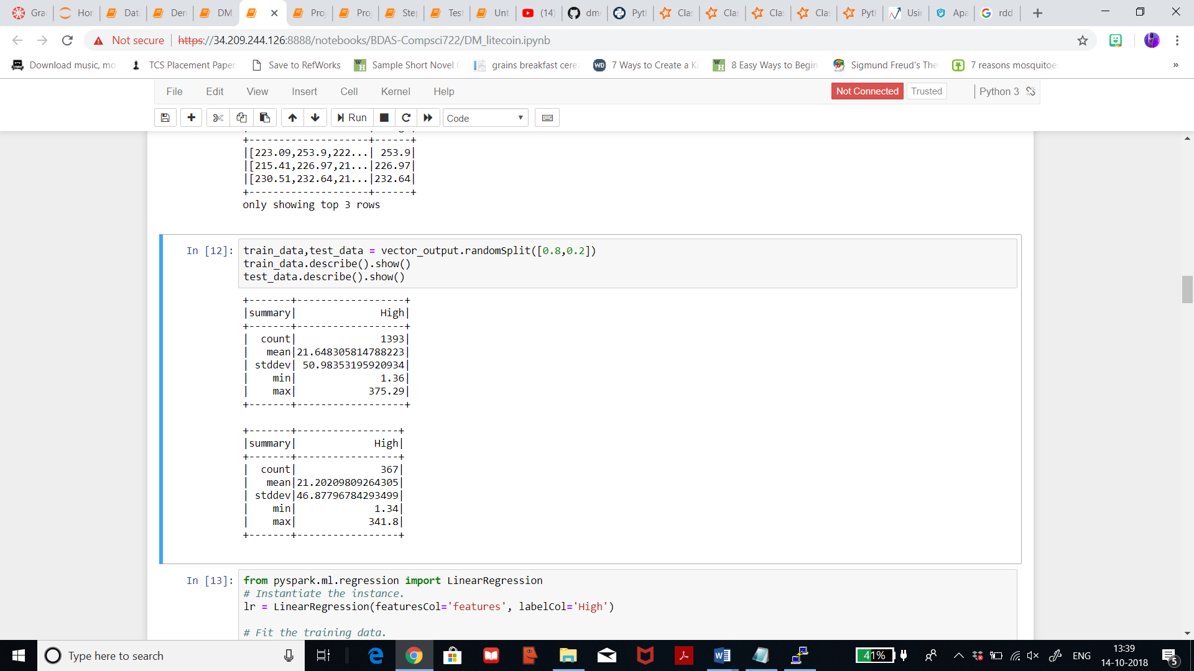

The below table represents the same for ethereum dataset.

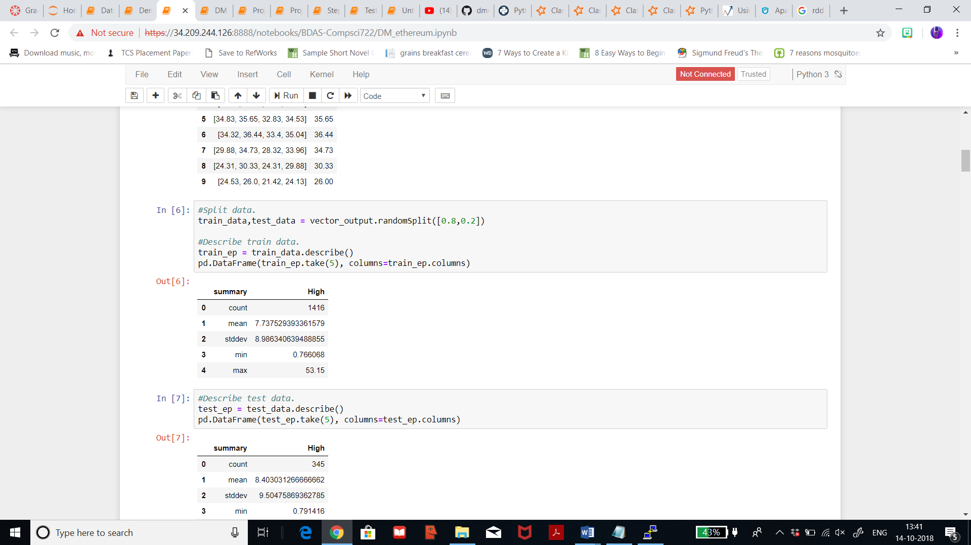

**7.2) Running Data Mining algorithms:**

**Linear Regression Iteration 1: Litecoin dataset**

First, I will be using Linear Regression method to see how a linear relationship is built between two independent variables. Here, I’ve initially instantiated the instance feature column and my target ‘High’, then I’ve tried fitting the trained data and then printing the co-efficient. I’ve set 10 iterations and 0.3 as regParam. After getting the co-efficients, I achieved the below predictions and Mean absolute error 0.3 and Root Mean Square Error of 1.3.

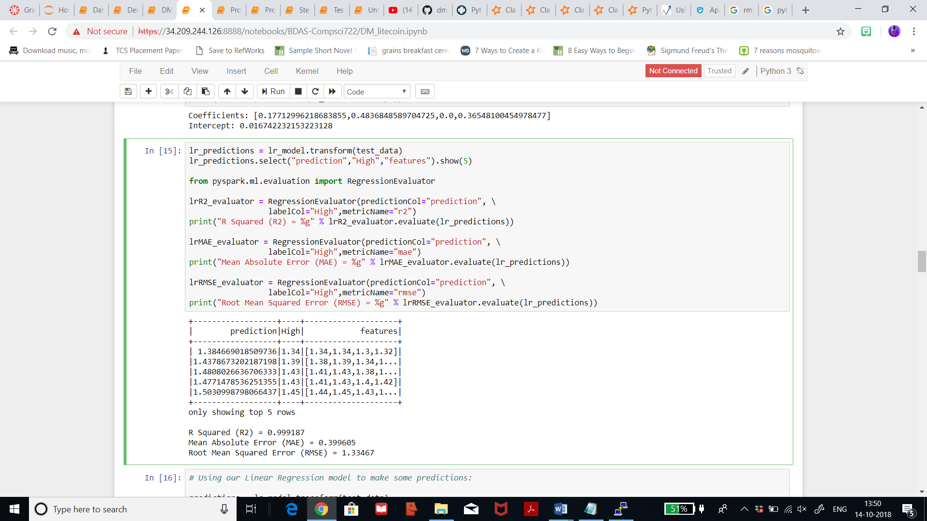

**Decision Regression Iteration 1: Litecoin dataset**

Decision trees are widely used since they are easy to interpret, handle categorical features, extend to the multiclass classification setting, do not require feature scaling, and are able to capture non-linearities and feature interactions. After fitting in the vector output, the Root Mean Squared Error on vector output is 10.34 and that on R2 is 0.95.

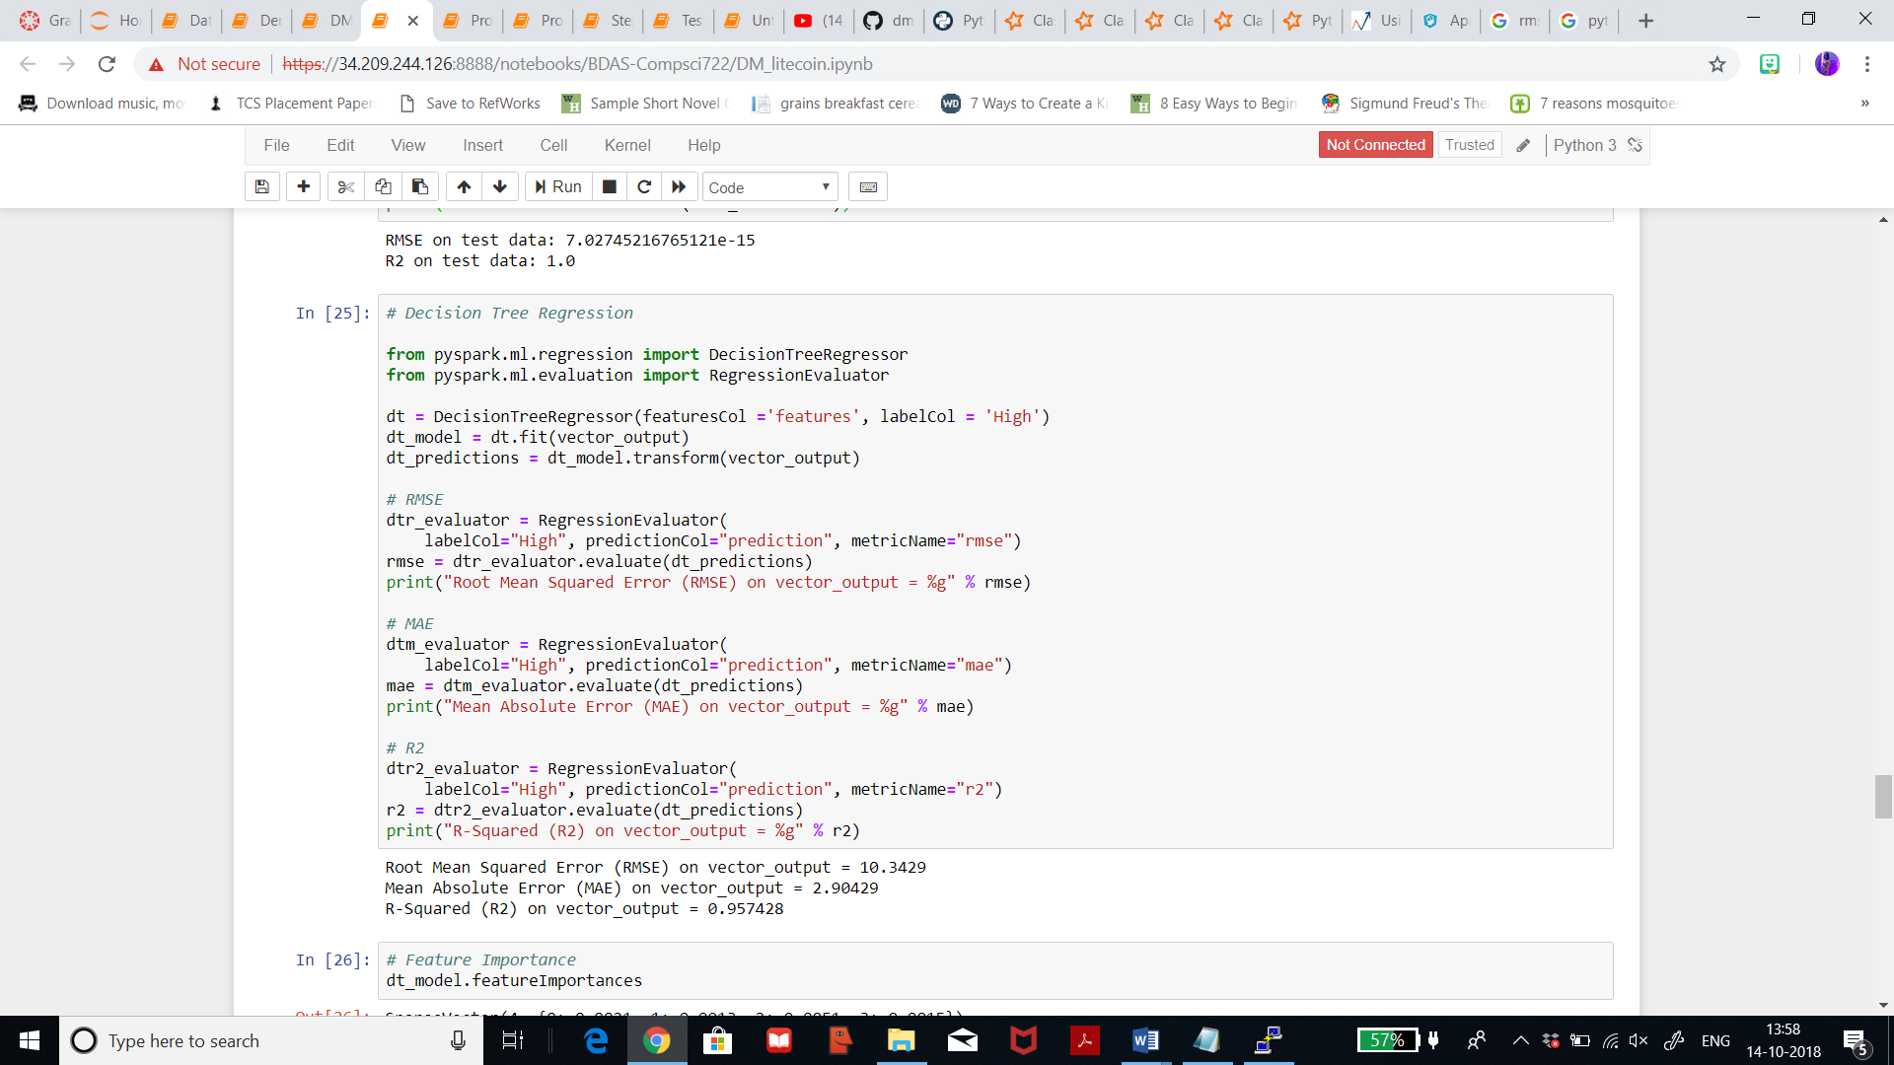

**Gradient boosted Tree Regression Iteration 1: Litecoin dataset**

GBTs iteratively train decision trees in order to minimize a loss function. The spark.ml implementation supports GBTs for binary classification and for regression, using both continuous and categorical features. Here, I’ve set 10 iterations, and I achieved R2 on vector output as 0.95.

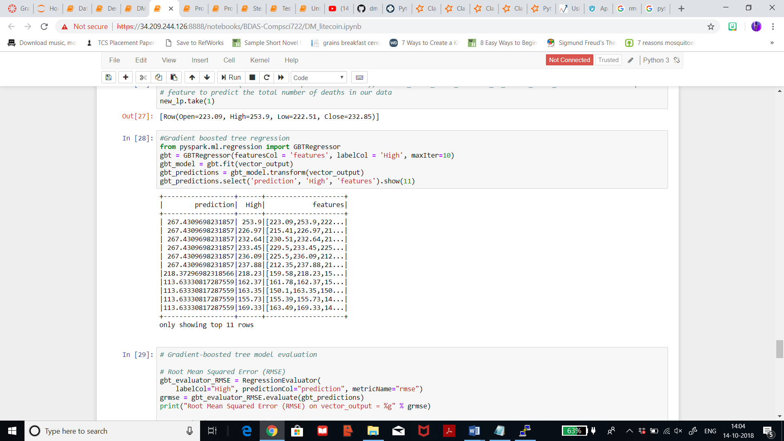

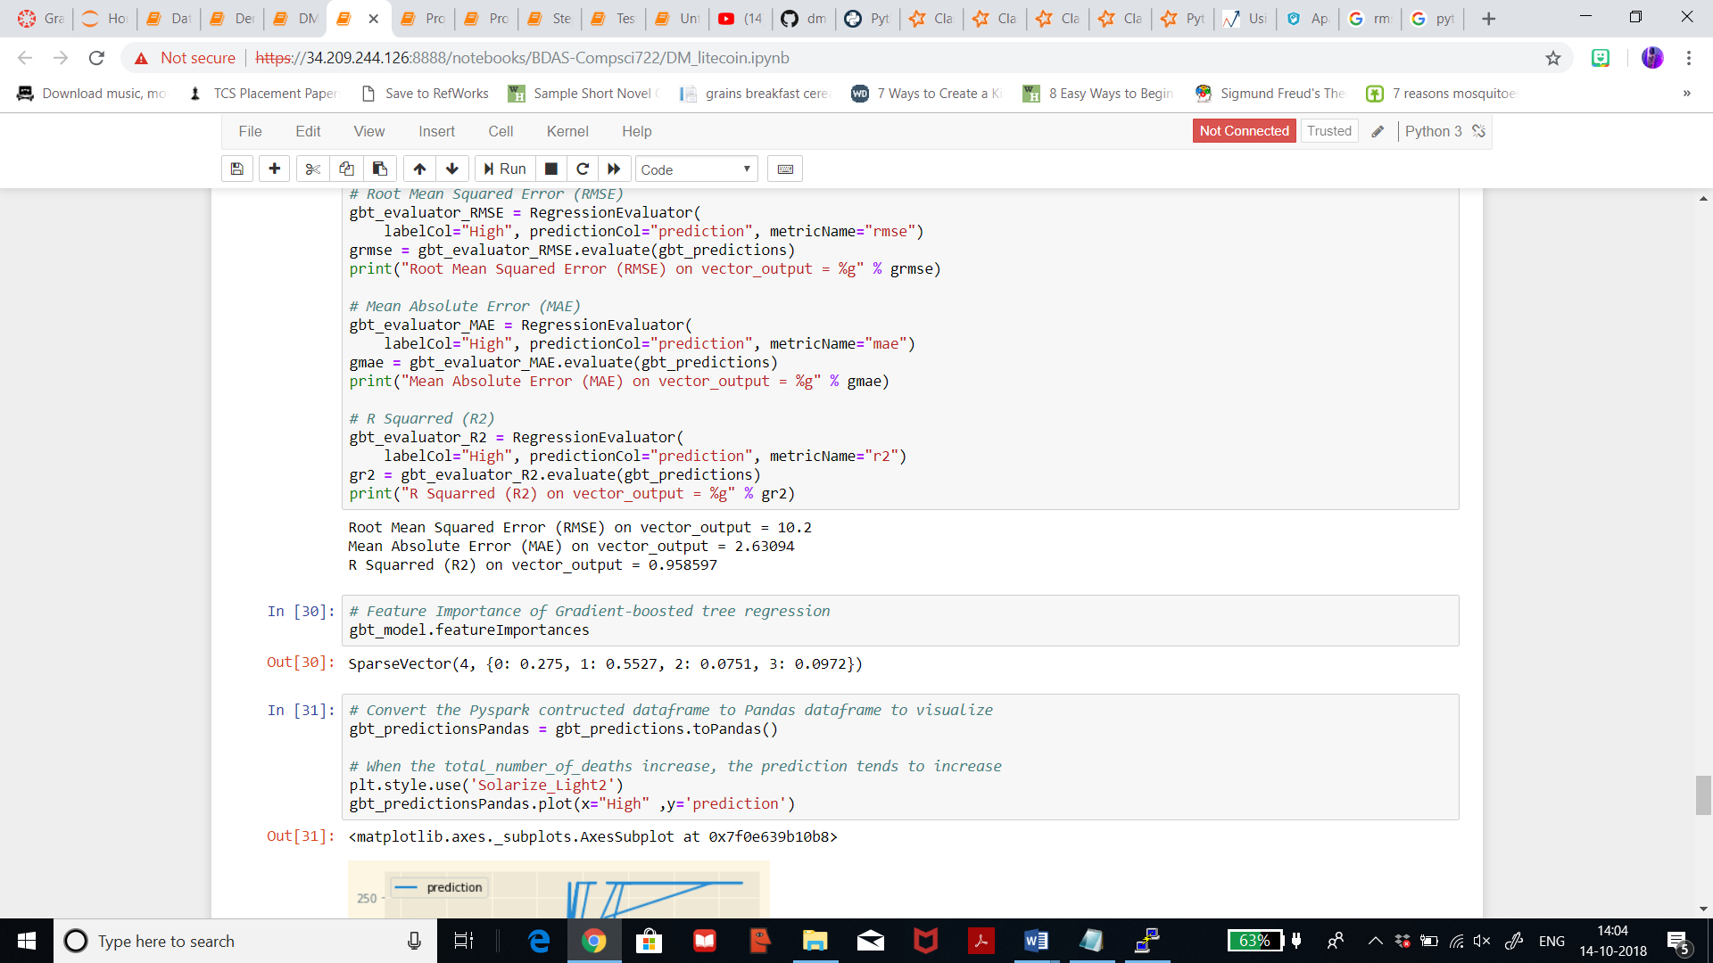

**Linear Regression Iteration 1: Ethereum dataset**

I will be using Linear Regression method to see how a linear relationship is built between two independent variables. Here, I’ve initially instantiated the instance feature column and my target ‘High’, then I’ve tried fitting the trained data and then printing the co-efficient. I’ve set 10 iterations and 0.3 as regParam. After getting the co-efficients, I achieved the below predictions and Mean absolute error 0.2 and Root Mean Square Error of 0.5.

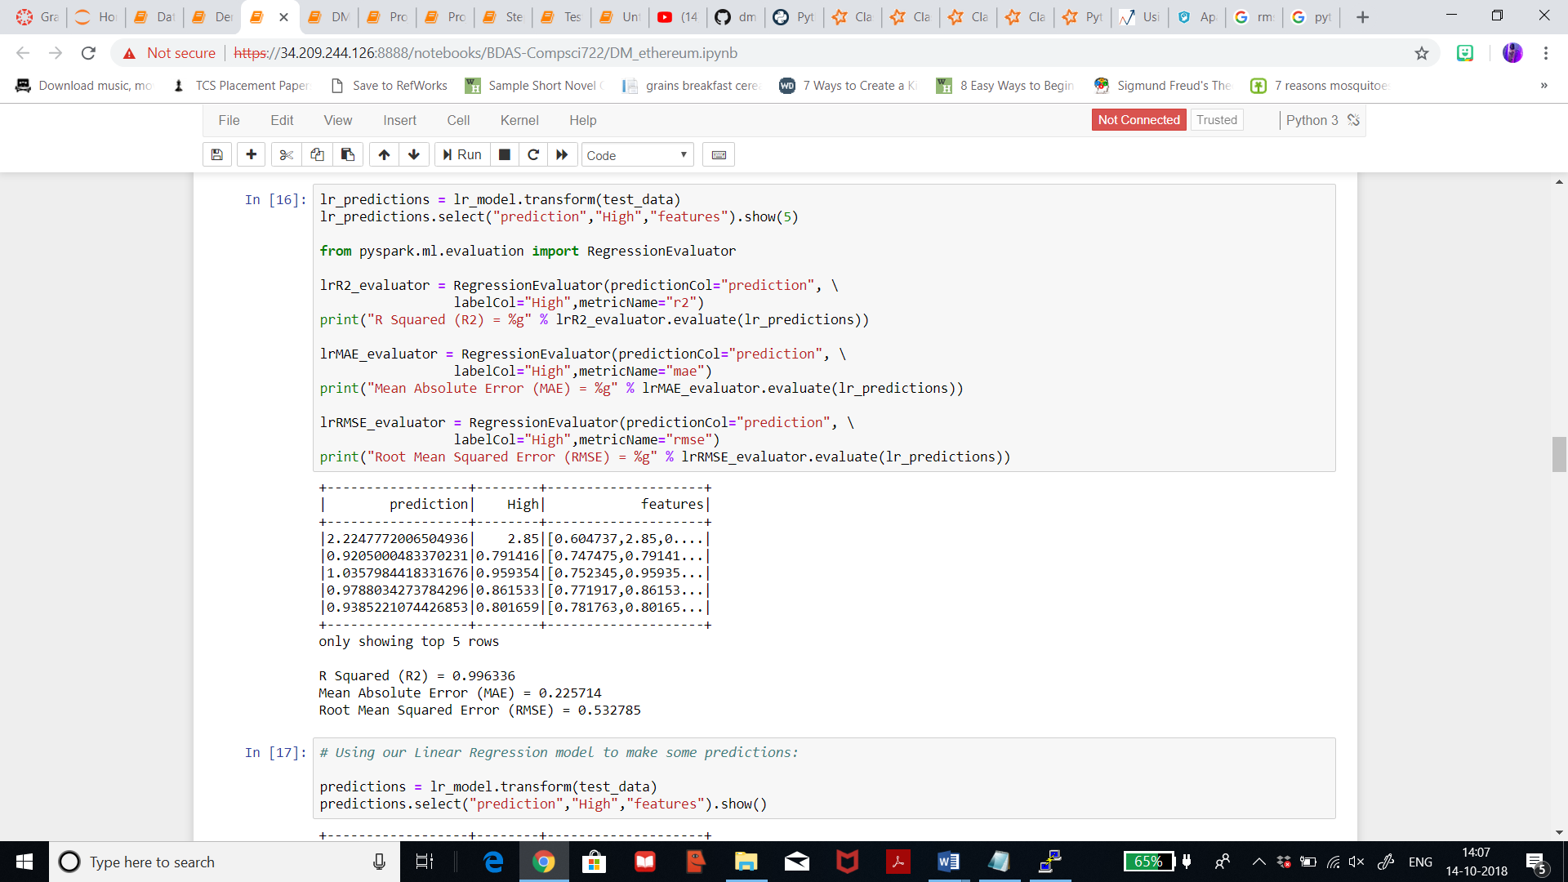

**Decision Regression Iteration 1: Ethereum dataset**

Decision trees are widely used since they are easy to interpret, handle categorical features, extend to the multiclass classification setting, do not require feature scaling, and are able to capture non-linearities and feature interactions. After fitting in the vector output, the Root Mean Squared Error on vector output is 0.88 and that on R2 is 0.99.

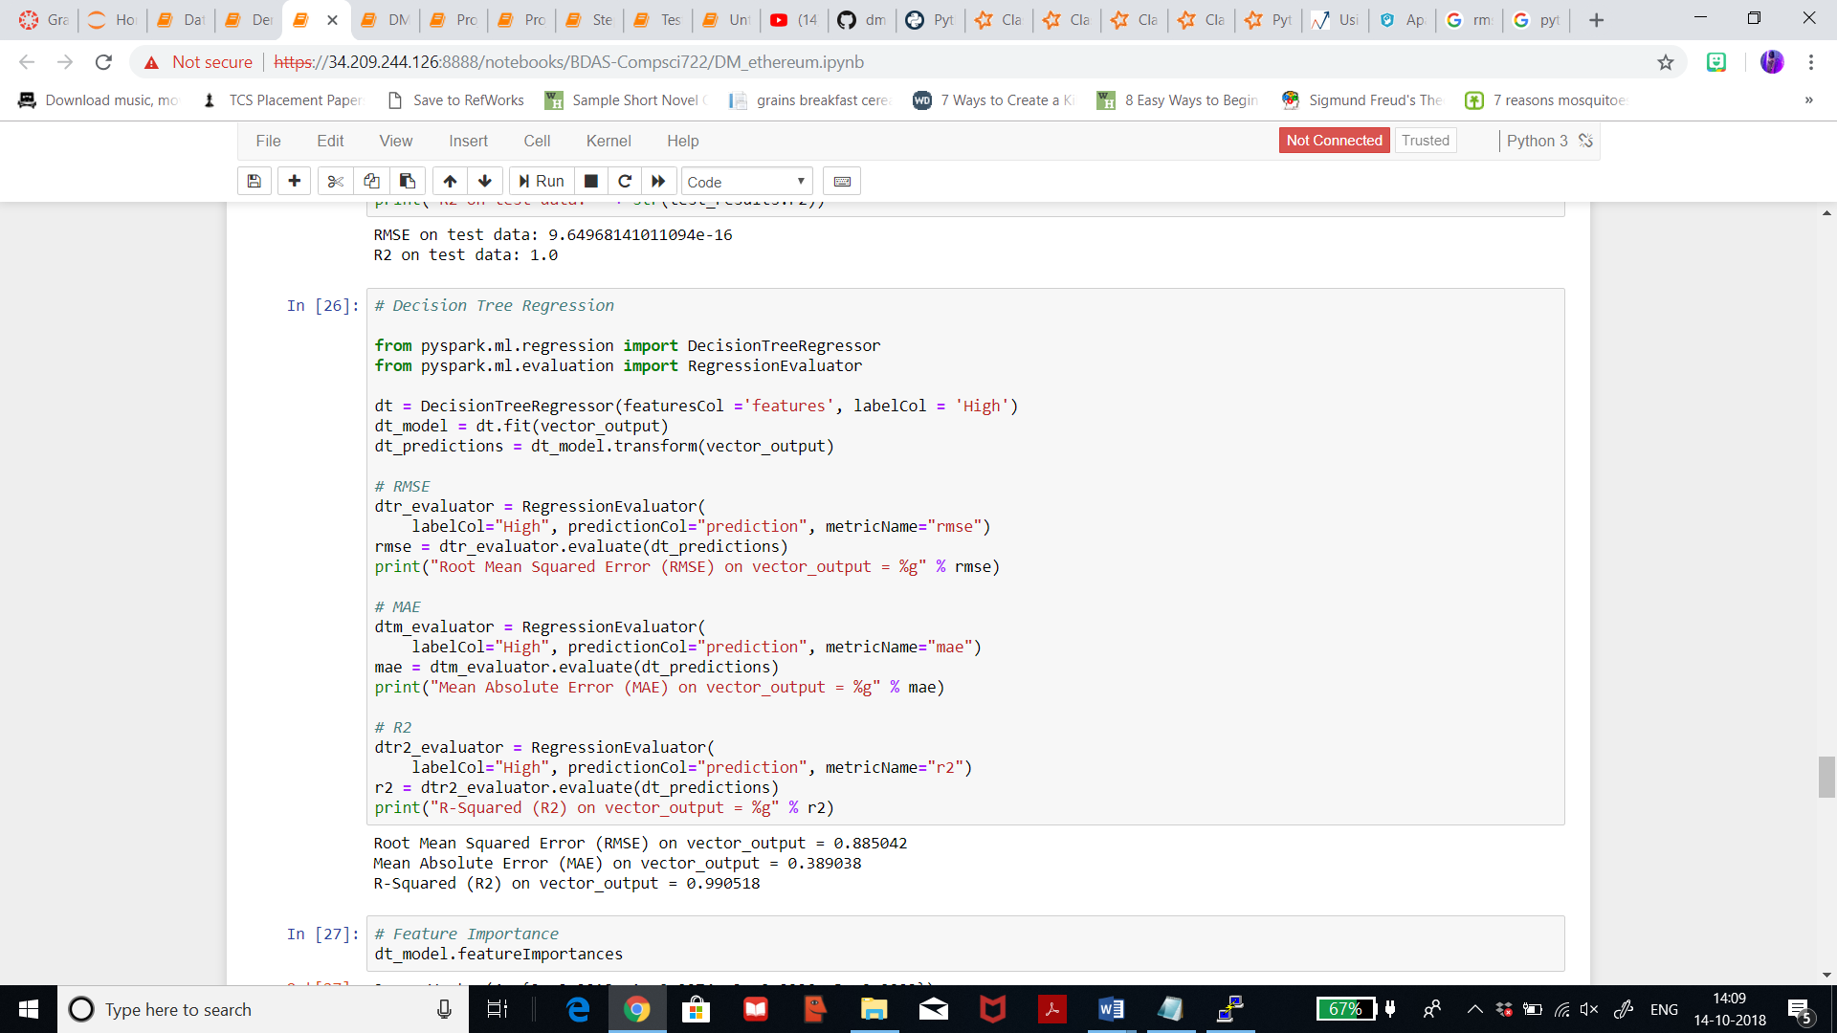

**Gradient boosted Tree Regression Iteration 1: Ethereum dataset**

GBTs iteratively train decision trees in order to minimize a loss function. The spark.ml implementation supports GBTs for binary classification and for regression, using both continuous and categorical features. Here, I’ve set 10 iterations, and I achieved R2 on vector output as 0.99.

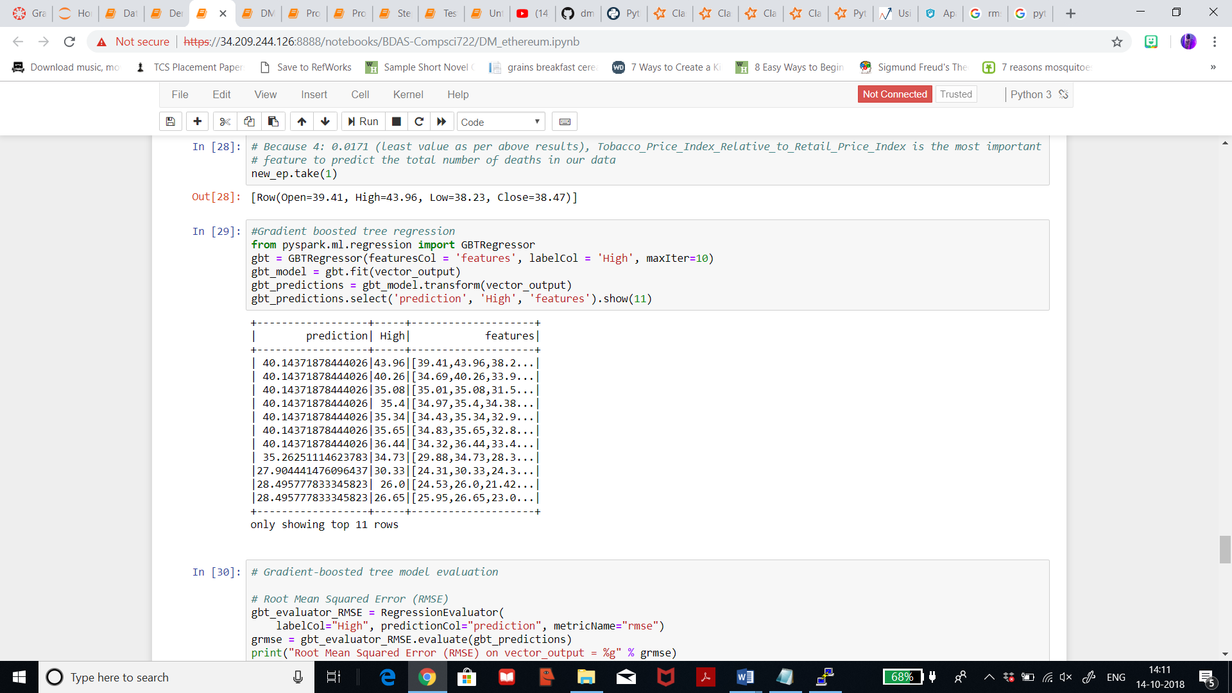

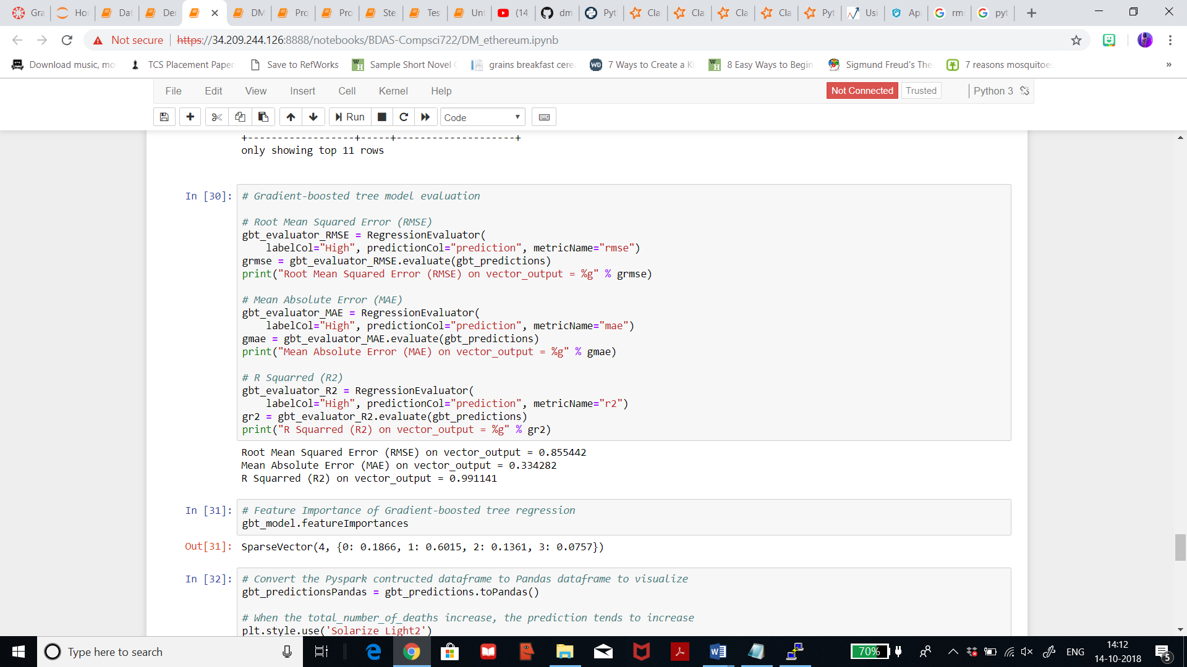

**7.3) Searching for Patterns:**

**Linear Regression:**

Histogram for ‘High’ and residuals for litecoin dataset.

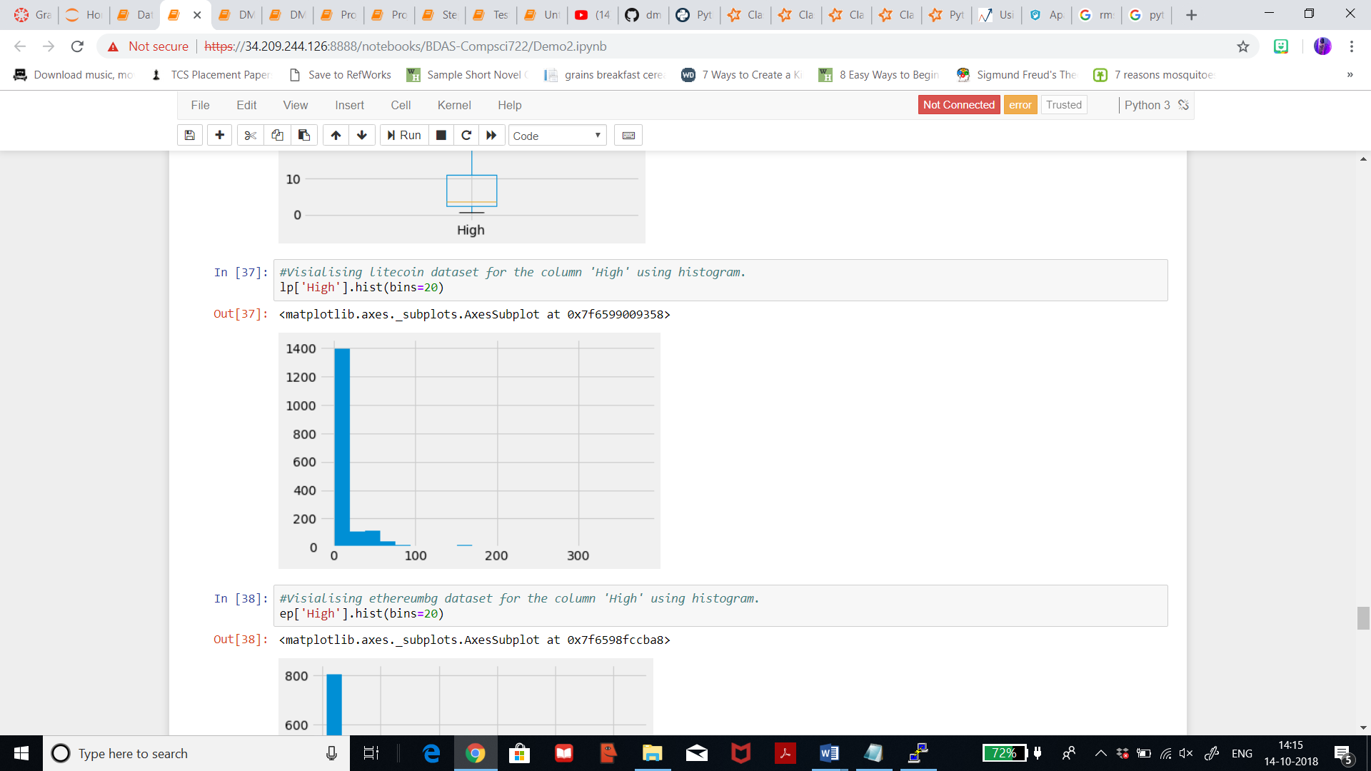

Histogram for ‘High’ and residual for ethereum dataset.

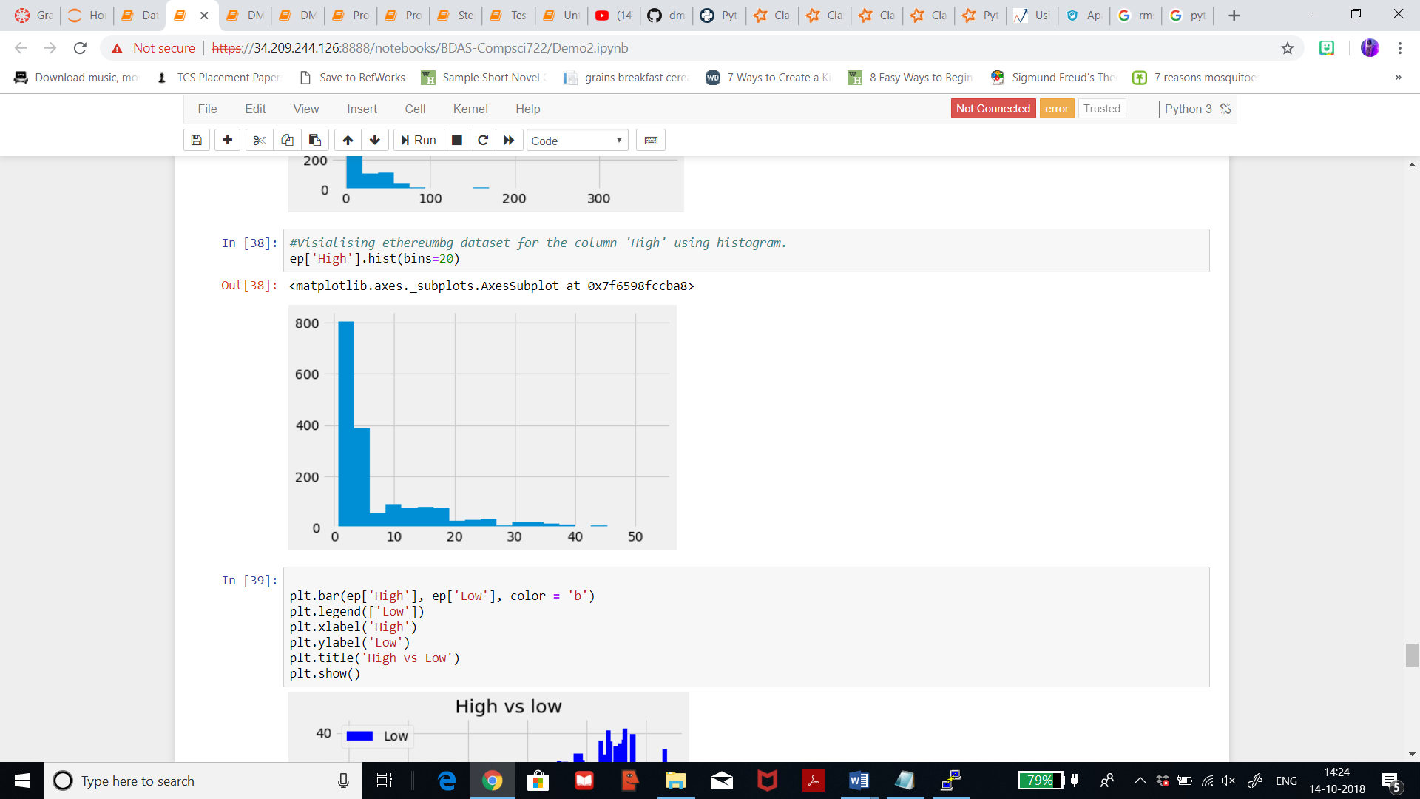

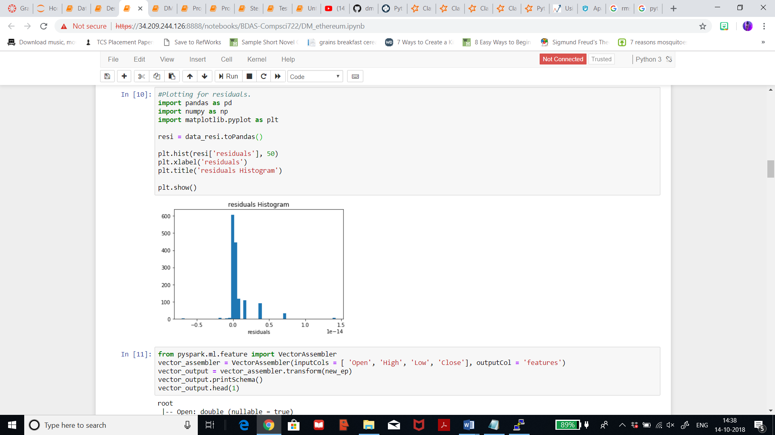

Describing the vector output for litecoin dataset, it displays mean of about 21.55 and standard deviation 50.14.

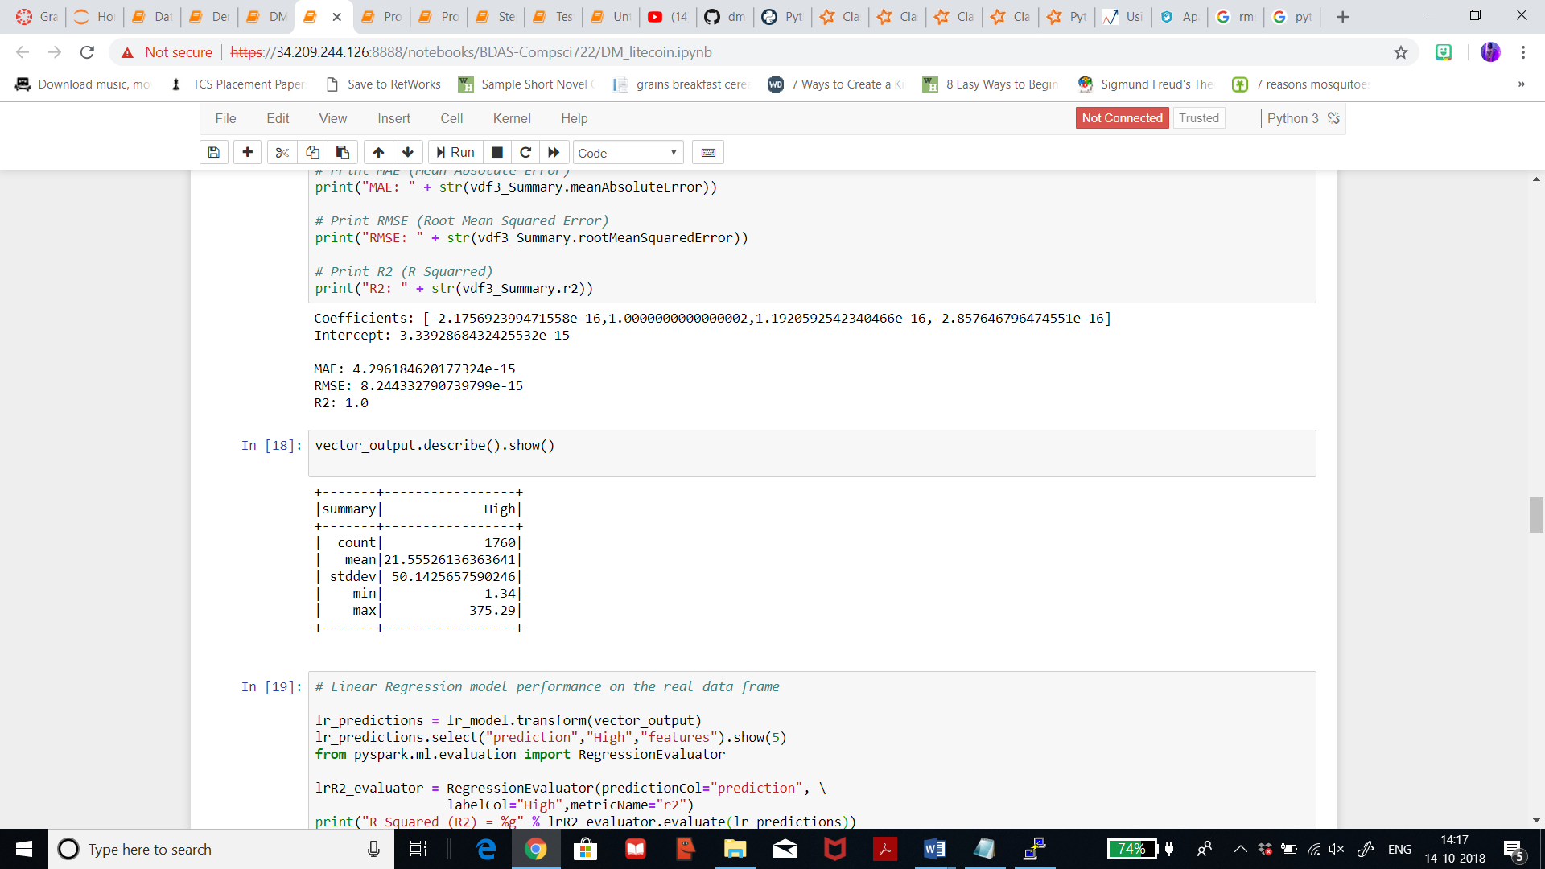

Describing the vector output for ethereum dataset, it displays mean of about 7.86and standard deviation 9.09.

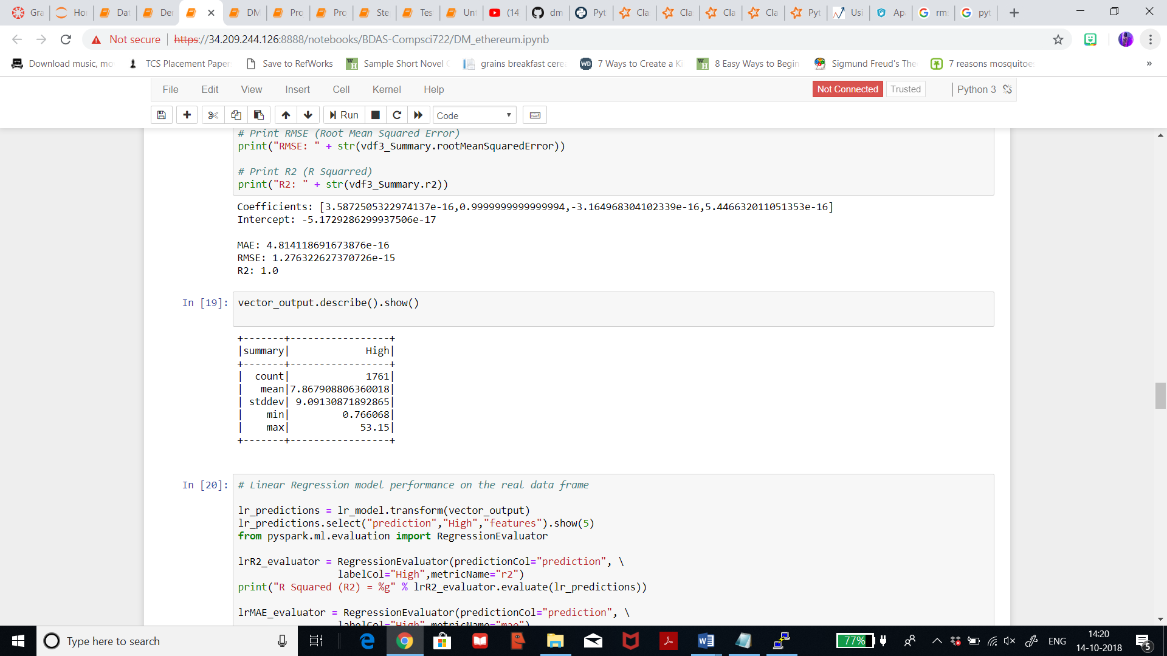

Displaying statistics for the predictions for litecoin dataset where mean is 21.5 for both label and prediction and standard deviation is also same for both.

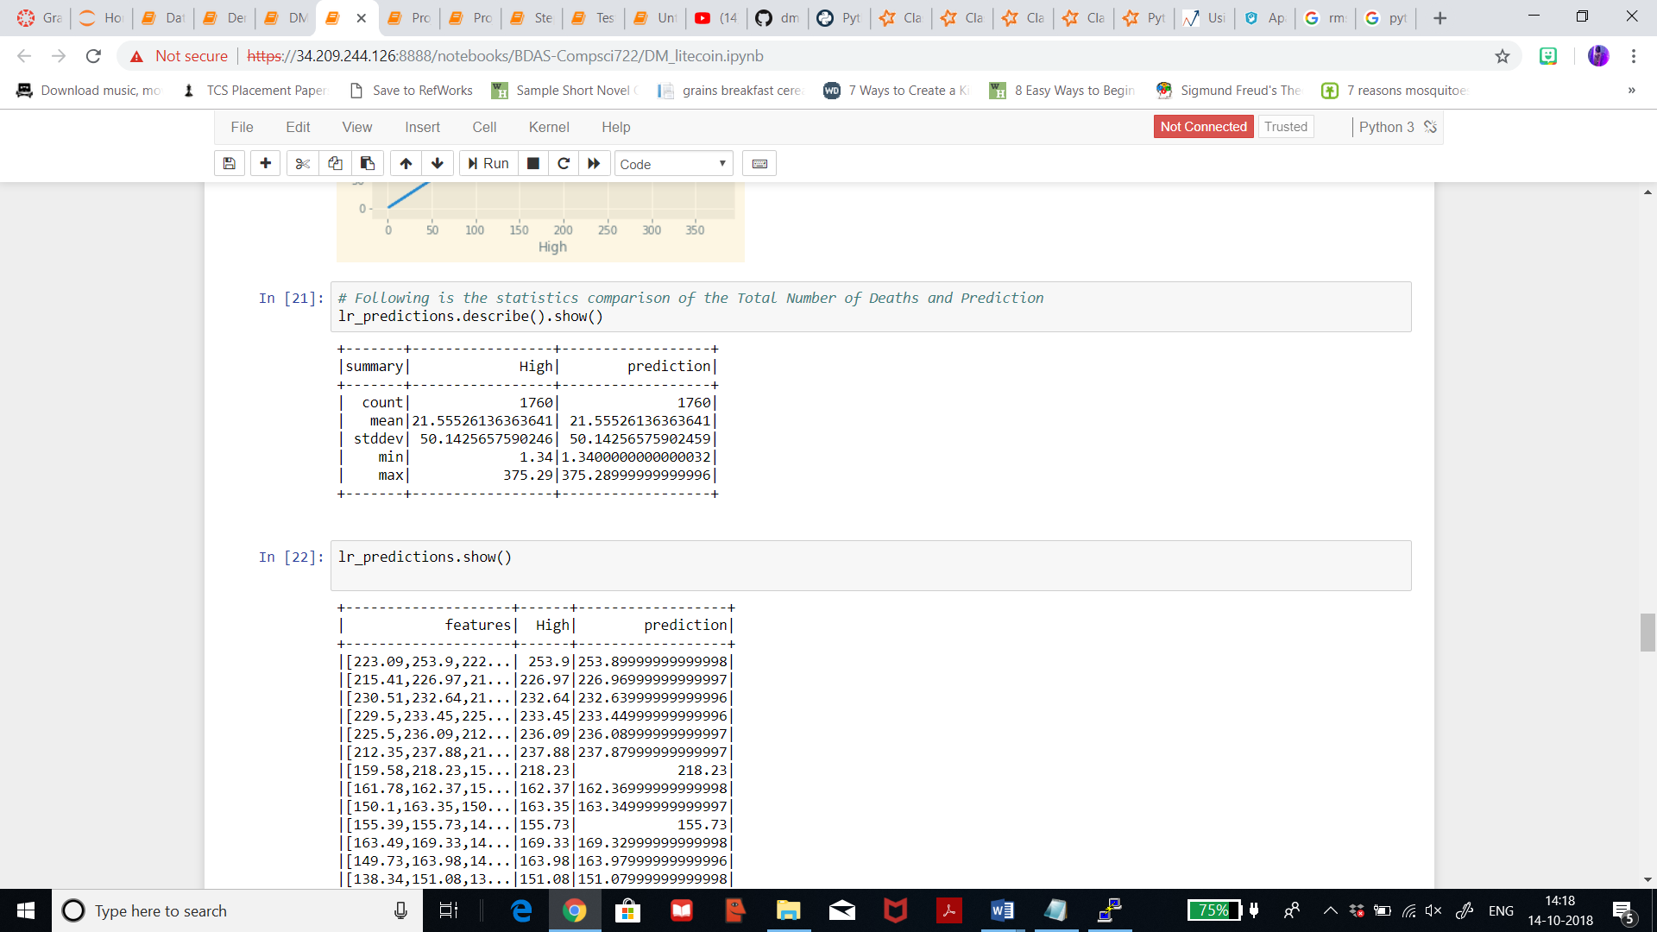

Displaying statistics for the predictions for ethereum dataset where mean is 7.86 for both label and prediction and standard deviation is 9.09 which is also same for both.

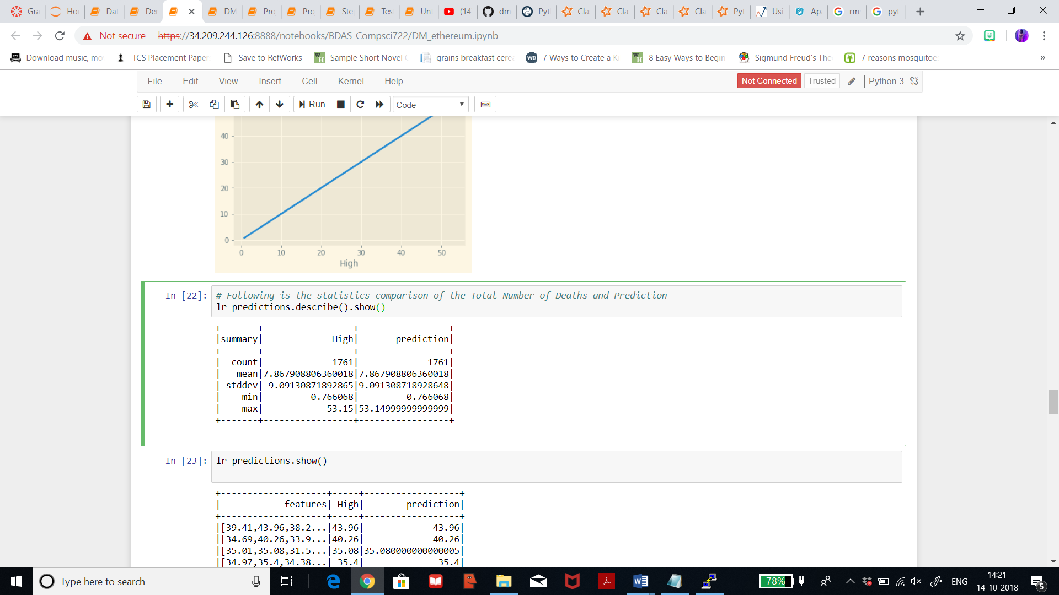

**Decision Tree Regression:**

Below shows the feature importance which states that 0 which is for column ‘Open’ has least value from all, thus the column for opening price is the most important for litecoin dataset for this model.

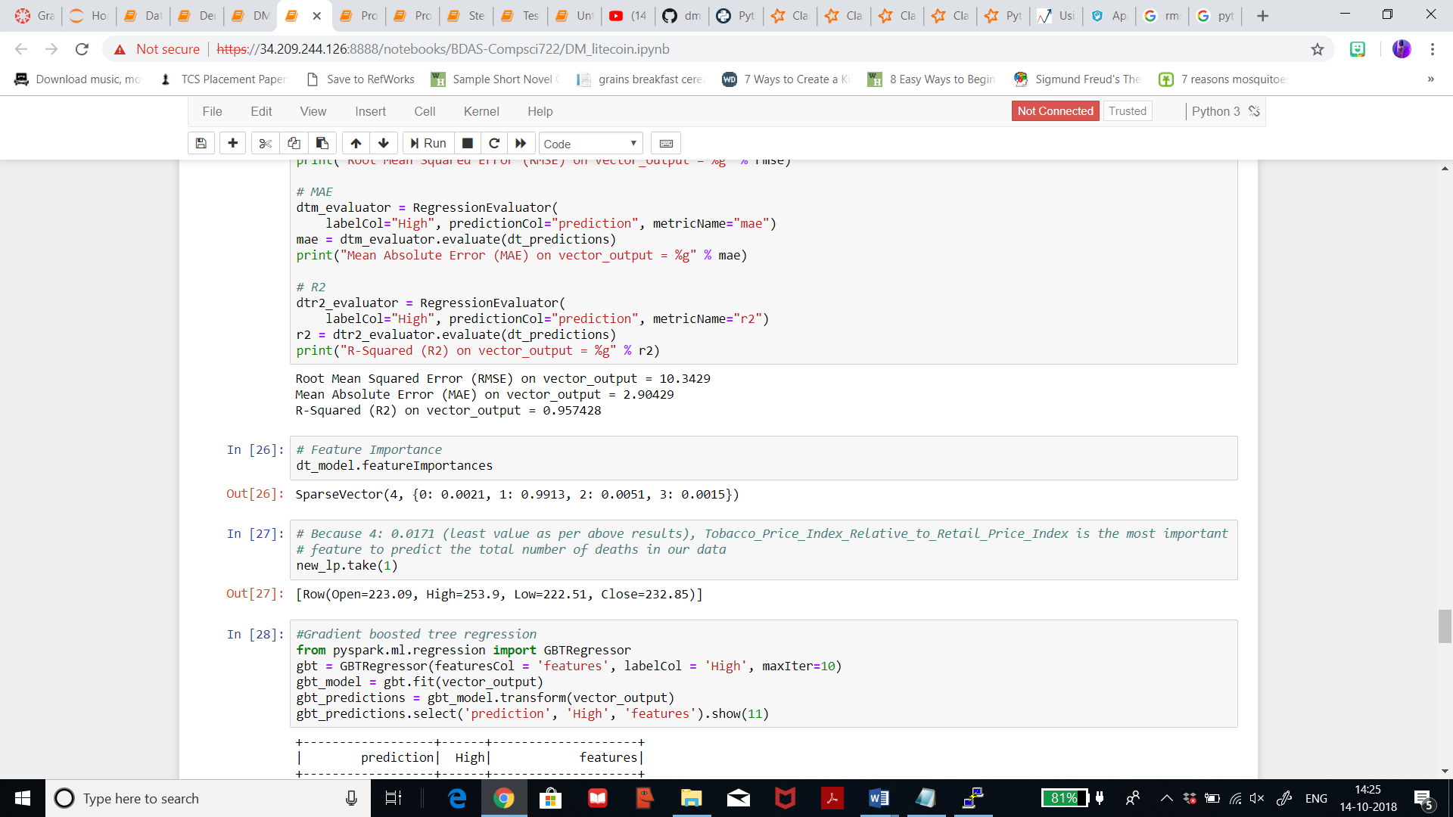

Below shows the feature importance which states that 3 which is for column ‘Close’ has least value from all, thus the column for closing price is the most important for ethereum dataset for this model.

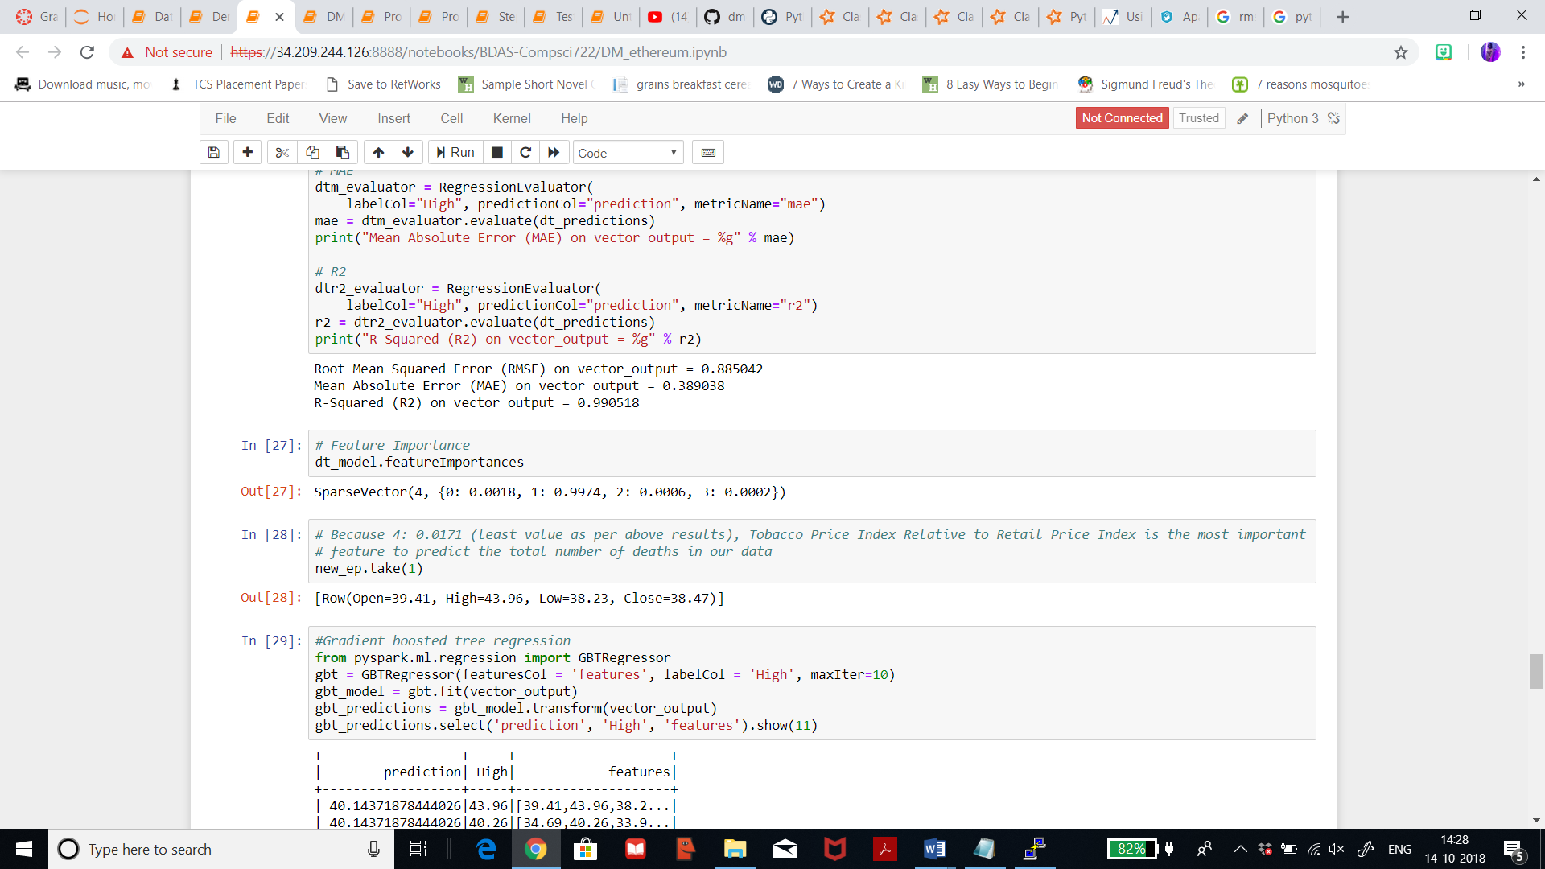

**Gradient Boosted tree model:**

Below shows the feature importance which states that 2 which is for column ‘Low’ has least value from all, thus the column for lowest price is the most important for litecoin dataset for this model.

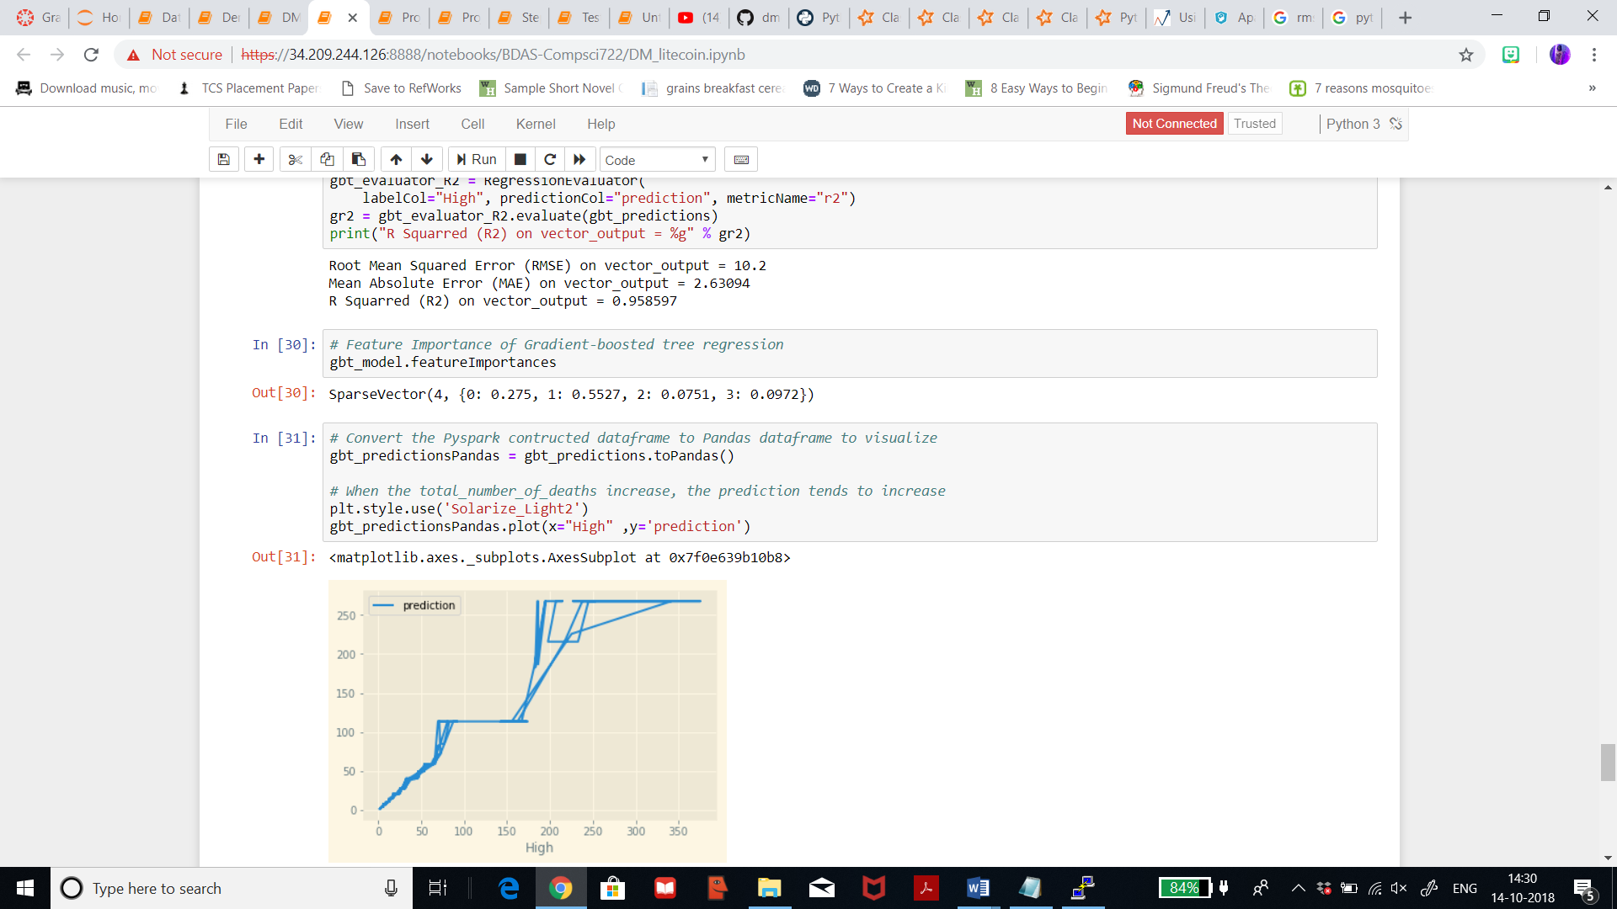

Below shows the feature importance which states that 3 which is for column ‘Close’ has least value from all, thus the column for closing price is the most important for ethereum dataset for this model.

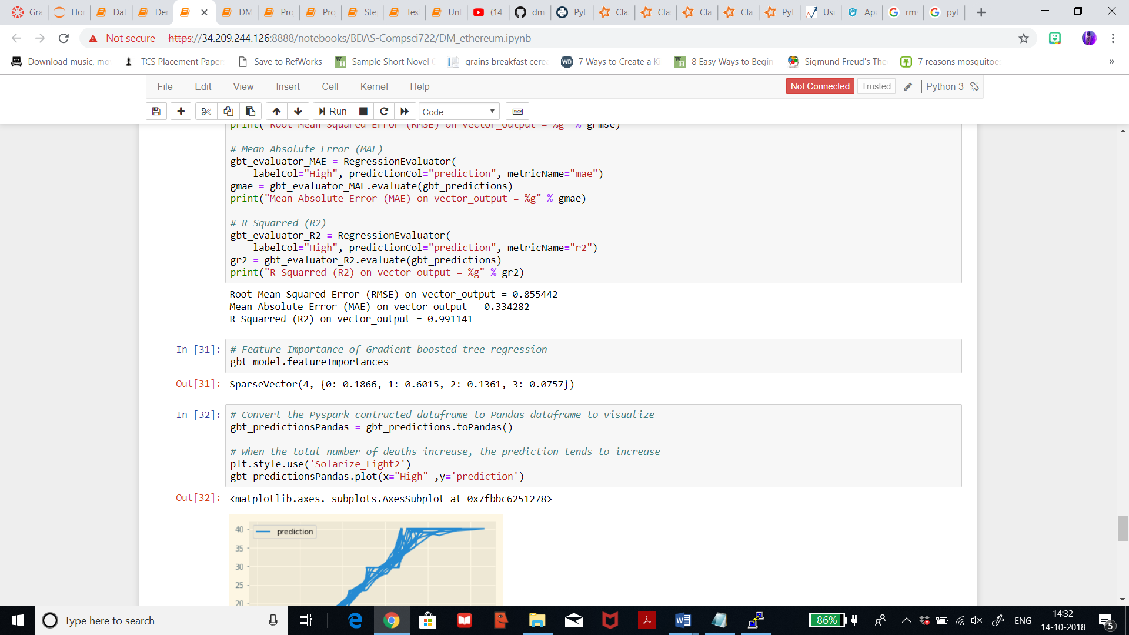

**8) Studying patterns, visualizing, discussing and re-iterating:**

The patterns achieved from the previous set show that the depiction for Linear Regression and Gradient boosted tree regression prove interesting and helpful in understanding the result set more. For Linear Regression vector output, the mean value is in the result set so that is depicted in the patterns above. Also, it states that feature importance for Decision tree and gradient boosted tree are almost the same and it will be very interesting to see how next iterations would result like.

**Analysing iteration 1 result for linear regression**: Basically, mean absolute error measures how close the predictions are to the actual value. In linear regression, the figure of 0.39 as MAE is low which means that the predictions are close enough for litecoin dataset and in ethereum dataset the MAE is 0.22 which is also low. Root **mean squared error** states the error in the model. By squaring the difference, the metric ignores the difference between over-prediction and under-prediction. I can see that the root mean square error is 0.99 for litecoin dataset which is the square of the difference, and it seems that the error is quite small and for ethereum dataset the RMSE is 0.53. I will have to run other methods to analyse which is the best. **R-squared** is 0.99 for litecoin dataset and ethereum dataset which close to the perfect fit. R-squared, represents the predictive power of the model as a value between 0 and 1. Zero means the model is random whereas 1 means there is a perfect fit. All of these metrics should be as low as possible because the lower the error, the better is the accuracy.

**Analysing iteration 1 result for decision tree regression**: Basically, mean absolute error measures how close the predictions are to the actual value. In linear regression, the figure of 2.9 as MAE is not that low and we will have to re-iterate to check that the predictions are close enough for litecoin dataset and in ethereum dataset the MAE is 0.3 which is low which means it is close enough for predicting the prices correctly. Root **mean squared error** states the error in the model. By squaring the difference, the metric ignores the difference between over-prediction and under-prediction. I can see that the root mean square error is 10.34 for litecoin dataset which is the square of the difference, and it seems that the error is quite huge and for ethereum dataset the RMSE is 0.88 which is also very low which is a good sign. I will have to run other methods to analyse which is the best. **R-squared** is 0.95 for litecoin dataset and 0.99 for ethereum dataset which is a statistical measure of how close the data are to the fitted regression line. It is also known as the coefficient of determination, or the coefficient of multiple determination for multiple regression. R2 measures how much of the variation in the response variable y is explained by variation in the regressors X. R-sqaured, also represents the predictive power of the model as a value between 0 and 1. Zero means the model is random whereas 1 means there is a perfect fit. All of these metrics should be as low as possible because the lower the error, the better is the accuracy.

**Analysing iteration 1 result for gradient boosted tree regression:** Basically, mean absolute error measures how close the predictions are to the actual value. In linear regression, the figure of 2.6 as MAE is not that low and we will have to re-iterate to check that the predictions are close enough for litecoin dataset and in ethereum dataset the MAE is 0.33 which is low which means it is close enough for predicting the prices correctly. Root **mean squared error** states the error in the model. By squaring the difference, the metric ignores the difference between over-prediction and under-prediction. I can see that the root mean square error is 10.2 for litecoin dataset which is the square of the difference, and it seems that the error is quite huge and for ethereum dataset the RMSE is 0.85 which is also very low which is a good sign. I will have to run other methods to analyse which is the best. **R-squared** is 0.95 for litecoin dataset and 0.99 for ethereum dataset which is a statistical measure of how close the data are to the fitted regression line. It is also known as the coefficient of determination, or the coefficient of multiple determination for multiple regression. R-squared also, represents the predictive power of the model as a value between 0 and 1. Zero means the model is random whereas 1 means there is a perfect fit. All of these metrics should be as low as possible because the lower the error, the better is the accuracy.

**Linear Regression Re-iteration 2: Litecoin dataset**

In this iteration I have tried to fit the vector output, and the result achieved seems good. **R-squared** is 1 for litecoin dataset which is the perfect fit. Root mean squared error is 1.27 which is also good.

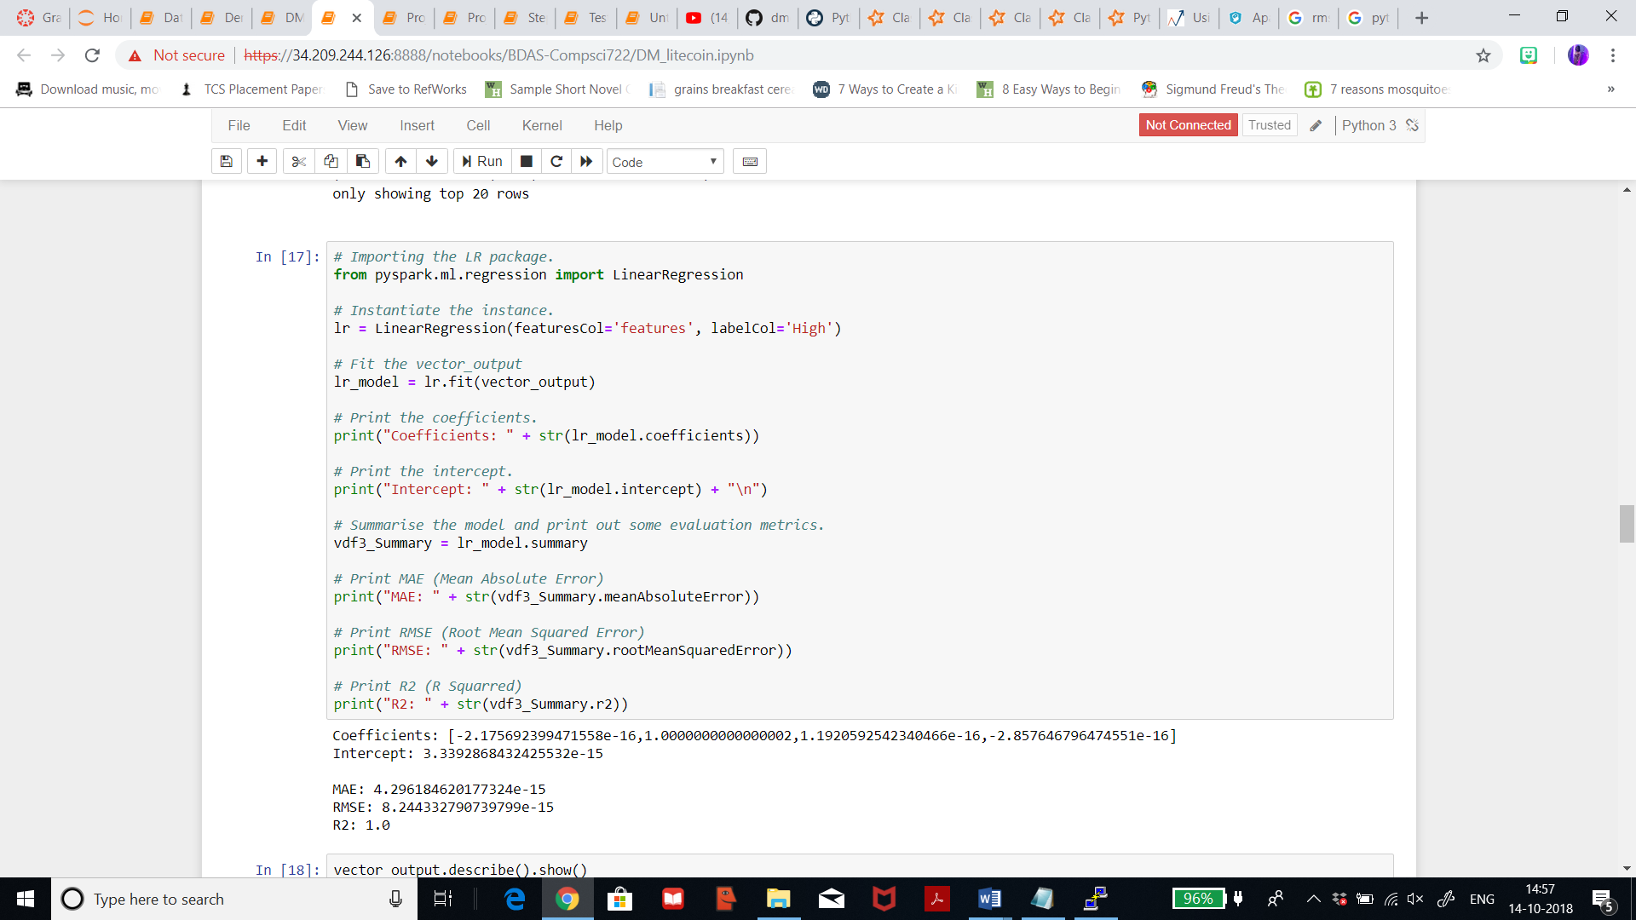

Prediction table:

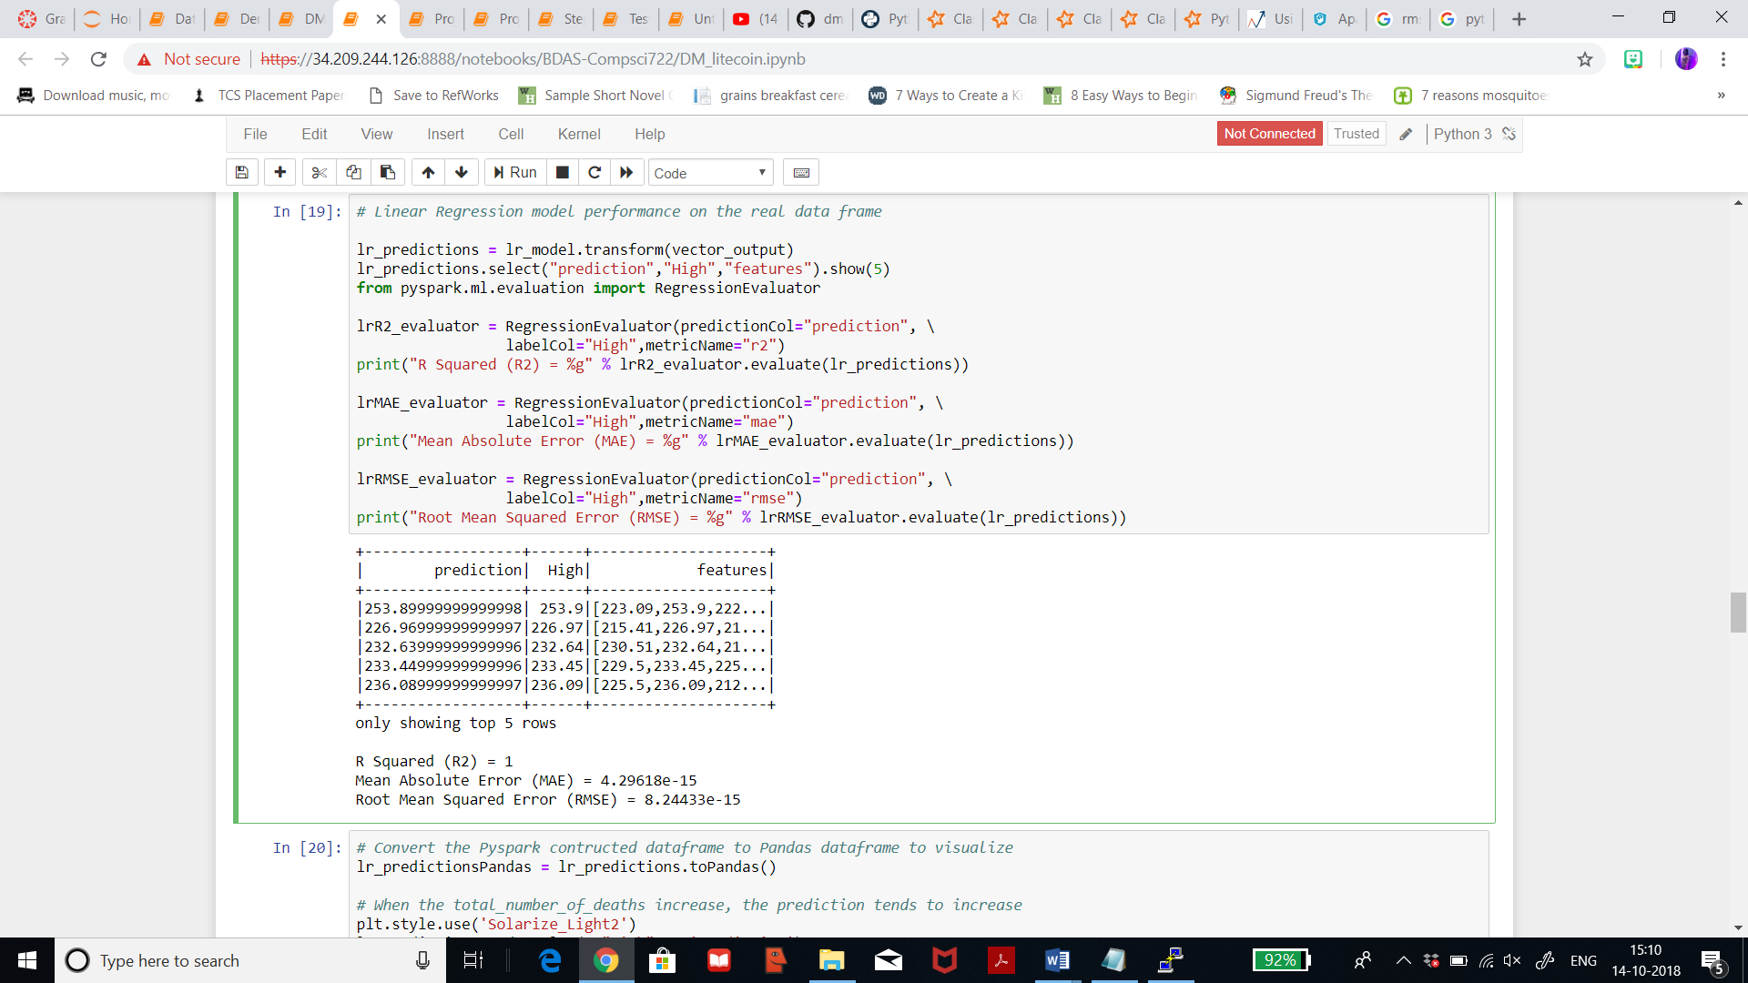

**Linear Regression Re-iteration 2: Ethereum dataset**

In this iteration I have tried to fit the vector output, and the result achieved seems good. **R-squared error** is 1 for ethereum dataset which is perfect fit. Root mean squared error is 1.27 which is also good.

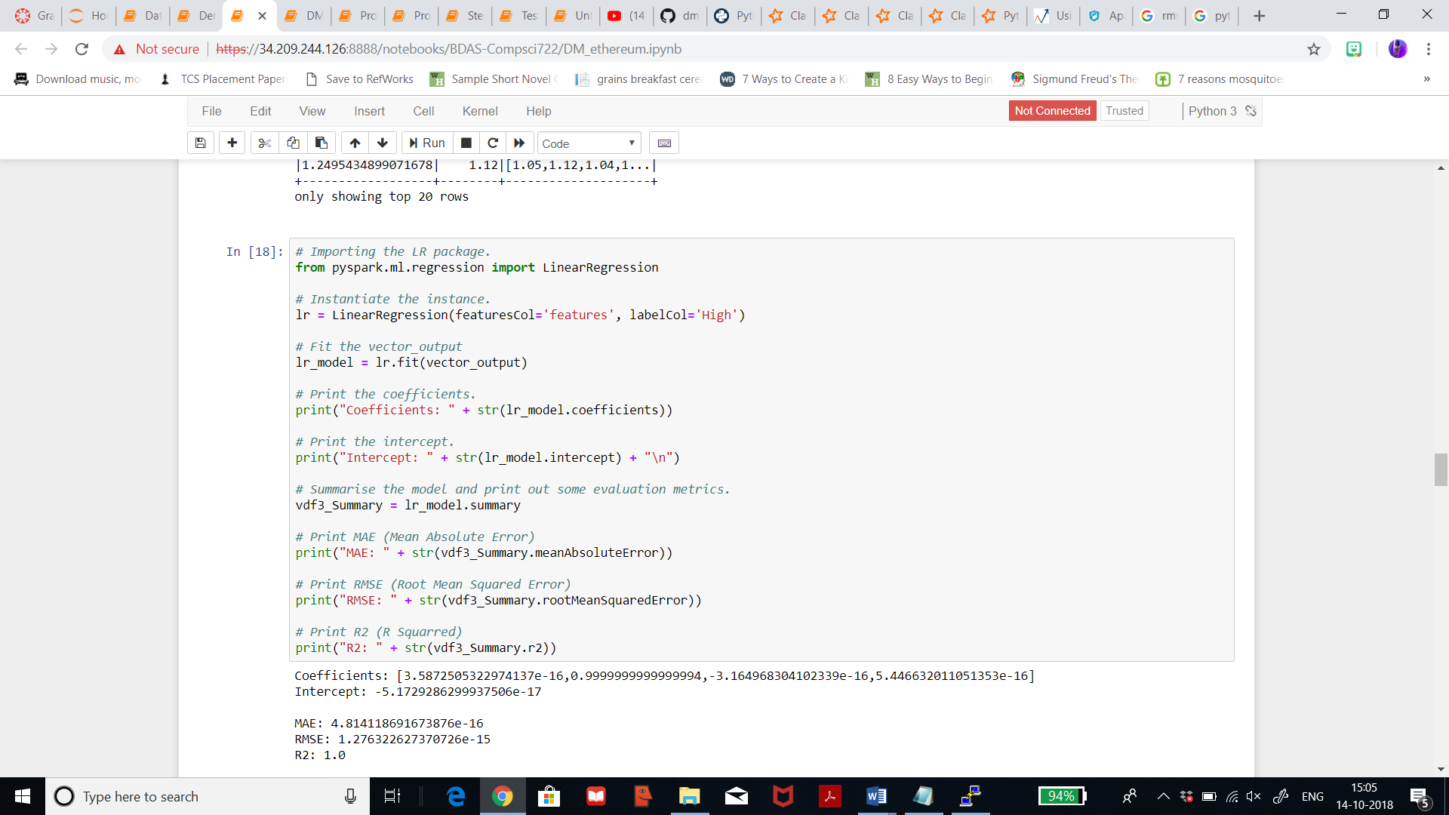

**Gradient boosted tree regression Iteration 2: litecoin dataset**

When I changed the maxIteration from 10 to 15, the result differed a little bit. The precision for prediction is 0.95.

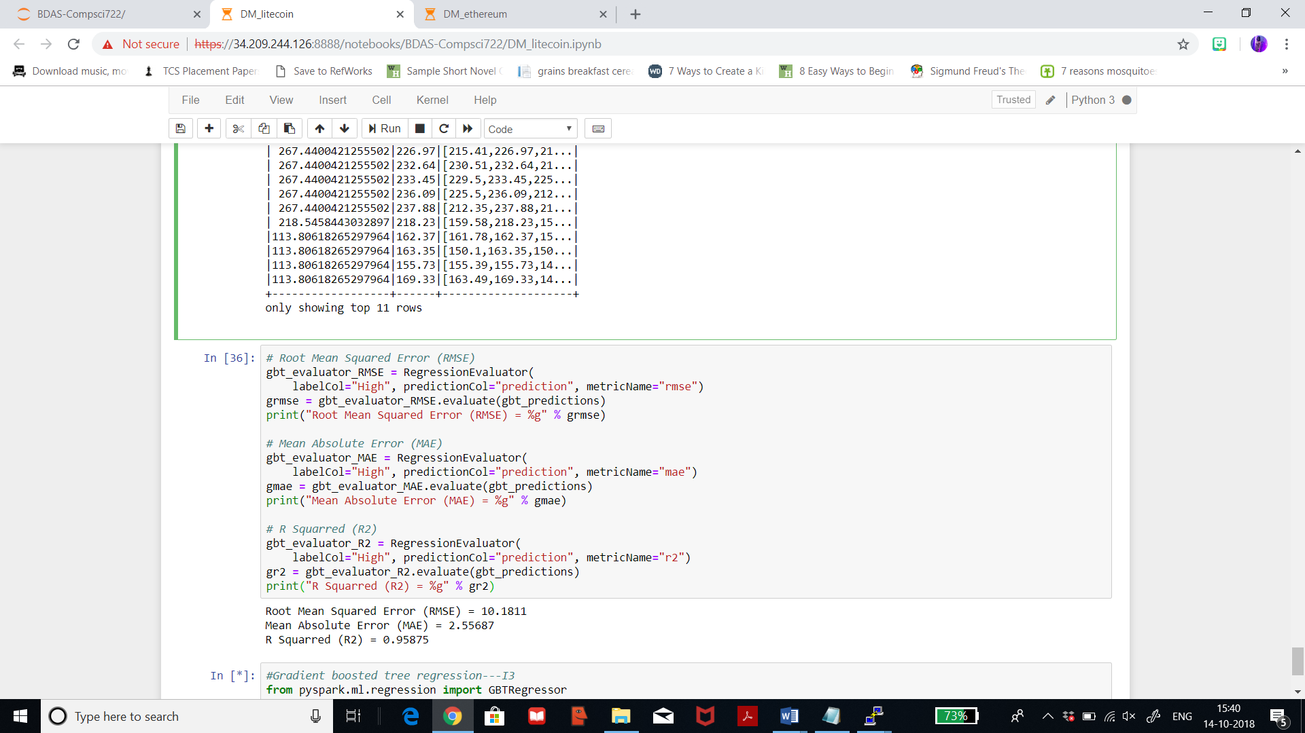

Gradient boosted tree regression Iteration 2: ethereum dataset

When I changed the maxIteration from 10 to 15, the result differed a little bit. The precision for prediction is 0.98.

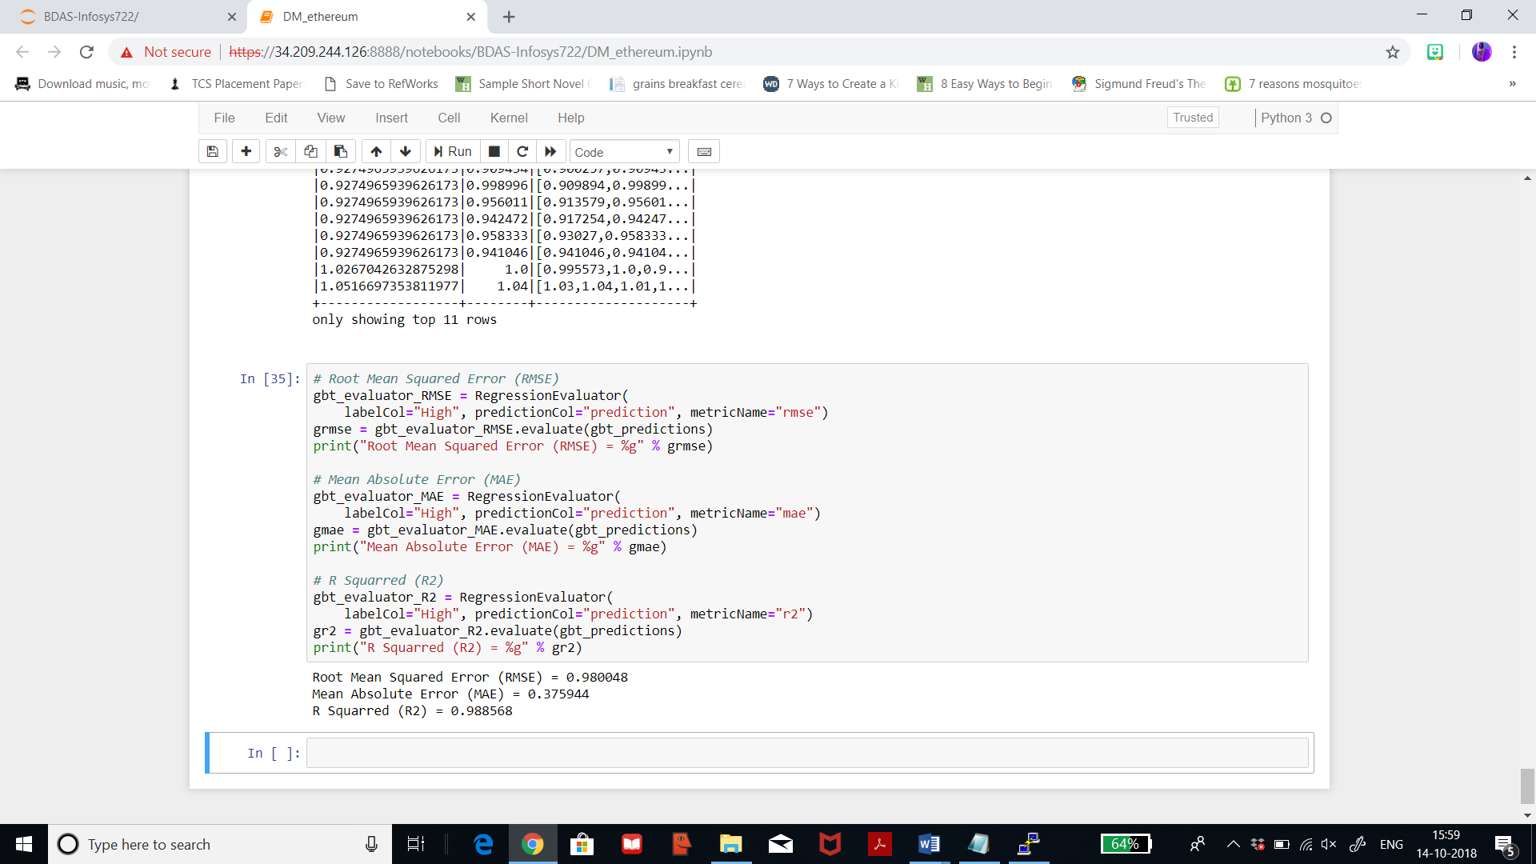

**Linear regression iteration 3: litecoin dataset**

I changed the maxIteration to 15 and regParam as 0.5, I achieved the below results. The precision to prediction, i.e, R2 is 0.99. The result was better in the last iteration.

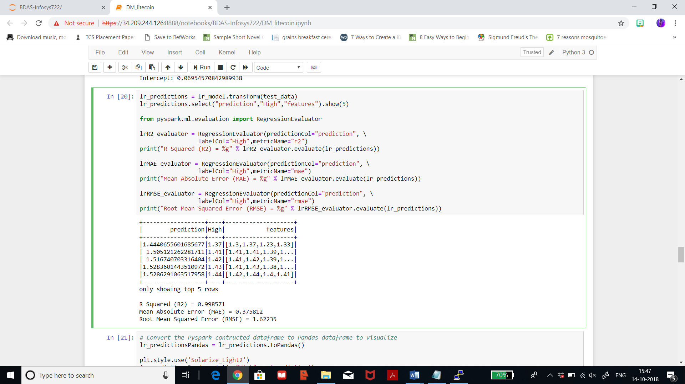

**Linear regression iteration 3: ethereum dataset**

I changed the maxIteration to 15 and regParam as 0.5, I achieved the below results. The precision to prediction, i.e, R2 is 0.99. The result was better in the last iteration

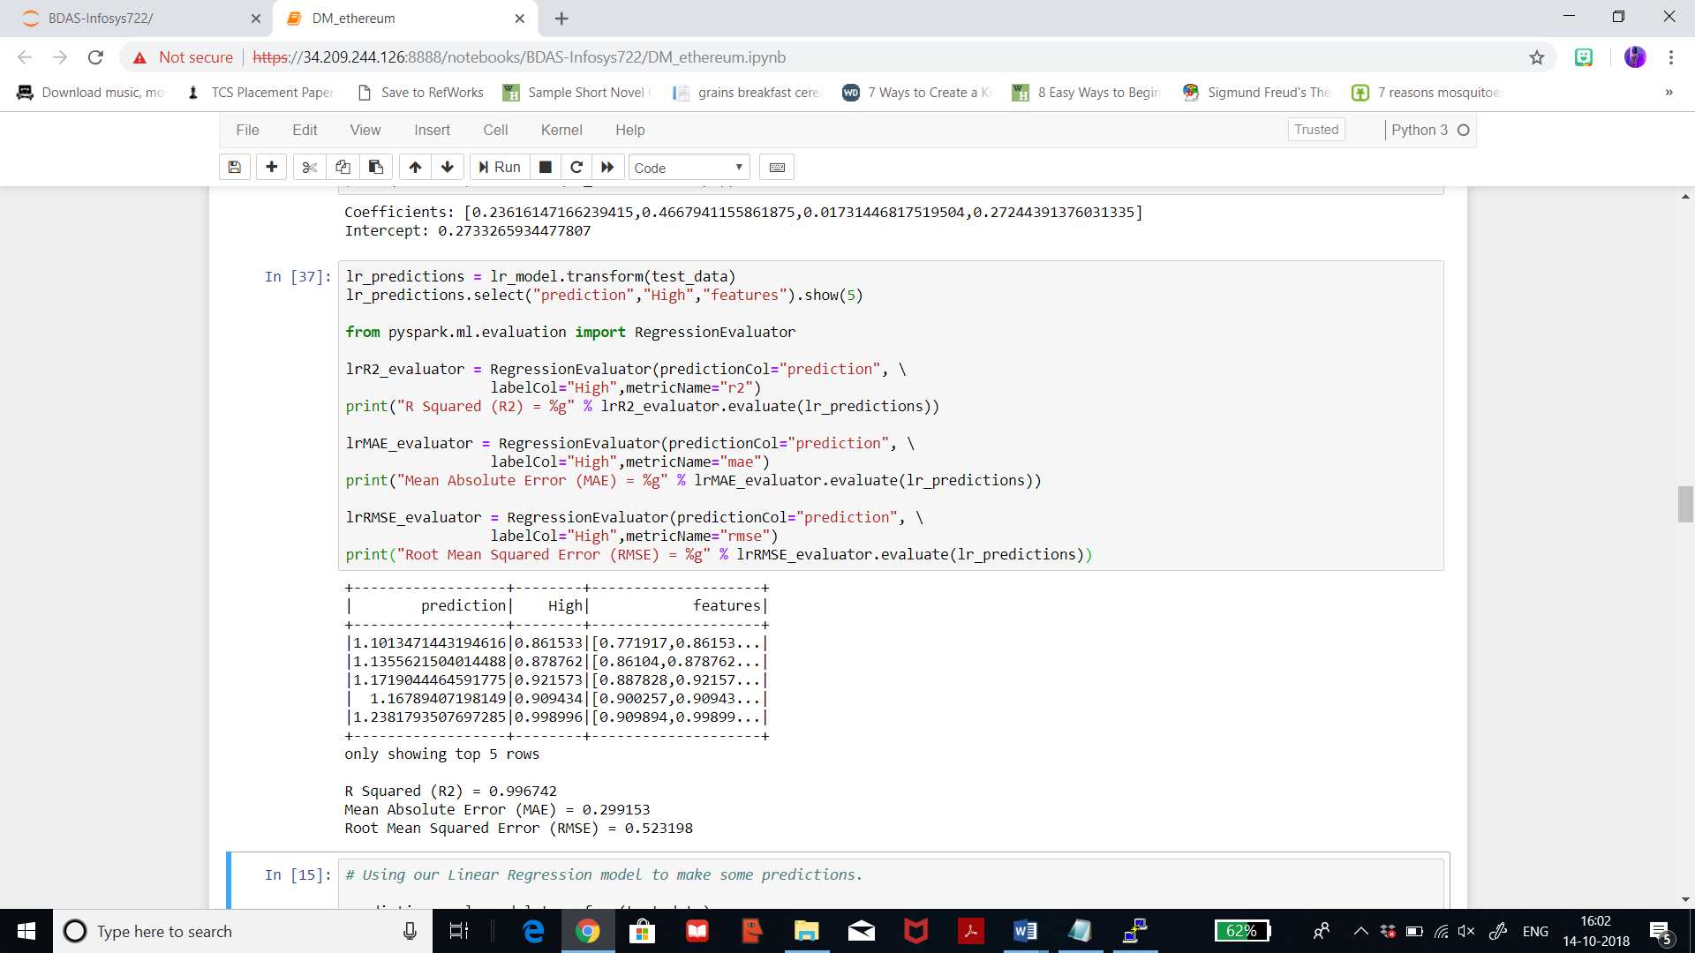

**Gradient boosted tree regression Iteration 3: litecoin dataset**

When I changed the maxIteration from 15 to 20, the result differed a little bit. The precision for prediction is 0.95. The difference in the last iteration and this one is just for a few decimal.

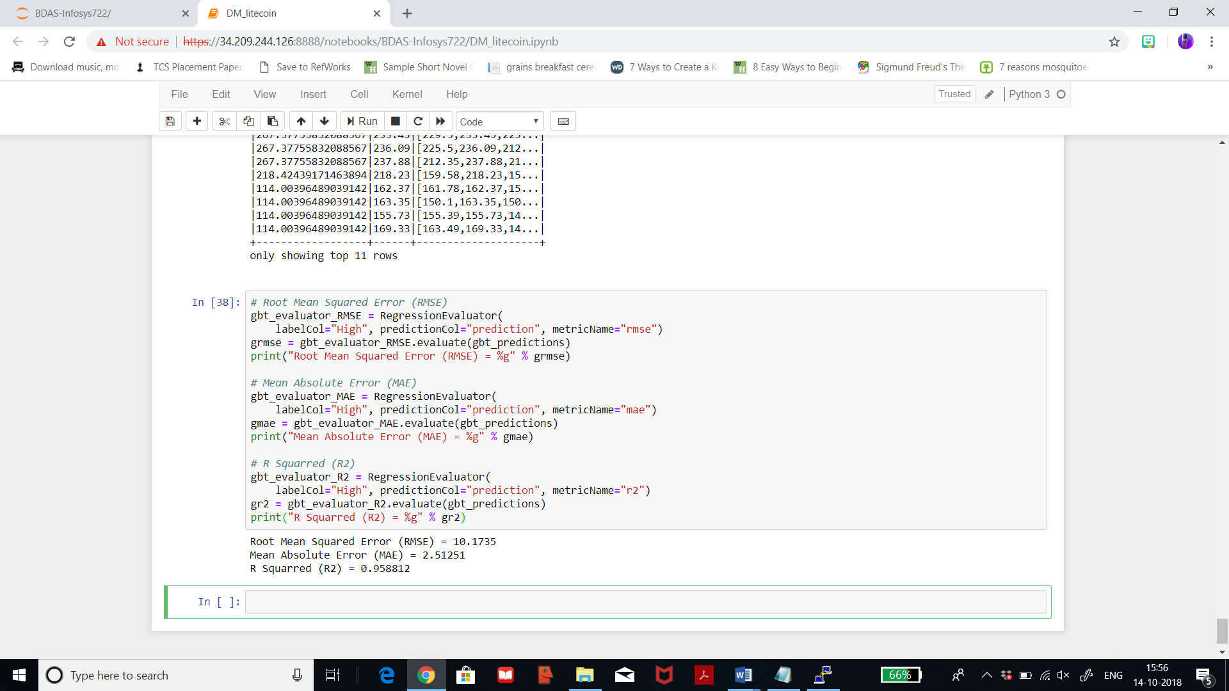

**Gradient boosted tree regression Iteration 3: ethereum dataset**

When I changed the maxIteration from 15 to 20, the result differed a little bit. The precision for prediction is 0.98 which is quite impressive. The difference in the last iteration and this one is just for a few decimal.

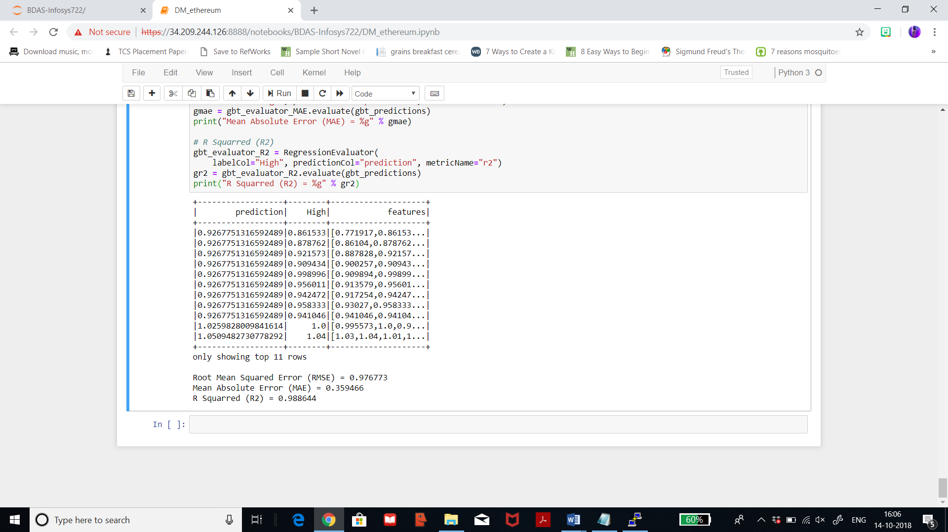

**Conclusion:**

**Linear regression: litecoin dataset**

Below I’m converting Pyspark constructed dataframe to pandas dataframe to visualise. We can see that it is a straight linear line graph with few skews and low points. But, overall the prediction is good.

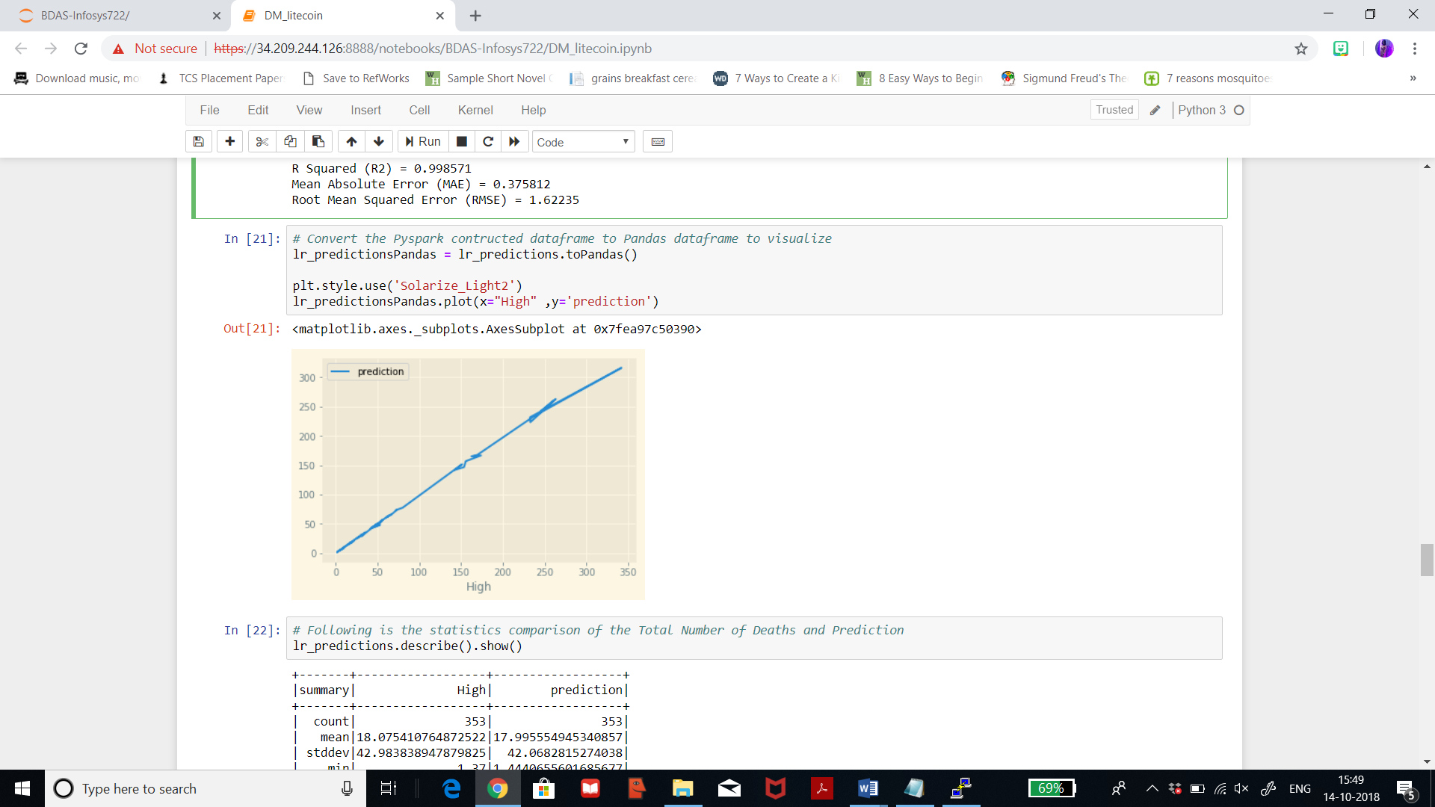

**Linear regression: ethereum dataset**

Below I’m converting Pyspark constructed dataframe to pandas dataframe to visualise. We can see that it is a straight linear line graph with no skews and low points. The prediction is a perfect fit and I’m happy with the result.

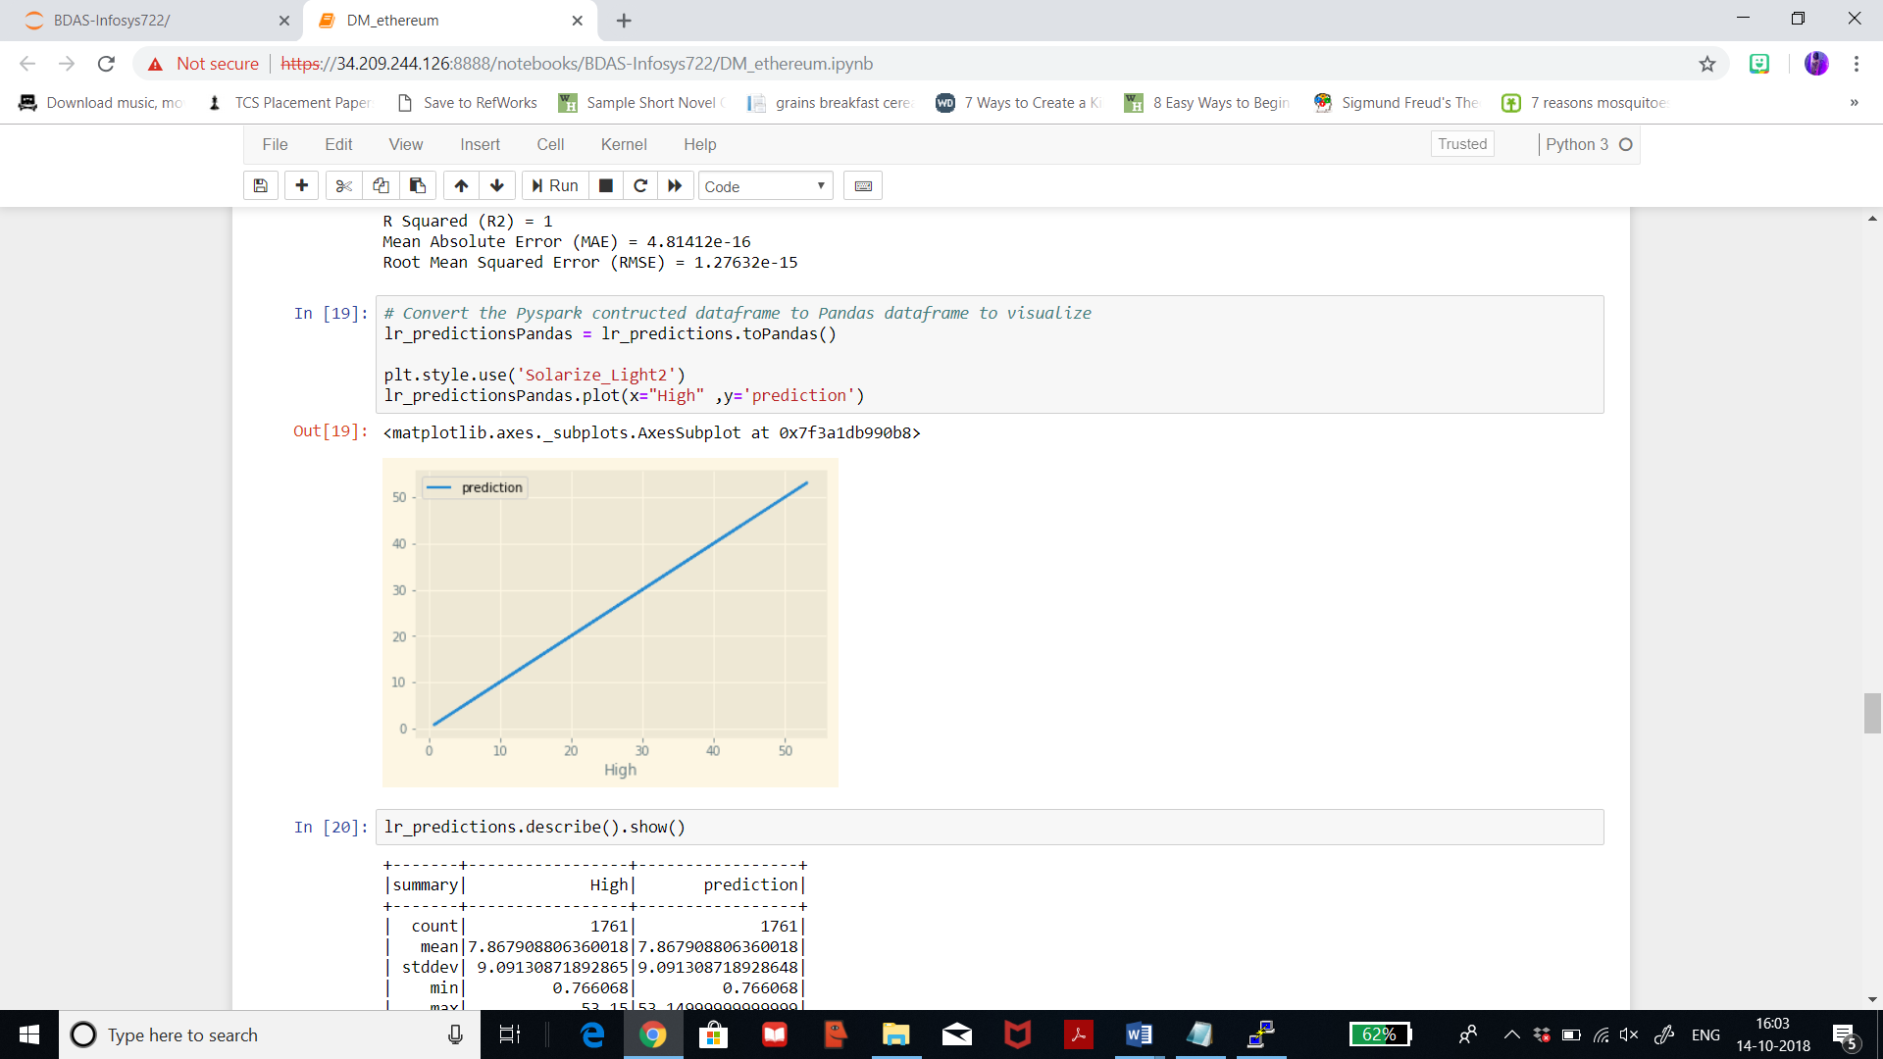

**Gradient boosted tree regression: litecoin dataset**

Below I’m converting Pyspark constructed dataframe to pandas dataframe to visualise. We can see that it is an uneven line graph with a lot of highs and lows. Thus, this line graph is not as satisfactory as that for linear regression.

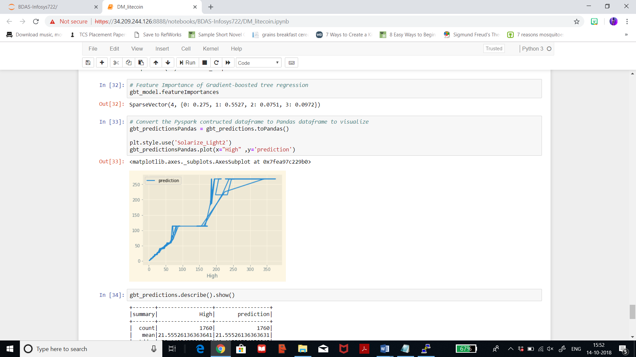

**Gradient boosted tree regression: ethereum dataset**

Below I’m converting Pyspark constructed dataframe to pandas dataframe to visualise. We can see that it is an uneven line graph with a lot of highs and lows. Thus, this line graph is not as satisfactory as that for linear regression.

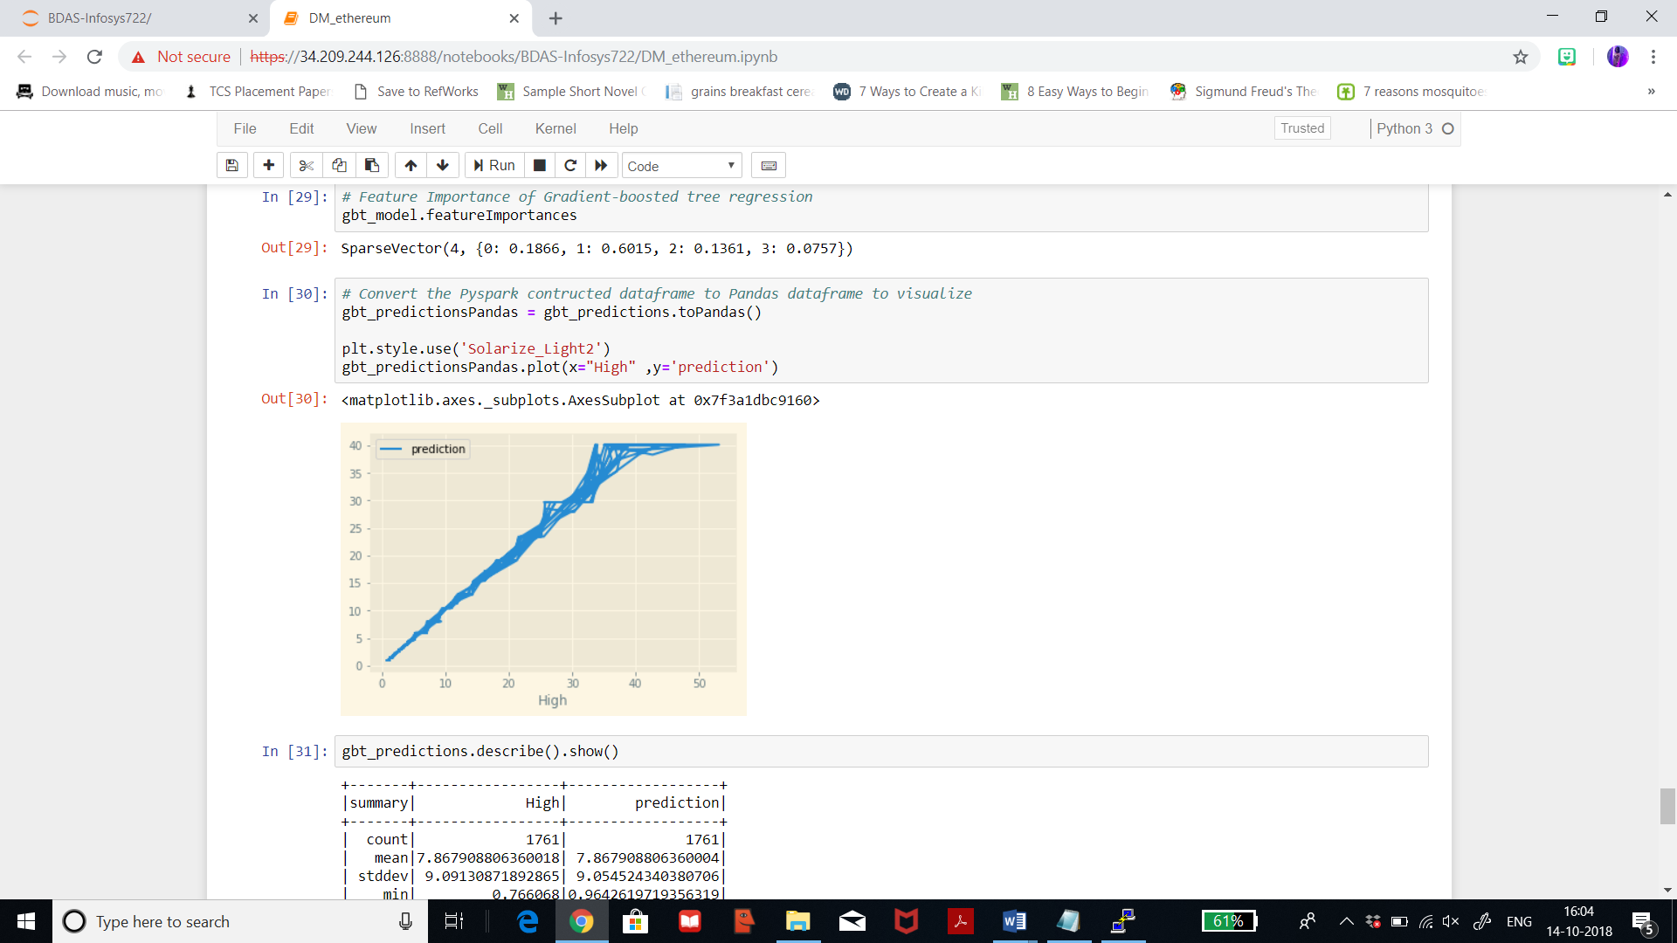

I haven’t considered a line graph for Decision Tree Regression since I’m not keen on diving in deep with the analyses for decision tree since gradient boosted tree regression is very interesting for me.

|  |  |  |  |
| --- | --- | --- | --- |
| Results | Linear Regression | Decision Tree Rgression | Gradient boosted tree Regression |
| Iteration 1 | R2 litecoin: 0.99  R2 ethereum: 0.997 | R2 litecoin: 0.95  R2 ethereum: 0.9905 | R2 litecoin: 0.958  R2 ethereum: 0.991 |
| Iteration 2 | R2 litecoin: 1.0  R2 ethereum: 1.0 | - | R2 litecoin: 0.958  R2 ethereum: 09885 |
| Iteration 3 | R2 litecoin: 0.998  R2 ethereum: 0.996 | - | R2 litecoin: 0.958  R2 ethereum: 0.9886 |

After running 3 iterations for the selected algorithms, I can finally say that linear regression have R2 of 1 in iteration 2 for both the datasets which is a perfect fit and that the predicted scores are quite accurate. But, as for my goal, I think Linear Regression is the best model for this prediction process. After analysing the patterns and visualizations, it can be said that Litecoin dataset is stable to invest in, the growth is on a slow pace but the prices won’t fall down which is how the forecast graph depicts. But, nothing is certain about how the market flows so according to this study and after analysing, I feel Litecoin is better option to invest in rather than Ethereum since Ethereum has the tendency to plunge. Also, recent reports claimed that Ethereum currency plunged this month. If I had more time, then I could have worked on building a recommender option by including more datasets, but within this scope and time, the above results were generated.